LinkedIn Latest Articles

Published 2 hours ago

**[[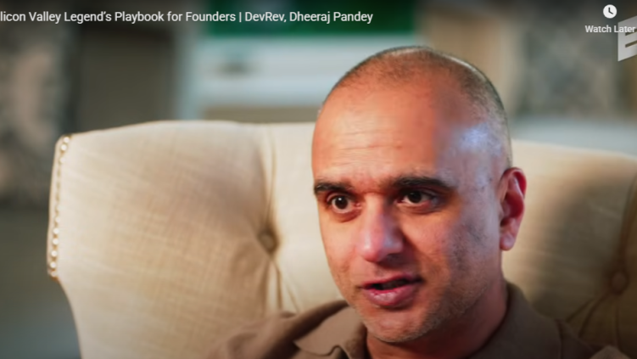](https://www.linkedin.com/pulse/devrev-bridging-developer-customer-gap-reshaping-crm-market-hukkeri-qwegc)](https://www.linkedin.com/pulse/devrev-bridging-developer-customer-gap-reshaping-crm-market-hukkeri-qwegc" \t "_self)**

**[DevRev: Bridging the Developer-Customer Gap and Reshaping the Enterprise CRM Market](https://www.linkedin.com/pulse/devrev-bridging-developer-customer-gap-reshaping-crm-market-hukkeri-qwegc" \t "_self)**

[Girish Hukkeri](https://www.linkedin.com/pulse/devrev-bridging-developer-customer-gap-reshaping-crm-market-hukkeri-qwegc" \t "_self)

* 1

Feed post

Published 11 hours ago

**[[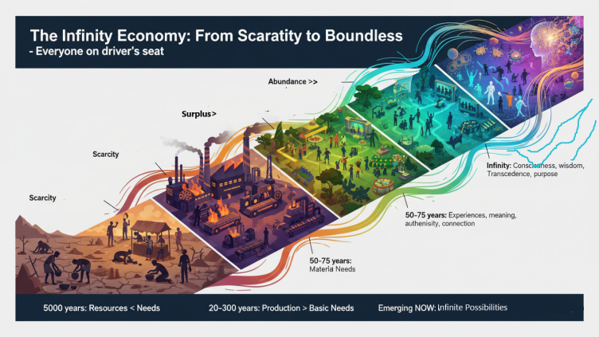](https://www.linkedin.com/pulse/zeroth-principles-extended-series-girish-hukkeri-dgxtc)](https://www.linkedin.com/pulse/zeroth-principles-extended-series-girish-hukkeri-dgxtc" \t "_self)**

**[Zeroth Principles Extended Series](https://www.linkedin.com/pulse/zeroth-principles-extended-series-girish-hukkeri-dgxtc" \t "_self)**

[Girish Hukkeri](https://www.linkedin.com/pulse/zeroth-principles-extended-series-girish-hukkeri-dgxtc" \t "_self)

* 4Munir Machmud Ali and 3 others

Feed post

Published 1 day ago

**[[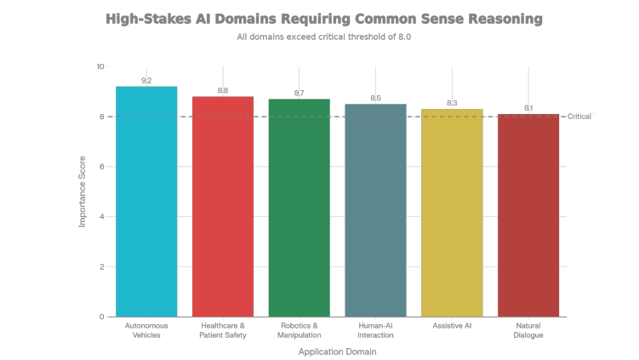](https://www.linkedin.com/pulse/seven-year-old-test-building-artificial-common-sense-general-hukkeri-vfpac)](https://www.linkedin.com/pulse/seven-year-old-test-building-artificial-common-sense-general-hukkeri-vfpac" \t "_self)**

**[The Seven-Year-Old Test: Building Artificial Common Sense as the Foundation for General Intelligence](https://www.linkedin.com/pulse/seven-year-old-test-building-artificial-common-sense-general-hukkeri-vfpac" \t "_self)**

[Girish Hukkeri](https://www.linkedin.com/pulse/seven-year-old-test-building-artificial-common-sense-general-hukkeri-vfpac" \t "_self)

* 5Ajijia Diwa and 4 others

Feed post

Published 2 days ago

**[[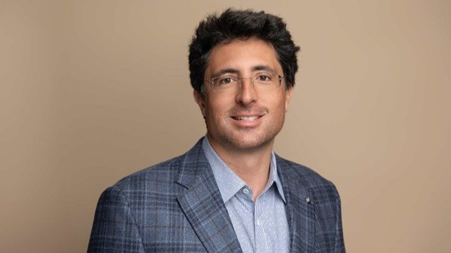](https://www.linkedin.com/pulse/niccolo-de-masi-physicist-ceo-leading-ionqs-quantum-girish-hukkeri-ztezc)](https://www.linkedin.com/pulse/niccolo-de-masi-physicist-ceo-leading-ionqs-quantum-girish-hukkeri-ztezc" \t "_self)**

**[Niccolo de Masi: The Physicist-CEO Leading IonQ's Quantum Revolution](https://www.linkedin.com/pulse/niccolo-de-masi-physicist-ceo-leading-ionqs-quantum-girish-hukkeri-ztezc" \t "_self)**

[Girish Hukkeri](https://www.linkedin.com/pulse/niccolo-de-masi-physicist-ceo-leading-ionqs-quantum-girish-hukkeri-ztezc" \t "_self)

* 10
  + 1 comment

Feed post

Published 2 days ago

**[[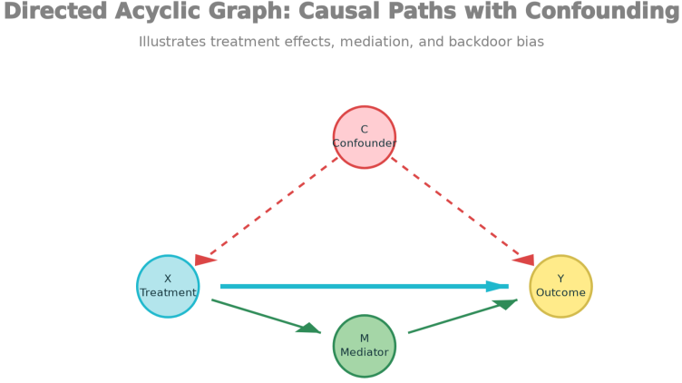](https://www.linkedin.com/pulse/from-prediction-understanding-causal-inference-gateway-girish-hukkeri-5uxnc)](https://www.linkedin.com/pulse/from-prediction-understanding-causal-inference-gateway-girish-hukkeri-5uxnc" \t "_self)**

**[From Prediction to Understanding: Causal Inference as the Gateway to True AI](https://www.linkedin.com/pulse/from-prediction-understanding-causal-inference-gateway-girish-hukkeri-5uxnc" \t "_self)**

[Girish Hukkeri](https://www.linkedin.com/pulse/from-prediction-understanding-causal-inference-gateway-girish-hukkeri-5uxnc" \t "_self)

* 3Mohammed Alomar and 2 others

Feed post

Published 3 days ago

**[[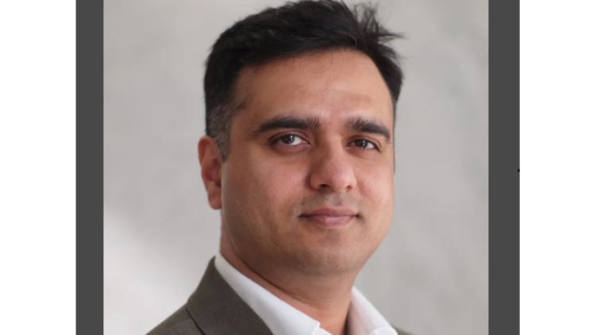](https://www.linkedin.com/pulse/dheeraj-pandey-architect-hybrid-cloud-infrastructure-girish-hukkeri-dlubc)](https://www.linkedin.com/pulse/dheeraj-pandey-architect-hybrid-cloud-infrastructure-girish-hukkeri-dlubc" \t "_self)**

**[Dheeraj Pandey: The Architect of Hybrid Cloud Infrastructure and the Visionary Reshaping Enterprise IT](https://www.linkedin.com/pulse/dheeraj-pandey-architect-hybrid-cloud-infrastructure-girish-hukkeri-dlubc" \t "_self)**

[Girish Hukkeri](https://www.linkedin.com/pulse/dheeraj-pandey-architect-hybrid-cloud-infrastructure-girish-hukkeri-dlubc" \t "_self)

* 8SATISH HUKKERI and 7 others

Feed post

Published 3 days ago

**[[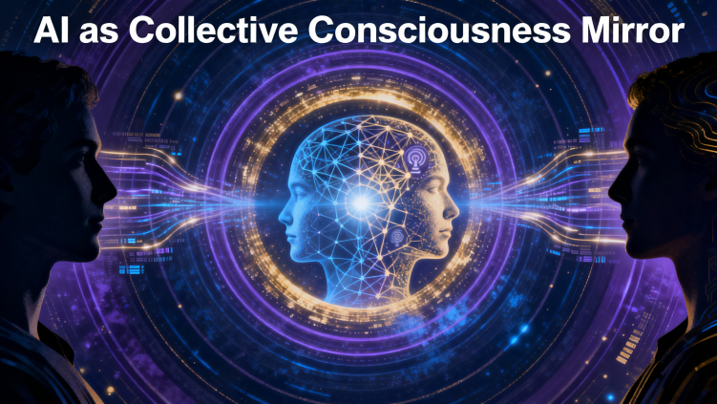](https://www.linkedin.com/pulse/zeroth-principles-part-two-ai-spectacle-humanitys-infinite-hukkeri-u6vrc)](https://www.linkedin.com/pulse/zeroth-principles-part-two-ai-spectacle-humanitys-infinite-hukkeri-u6vrc" \t "_self)**

**[Zeroth Principles - Part Two: AI as Spectacle, Humanity’s Infinite Mirror](https://www.linkedin.com/pulse/zeroth-principles-part-two-ai-spectacle-humanitys-infinite-hukkeri-u6vrc" \t "_self)**

[Girish Hukkeri](https://www.linkedin.com/pulse/zeroth-principles-part-two-ai-spectacle-humanitys-infinite-hukkeri-u6vrc" \t "_self)

* 1
  + 3 comments

Feed post

Published 4 days ago

**[[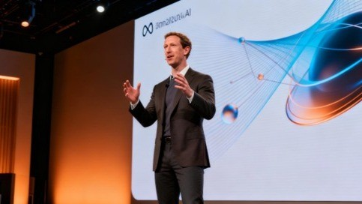](https://www.linkedin.com/pulse/metas-ai-present-future-llama-agi-2025-30-vision-girish-hukkeri-i90je)](https://www.linkedin.com/pulse/metas-ai-present-future-llama-agi-2025-30-vision-girish-hukkeri-i90je" \t "_self)**

**[Meta's AI Present and Future: Llama, AGI, and the 2025-'30 Vision](https://www.linkedin.com/pulse/metas-ai-present-future-llama-agi-2025-30-vision-girish-hukkeri-i90je" \t "_self)**

[Girish Hukkeri](https://www.linkedin.com/pulse/metas-ai-present-future-llama-agi-2025-30-vision-girish-hukkeri-i90je" \t "_self)

* 5Amoni Finau and 4 others
  + 4 comments

Feed post

Published 4 days ago

**[[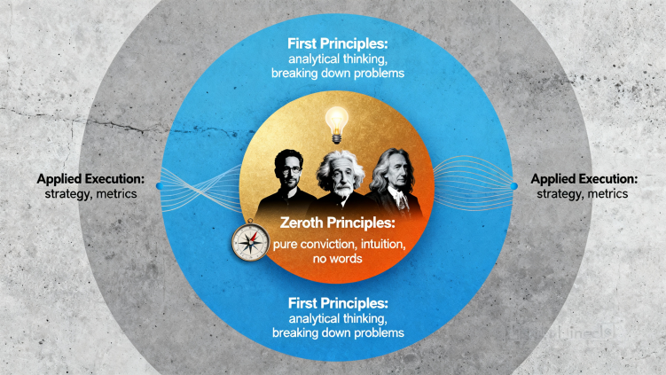](https://www.linkedin.com/pulse/zeroth-principles-part-one-insight-precedes-invention-girish-hukkeri-ugwgc)](https://www.linkedin.com/pulse/zeroth-principles-part-one-insight-precedes-invention-girish-hukkeri-ugwgc" \t "_self)**

**[Zeroth Principles - Part One: The Insight Precedes the Invention](https://www.linkedin.com/pulse/zeroth-principles-part-one-insight-precedes-invention-girish-hukkeri-ugwgc" \t "_self)**

[Girish Hukkeri](https://www.linkedin.com/pulse/zeroth-principles-part-one-insight-precedes-invention-girish-hukkeri-ugwgc" \t "_self)

* 4Ronnie A. Dumaguin and 3 others
  + 14 comments

Feed post

Published 5 days ago

**[[](https://www.linkedin.com/pulse/metas-mobile-revolution-advertising-dominance-2012-18-girish-hukkeri-xrdqe)](https://www.linkedin.com/pulse/metas-mobile-revolution-advertising-dominance-2012-18-girish-hukkeri-xrdqe" \t "_self)**

**[Meta's Mobile Revolution and Advertising Dominance (2012-'18)](https://www.linkedin.com/pulse/metas-mobile-revolution-advertising-dominance-2012-18-girish-hukkeri-xrdqe" \t "_self)**

[Girish Hukkeri](https://www.linkedin.com/pulse/metas-mobile-revolution-advertising-dominance-2012-18-girish-hukkeri-xrdqe" \t "_self)

* 5Singgih Tjahjono and 4 others
  + 2 comments

Feed post

Published 5 days ago

**[[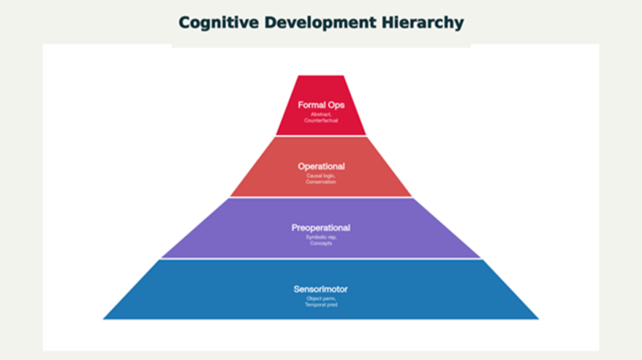](https://www.linkedin.com/pulse/building-artificial-minds-world-models-cognitive-path-girish-hukkeri-fauze)](https://www.linkedin.com/pulse/building-artificial-minds-world-models-cognitive-path-girish-hukkeri-fauze" \t "_self)**

**[Building Artificial Minds: World Models and Cognitive Development as the Path to AGI](https://www.linkedin.com/pulse/building-artificial-minds-world-models-cognitive-path-girish-hukkeri-fauze" \t "_self)**

[Girish Hukkeri](https://www.linkedin.com/pulse/building-artificial-minds-world-models-cognitive-path-girish-hukkeri-fauze" \t "_self)

* 7SATISH HUKKERI and 6 others
  + 2 comments

Feed post

Published 6 days ago

**[[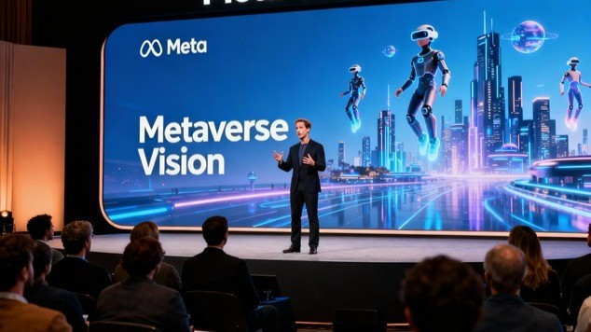](https://www.linkedin.com/pulse/metas-metaverse-pivot-reality-labs-investment-2019-23-girish-hukkeri-gsyae)](https://www.linkedin.com/pulse/metas-metaverse-pivot-reality-labs-investment-2019-23-girish-hukkeri-gsyae" \t "_self)**

**[Meta's Metaverse Pivot and Reality Labs Investment (2019-'23)](https://www.linkedin.com/pulse/metas-metaverse-pivot-reality-labs-investment-2019-23-girish-hukkeri-gsyae" \t "_self)**

[Girish Hukkeri](https://www.linkedin.com/pulse/metas-metaverse-pivot-reality-labs-investment-2019-23-girish-hukkeri-gsyae" \t "_self)

* 1

Feed post

Published 6 days ago

**[[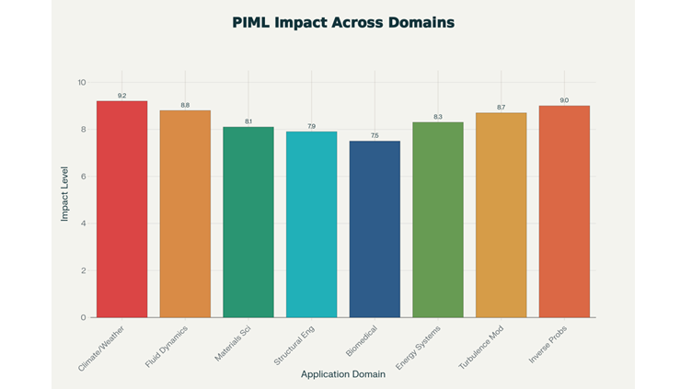](https://www.linkedin.com/pulse/physics-informed-machine-learning-embedding-laws-nature-hukkeri-ceqke)](https://www.linkedin.com/pulse/physics-informed-machine-learning-embedding-laws-nature-hukkeri-ceqke" \t "_self)**

**[Physics-Informed Machine Learning: Embedding the Laws of Nature into AI](https://www.linkedin.com/pulse/physics-informed-machine-learning-embedding-laws-nature-hukkeri-ceqke" \t "_self)**

[Girish Hukkeri](https://www.linkedin.com/pulse/physics-informed-machine-learning-embedding-laws-nature-hukkeri-ceqke" \t "_self)

* 2Singgih Tjahjono and 1 other

Feed post

Published 1 week ago

**[[](https://www.linkedin.com/pulse/metas-genesis-from-harvard-dorm-social-media-empire-girish-hukkeri-hwdae)](https://www.linkedin.com/pulse/metas-genesis-from-harvard-dorm-social-media-empire-girish-hukkeri-hwdae" \t "_self)**

**[Meta's Genesis: From Harvard Dorm to Social Media Empire (2004-2012)](https://www.linkedin.com/pulse/metas-genesis-from-harvard-dorm-social-media-empire-girish-hukkeri-hwdae" \t "_self)**

[Girish Hukkeri](https://www.linkedin.com/pulse/metas-genesis-from-harvard-dorm-social-media-empire-girish-hukkeri-hwdae" \t "_self)

Feed post

Published 1 week ago

**[[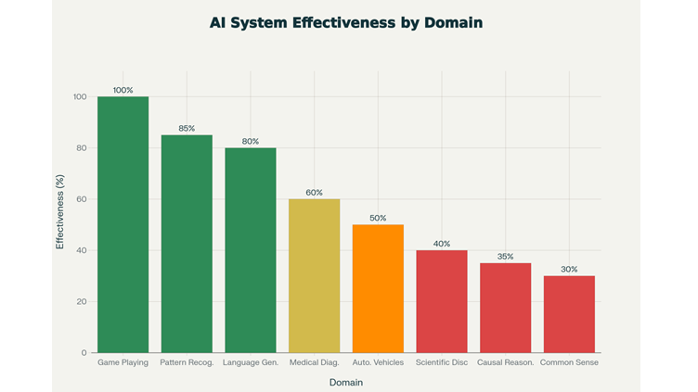](https://www.linkedin.com/pulse/ai-spring-lingering-winter-beyond-pattern-recognition-girish-hukkeri-61gze)](https://www.linkedin.com/pulse/ai-spring-lingering-winter-beyond-pattern-recognition-girish-hukkeri-61gze" \t "_self)**

**[The AI Spring and the Lingering Winter: Beyond Pattern Recognition to Understanding Unknown Laws](https://www.linkedin.com/pulse/ai-spring-lingering-winter-beyond-pattern-recognition-girish-hukkeri-61gze" \t "_self)**

[Girish Hukkeri](https://www.linkedin.com/pulse/ai-spring-lingering-winter-beyond-pattern-recognition-girish-hukkeri-61gze" \t "_self)

* 7Pavan Goyal and 6 others
  + 1 comment

Feed post

Published 1 week ago

**[[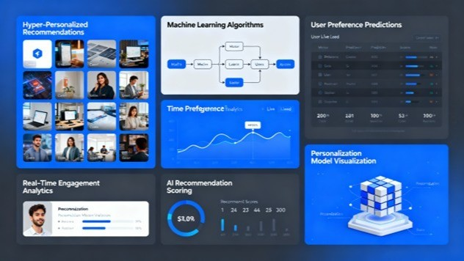](https://www.linkedin.com/pulse/entertainment-ai-era-generative-content-future-models-girish-hukkeri-ioxee)](https://www.linkedin.com/pulse/entertainment-ai-era-generative-content-future-models-girish-hukkeri-ioxee" \t "_self)**

**[Entertainment in the AI Era: Generative Content, Personalization, and Future Models (2025-'30)](https://www.linkedin.com/pulse/entertainment-ai-era-generative-content-future-models-girish-hukkeri-ioxee" \t "_self)**

[Girish Hukkeri](https://www.linkedin.com/pulse/entertainment-ai-era-generative-content-future-models-girish-hukkeri-ioxee" \t "_self)

* 9Rishi Raj Kishore and 8 others
  + 4 comments

Feed post

Published 1 week ago

**[[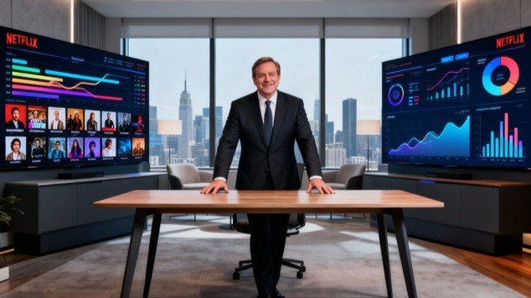](https://www.linkedin.com/pulse/streaming-wars-password-sharing-crackdown-focus-girish-hukkeri-eoq7e)](https://www.linkedin.com/pulse/streaming-wars-password-sharing-crackdown-focus-girish-hukkeri-eoq7e" \t "_self)**

**[Streaming Wars, Password Sharing Crackdown, and Profitability Focus (2015-2025)](https://www.linkedin.com/pulse/streaming-wars-password-sharing-crackdown-focus-girish-hukkeri-eoq7e" \t "_self)**

[Girish Hukkeri](https://www.linkedin.com/pulse/streaming-wars-password-sharing-crackdown-focus-girish-hukkeri-eoq7e" \t "_self)

* 2Ronnie A. Dumaguin and 1 other

Feed post

Published 1 week ago

**[[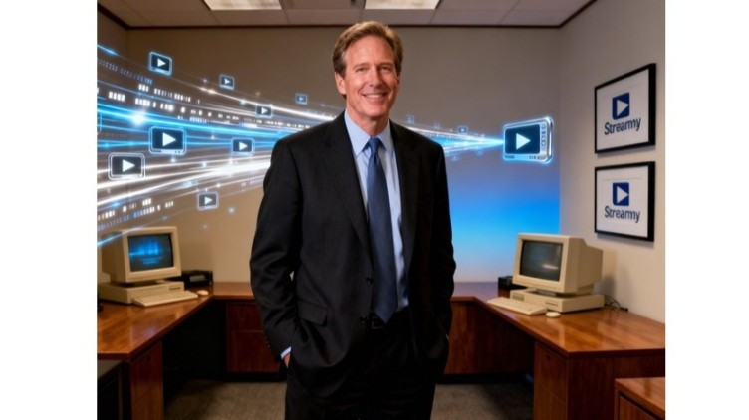](https://www.linkedin.com/pulse/netflix-origins-dvd-disruption-1997-2005-girish-hukkeri-v90xe)](https://www.linkedin.com/pulse/netflix-origins-dvd-disruption-1997-2005-girish-hukkeri-v90xe" \t "_self)**

**[Netflix Origins and DVD Disruption (1997-2005)](https://www.linkedin.com/pulse/netflix-origins-dvd-disruption-1997-2005-girish-hukkeri-v90xe" \t "_self)**

[Girish Hukkeri](https://www.linkedin.com/pulse/netflix-origins-dvd-disruption-1997-2005-girish-hukkeri-v90xe" \t "_self)

* 3Kaushik Naarayan and 2 others
  + 1 comment

Feed post

Published 1 week ago

**[[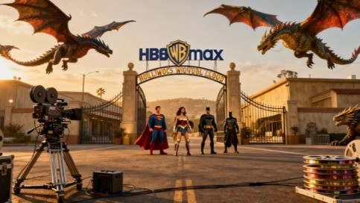](https://www.linkedin.com/pulse/netflix-acquires-warner-bros-discovery-entertainment-industry-girish-7as0e)](https://www.linkedin.com/pulse/netflix-acquires-warner-bros-discovery-entertainment-industry-girish-7as0e" \t "_self)**

**[Netflix Acquires Warner Bros. Discovery: The Entertainment Industry Consolidation Catalyst (December 2025)](https://www.linkedin.com/pulse/netflix-acquires-warner-bros-discovery-entertainment-industry-girish-7as0e" \t "_self)**

[Girish Hukkeri](https://www.linkedin.com/pulse/netflix-acquires-warner-bros-discovery-entertainment-industry-girish-7as0e" \t "_self)

* 6
  + 2 comments

Feed post

Published 1 week ago

**[[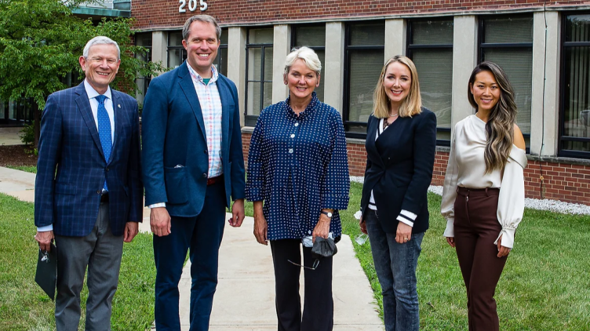](https://www.linkedin.com/pulse/jacob-dewitte-caroline-cochran-building-nuclear-through-hukkeri-0aoye)](https://www.linkedin.com/pulse/jacob-dewitte-caroline-cochran-building-nuclear-through-hukkeri-0aoye" \t "_self)**

**[Jacob DeWitte & Caroline Cochran: Building the Nuclear Renaissance Through Oklo Inc.](https://www.linkedin.com/pulse/jacob-dewitte-caroline-cochran-building-nuclear-through-hukkeri-0aoye" \t "_self)**

[Girish Hukkeri](https://www.linkedin.com/pulse/jacob-dewitte-caroline-cochran-building-nuclear-through-hukkeri-0aoye" \t "_self)

* 4Trevor Dawson and 3 others
  + 4 comments

Feed post

Published 1 week ago

**[[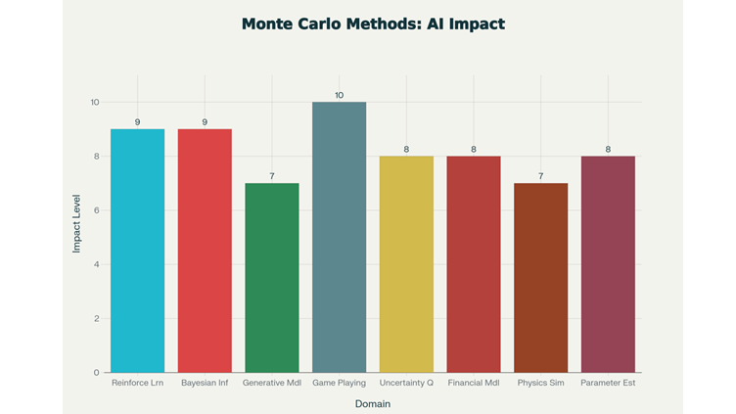](https://www.linkedin.com/pulse/monte-carlo-simulation-its-impact-ai-girish-hukkeri-5ca4e)](https://www.linkedin.com/pulse/monte-carlo-simulation-its-impact-ai-girish-hukkeri-5ca4e" \t "_self)**

**[Monte Carlo Simulation and Its Impact on AI](https://www.linkedin.com/pulse/monte-carlo-simulation-its-impact-ai-girish-hukkeri-5ca4e" \t "_self)**

[Girish Hukkeri](https://www.linkedin.com/pulse/monte-carlo-simulation-its-impact-ai-girish-hukkeri-5ca4e" \t "_self)

* 8Shubham Kumar and 7 others
  + 1 comment

Feed post

Published 1 week ago

**[[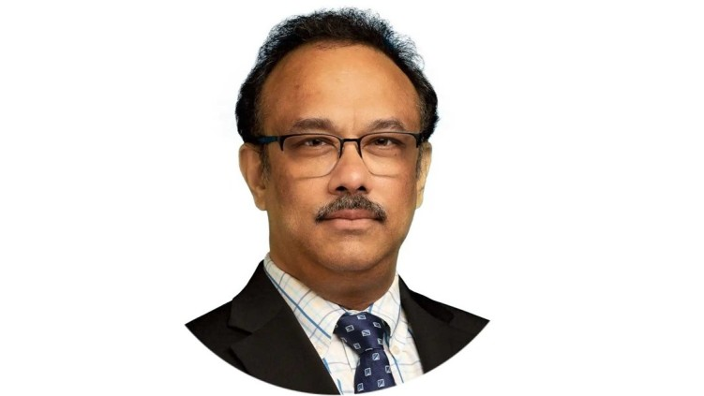](https://www.linkedin.com/pulse/rajeeb-raj-hazra-architect-behind-quantinuums-quantum-girish-hukkeri-ovqke)](https://www.linkedin.com/pulse/rajeeb-raj-hazra-architect-behind-quantinuums-quantum-girish-hukkeri-ovqke" \t "_self)**

**[Rajeeb (Raj) Hazra: The Architect Behind Quantinuum's Quantum Revolution](https://www.linkedin.com/pulse/rajeeb-raj-hazra-architect-behind-quantinuums-quantum-girish-hukkeri-ovqke" \t "_self)**

[Girish Hukkeri](https://www.linkedin.com/pulse/rajeeb-raj-hazra-architect-behind-quantinuums-quantum-girish-hukkeri-ovqke" \t "_self)

* 4Ronnie A. Dumaguin and 3 others
  + 1 comment

Feed post

Published 1 week ago

**[[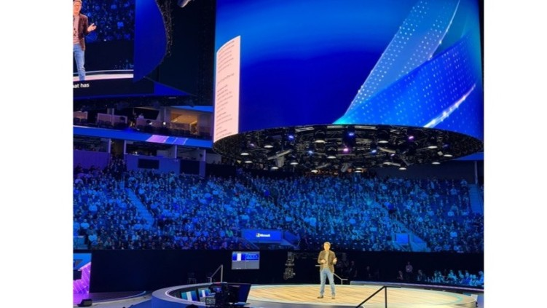](https://www.linkedin.com/pulse/microsofts-ai-future-copilot-integration-quantum-path-girish-hukkeri-sh3pe)](https://www.linkedin.com/pulse/microsofts-ai-future-copilot-integration-quantum-path-girish-hukkeri-sh3pe" \t "_self)**

**[Microsoft's AI Future: Copilot Integration, Quantum Computing, AI Infrastructure, and Path to AGI (2025-2035)](https://www.linkedin.com/pulse/microsofts-ai-future-copilot-integration-quantum-path-girish-hukkeri-sh3pe" \t "_self)**

[Girish Hukkeri](https://www.linkedin.com/pulse/microsofts-ai-future-copilot-integration-quantum-path-girish-hukkeri-sh3pe" \t "_self)

* 2Ronnie A. Dumaguin and 1 other

Feed post

Published 1 week ago

**[[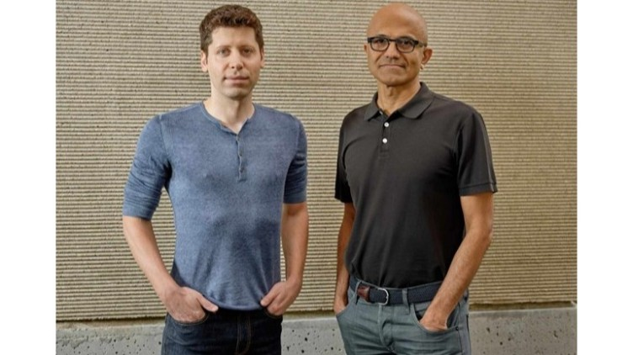](https://www.linkedin.com/pulse/satya-nadella-era-part-2-from-cloud-leader-ai-girish-hukkeri-afv5e)](https://www.linkedin.com/pulse/satya-nadella-era-part-2-from-cloud-leader-ai-girish-hukkeri-afv5e" \t "_self)**

**[Satya Nadella Era Part 2: From Cloud Leader to AI Powerhouse (2017-2025)](https://www.linkedin.com/pulse/satya-nadella-era-part-2-from-cloud-leader-ai-girish-hukkeri-afv5e" \t "_self)**

[Girish Hukkeri](https://www.linkedin.com/pulse/satya-nadella-era-part-2-from-cloud-leader-ai-girish-hukkeri-afv5e" \t "_self)

* 10Fawaz AbdulQader and 9 others
  + 4 comments

Feed post

Published 1 week ago

**[[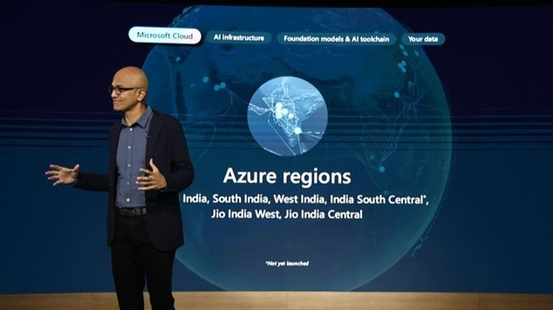](https://www.linkedin.com/pulse/satya-nadella-era-part-1-transformation-begins-girish-hukkeri-geoce)](https://www.linkedin.com/pulse/satya-nadella-era-part-1-transformation-begins-girish-hukkeri-geoce" \t "_self)**

**[Satya Nadella Era Part 1: The Transformation Begins (2014-2017)](https://www.linkedin.com/pulse/satya-nadella-era-part-1-transformation-begins-girish-hukkeri-geoce" \t "_self)**

[Girish Hukkeri](https://www.linkedin.com/pulse/satya-nadella-era-part-1-transformation-begins-girish-hukkeri-geoce" \t "_self)

* 6Ronnie A. Dumaguin and 5 others
  + 1 comment

Feed post

Published 1 week ago

**[[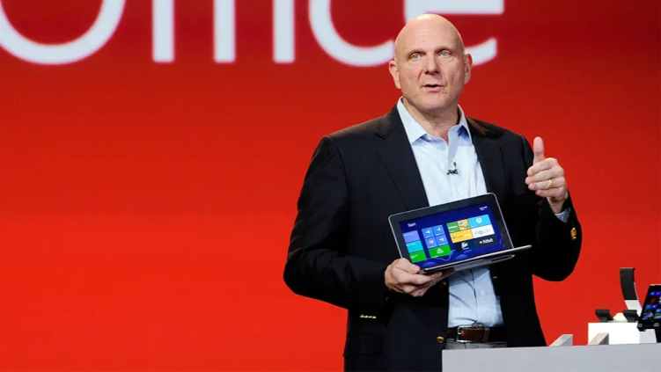](https://www.linkedin.com/pulse/steve-ballmer-interim-leadership-era-from-cloud-girish-hukkeri-jozne)](https://www.linkedin.com/pulse/steve-ballmer-interim-leadership-era-from-cloud-girish-hukkeri-jozne" \t "_self)**

**[The Steve Ballmer and Interim Leadership Era: From Consolidation to Cloud Skepticism (2000-2013)](https://www.linkedin.com/pulse/steve-ballmer-interim-leadership-era-from-cloud-girish-hukkeri-jozne" \t "_self)**

[Girish Hukkeri](https://www.linkedin.com/pulse/steve-ballmer-interim-leadership-era-from-cloud-girish-hukkeri-jozne" \t "_self)

* 1

Feed post

Published 1 week ago

**[[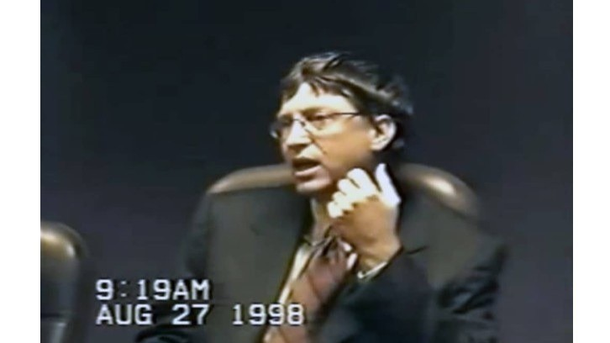](https://www.linkedin.com/pulse/bill-gates-era-part-3-antitrust-cloud-ambitions-girish-hukkeri-jydke)](https://www.linkedin.com/pulse/bill-gates-era-part-3-antitrust-cloud-ambitions-girish-hukkeri-jydke" \t "_self)**

**[The Bill Gates Era Part 3: Antitrust, Cloud Ambitions, and Gates' Transition (2000-2006)](https://www.linkedin.com/pulse/bill-gates-era-part-3-antitrust-cloud-ambitions-girish-hukkeri-jydke" \t "_self)**

[Girish Hukkeri](https://www.linkedin.com/pulse/bill-gates-era-part-3-antitrust-cloud-ambitions-girish-hukkeri-jydke" \t "_self)

* 3Singgih Tjahjono and 2 others

Feed post

Published 2 weeks ago

**[[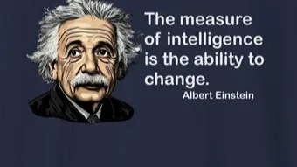](https://www.linkedin.com/pulse/einstein-measure-intelligence-ability-change-girish-hukkeri-4asae)](https://www.linkedin.com/pulse/einstein-measure-intelligence-ability-change-girish-hukkeri-4asae" \t "_self)**

**[Einstein: The Measure of Intelligence - The Ability to Change](https://www.linkedin.com/pulse/einstein-measure-intelligence-ability-change-girish-hukkeri-4asae" \t "_self)**

[Girish Hukkeri](https://www.linkedin.com/pulse/einstein-measure-intelligence-ability-change-girish-hukkeri-4asae" \t "_self)

* 4Fawaz AbdulQader and 3 others
  + 1 comment

Feed post

Published 2 weeks ago

**[[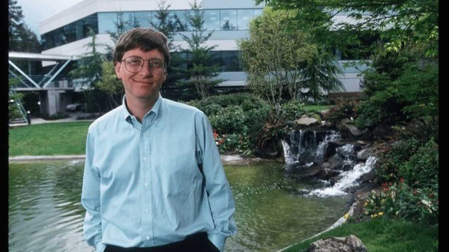](https://www.linkedin.com/pulse/bill-gates-era-part-2-windows-dominance-personal-girish-hukkeri-jmane)](https://www.linkedin.com/pulse/bill-gates-era-part-2-windows-dominance-personal-girish-hukkeri-jmane" \t "_self)**

**[The Bill Gates Era Part 2: Windows Dominance and Personal Computing Revolution (1990-2000)](https://www.linkedin.com/pulse/bill-gates-era-part-2-windows-dominance-personal-girish-hukkeri-jmane" \t "_self)**

[Girish Hukkeri](https://www.linkedin.com/pulse/bill-gates-era-part-2-windows-dominance-personal-girish-hukkeri-jmane" \t "_self)

* 7Ajay Babbar and 6 others
  + 2 comments

Feed post

Published 2 weeks ago

**[[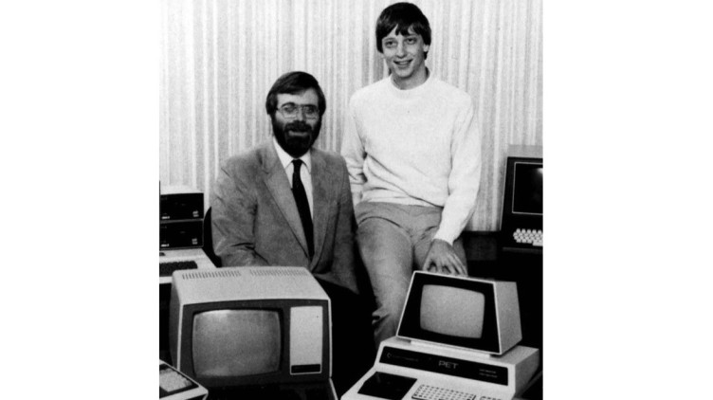](https://www.linkedin.com/pulse/bill-gates-era-part-1-from-garage-monopoly-1975-1990-girish-hukkeri-klvde)](https://www.linkedin.com/pulse/bill-gates-era-part-1-from-garage-monopoly-1975-1990-girish-hukkeri-klvde" \t "_self)**

**[The Bill Gates Era Part 1: From Garage to Monopoly (1975-1990)](https://www.linkedin.com/pulse/bill-gates-era-part-1-from-garage-monopoly-1975-1990-girish-hukkeri-klvde" \t "_self)**

[Girish Hukkeri](https://www.linkedin.com/pulse/bill-gates-era-part-1-from-garage-monopoly-1975-1990-girish-hukkeri-klvde" \t "_self)

* 6Bharat Shree Maheshwari and 5 others

Feed post

Published 2 weeks ago

**[[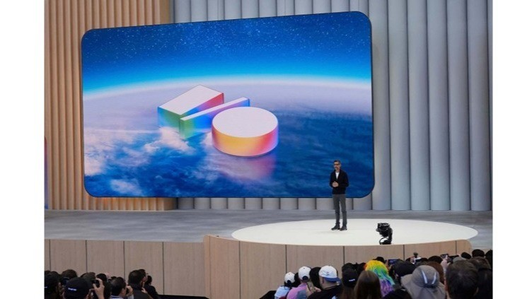](https://www.linkedin.com/pulse/alphabets-ai-future-investments-initiatives-path-agi-beyond-hukkeri-m2pre)](https://www.linkedin.com/pulse/alphabets-ai-future-investments-initiatives-path-agi-beyond-hukkeri-m2pre" \t "_self)**

**[Alphabet's AI Future: Investments, Initiatives, and the Path to AGI and Beyond (2024-2030)](https://www.linkedin.com/pulse/alphabets-ai-future-investments-initiatives-path-agi-beyond-hukkeri-m2pre" \t "_self)**

[Girish Hukkeri](https://www.linkedin.com/pulse/alphabets-ai-future-investments-initiatives-path-agi-beyond-hukkeri-m2pre" \t "_self)

* 7Singgih Tjahjono and 6 others
  + 5 comments

Feed post

Published 2 weeks ago

**[[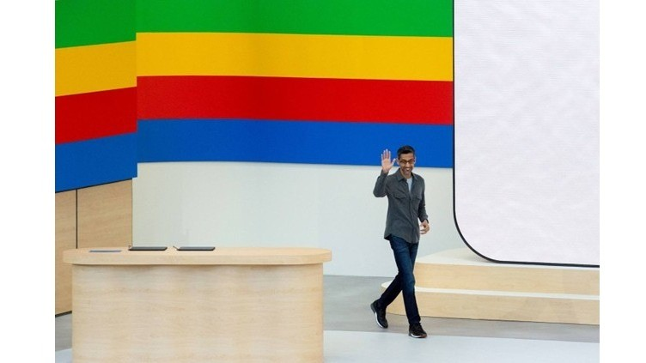](https://www.linkedin.com/pulse/chatgpt-wake-up-call-googles-response-openai-ai-arms-race-hukkeri-m6mye)](https://www.linkedin.com/pulse/chatgpt-wake-up-call-googles-response-openai-ai-arms-race-hukkeri-m6mye" \t "_self)**

**[The ChatGPT Wake-Up Call: Google's Response to OpenAI and the AI Arms Race (2017–2025)](https://www.linkedin.com/pulse/chatgpt-wake-up-call-googles-response-openai-ai-arms-race-hukkeri-m6mye" \t "_self)**

[Girish Hukkeri](https://www.linkedin.com/pulse/chatgpt-wake-up-call-googles-response-openai-ai-arms-race-hukkeri-m6mye" \t "_self)

* 3Ganesh Seshan and 2 others

Feed post

Published 2 weeks ago

**[[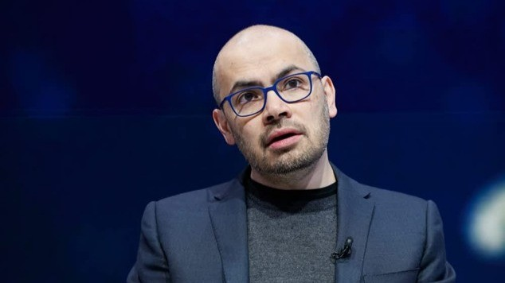](https://www.linkedin.com/pulse/deepmind-acquisition-early-ai-initiatives-googles-pivot-hukkeri-sdaxe)](https://www.linkedin.com/pulse/deepmind-acquisition-early-ai-initiatives-googles-pivot-hukkeri-sdaxe" \t "_self)**

**[The DeepMind Acquisition and Early AI Initiatives: Google's Pivot to Artificial Intelligence (2011–2017)](https://www.linkedin.com/pulse/deepmind-acquisition-early-ai-initiatives-googles-pivot-hukkeri-sdaxe" \t "_self)**

[Girish Hukkeri](https://www.linkedin.com/pulse/deepmind-acquisition-early-ai-initiatives-googles-pivot-hukkeri-sdaxe" \t "_self)

* 5Trevor Dawson and 4 others

Feed post

Published 2 weeks ago

**[[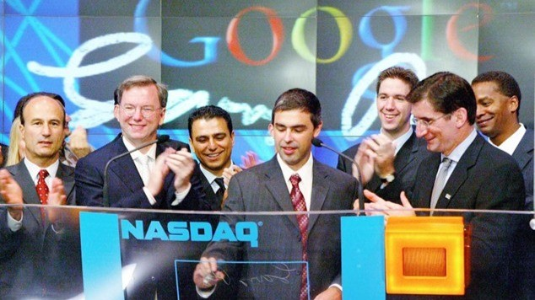](https://www.linkedin.com/pulse/establishing-leadership-googles-expansion-product-20042014-hukkeri-yncxe)](https://www.linkedin.com/pulse/establishing-leadership-googles-expansion-product-20042014-hukkeri-yncxe" \t "_self)**

**[Establishing Leadership: Google's Expansion and Product Ecosystem Dominance (2004–2014)](https://www.linkedin.com/pulse/establishing-leadership-googles-expansion-product-20042014-hukkeri-yncxe" \t "_self)**

[Girish Hukkeri](https://www.linkedin.com/pulse/establishing-leadership-googles-expansion-product-20042014-hukkeri-yncxe" \t "_self)

* 1

Feed post

Published 2 weeks ago

**[[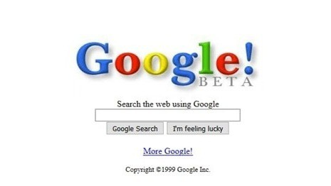](https://www.linkedin.com/pulse/google-genesis-backrub-project-search-engine-19962004-girish-hukkeri-mlfje)](https://www.linkedin.com/pulse/google-genesis-backrub-project-search-engine-19962004-girish-hukkeri-mlfje" \t "_self)**

**[Google Genesis: The BackRub Project to Search Engine Supremacy (1996–2004)](https://www.linkedin.com/pulse/google-genesis-backrub-project-search-engine-19962004-girish-hukkeri-mlfje" \t "_self)**

[Girish Hukkeri](https://www.linkedin.com/pulse/google-genesis-backrub-project-search-engine-19962004-girish-hukkeri-mlfje" \t "_self)

* 6Pavan Goyal and 5 others

Feed post

Published 2 weeks ago

**[[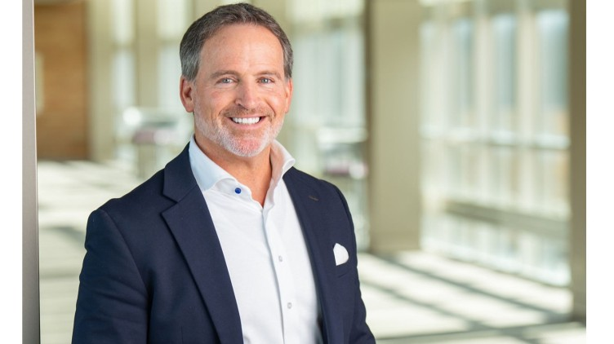](https://www.linkedin.com/pulse/bryan-hanson-solventum-architecting-healthcare-from-3m-girish-hukkeri-hkt9e)](https://www.linkedin.com/pulse/bryan-hanson-solventum-architecting-healthcare-from-3m-girish-hukkeri-hkt9e" \t "_self)**

**[Bryan Hanson & Solventum: Architecting Healthcare Independence from the 3M Legacy](https://www.linkedin.com/pulse/bryan-hanson-solventum-architecting-healthcare-from-3m-girish-hukkeri-hkt9e" \t "_self)**

[Girish Hukkeri](https://www.linkedin.com/pulse/bryan-hanson-solventum-architecting-healthcare-from-3m-girish-hukkeri-hkt9e" \t "_self)

* 6Pavan Goyal and 5 others
  + 1 comment

Feed post

Published 2 weeks ago

**[[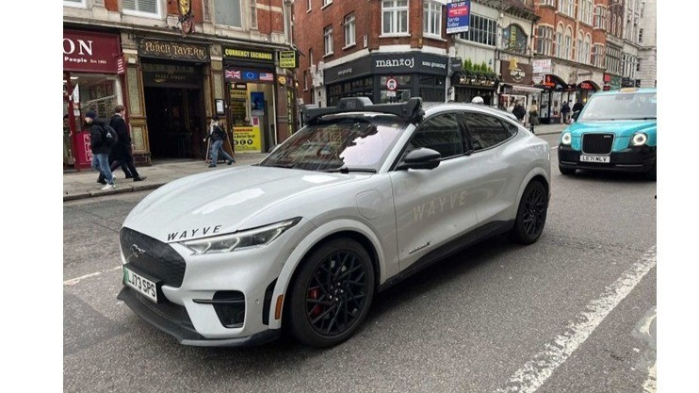](https://www.linkedin.com/pulse/alex-kendall-visionary-redefining-autonomous-mobility-girish-hukkeri-tt5ve)](https://www.linkedin.com/pulse/alex-kendall-visionary-redefining-autonomous-mobility-girish-hukkeri-tt5ve" \t "_self)**

**[Alex Kendall: The Visionary Redefining Autonomous Mobility with Embodied Intelligence](https://www.linkedin.com/pulse/alex-kendall-visionary-redefining-autonomous-mobility-girish-hukkeri-tt5ve" \t "_self)**

[Girish Hukkeri](https://www.linkedin.com/pulse/alex-kendall-visionary-redefining-autonomous-mobility-girish-hukkeri-tt5ve" \t "_self)

* 4Ajijia Diwa and 3 others
  + 1 comment

Feed post

Published 2 weeks ago

**[[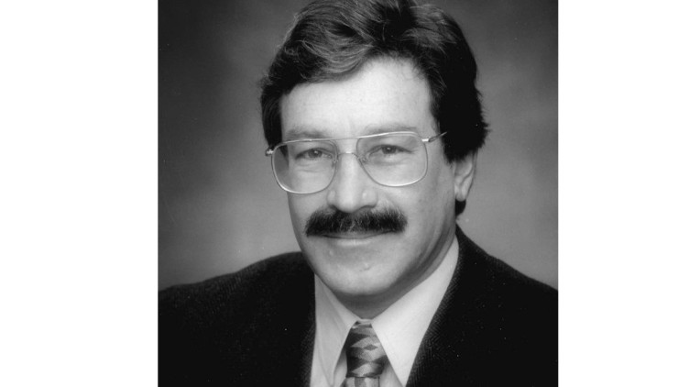](https://www.linkedin.com/pulse/rick-klausner-polymath-pioneer-transforming-cancer-cellular-hukkeri-tur7e)](https://www.linkedin.com/pulse/rick-klausner-polymath-pioneer-transforming-cancer-cellular-hukkeri-tur7e" \t "_self)**

**[Rick Klausner: The Polymath Pioneer Transforming Cancer Detection and Cellular Medicine](https://www.linkedin.com/pulse/rick-klausner-polymath-pioneer-transforming-cancer-cellular-hukkeri-tur7e" \t "_self)**

[Girish Hukkeri](https://www.linkedin.com/pulse/rick-klausner-polymath-pioneer-transforming-cancer-cellular-hukkeri-tur7e" \t "_self)

* 5Hrishikesh Hukkeri and 4 others
  + 1 comment

Feed post

Published 2 weeks ago

**[[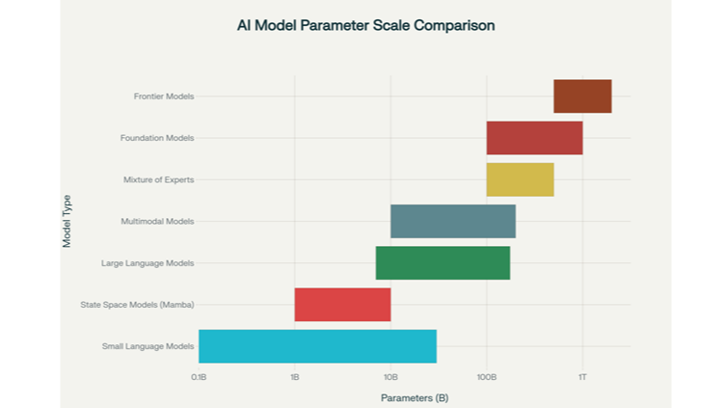](https://www.linkedin.com/pulse/evolution-ai-models-understanding-foundation-frontier-girish-hukkeri-mnp8f)](https://www.linkedin.com/pulse/evolution-ai-models-understanding-foundation-frontier-girish-hukkeri-mnp8f" \t "_self)**

**[The Evolution of AI Models: Understanding Foundation, Frontier, and Emerging Architectures](https://www.linkedin.com/pulse/evolution-ai-models-understanding-foundation-frontier-girish-hukkeri-mnp8f" \t "_self)**

[Girish Hukkeri](https://www.linkedin.com/pulse/evolution-ai-models-understanding-foundation-frontier-girish-hukkeri-mnp8f" \t "_self)

* 3Ajijia Diwa and 2 others

Feed post

Published 2 weeks ago

**[[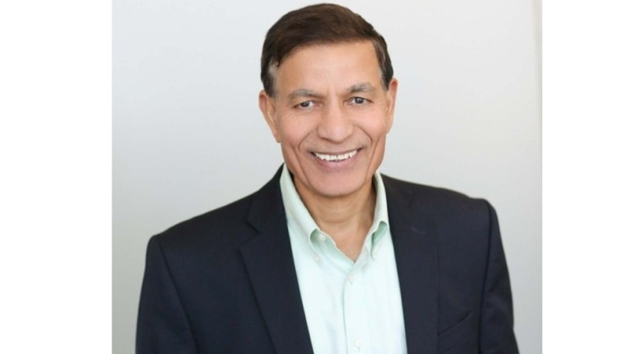](https://www.linkedin.com/pulse/jay-chaudhry-architect-zero-trust-security-girish-hukkeri-ppcue)](https://www.linkedin.com/pulse/jay-chaudhry-architect-zero-trust-security-girish-hukkeri-ppcue" \t "_self)**

**[Jay Chaudhry: The Architect of Zero Trust Security](https://www.linkedin.com/pulse/jay-chaudhry-architect-zero-trust-security-girish-hukkeri-ppcue" \t "_self)**

[Girish Hukkeri](https://www.linkedin.com/pulse/jay-chaudhry-architect-zero-trust-security-girish-hukkeri-ppcue" \t "_self)

* 5
  + 1 comment

Feed post

Published 2 weeks ago

**[[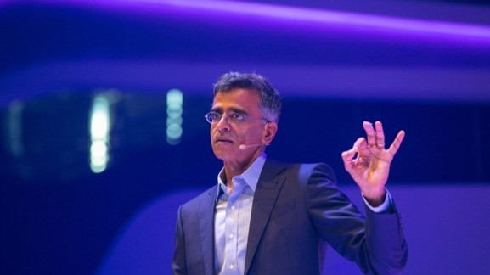](https://www.linkedin.com/pulse/sridhar-ramaswamy-data-visionary-transforming-ai-girish-hukkeri-mskbe)](https://www.linkedin.com/pulse/sridhar-ramaswamy-data-visionary-transforming-ai-girish-hukkeri-mskbe" \t "_self)**

**[Sridhar Ramaswamy: The Data Visionary Transforming Enterprise AI at Snowflake](https://www.linkedin.com/pulse/sridhar-ramaswamy-data-visionary-transforming-ai-girish-hukkeri-mskbe" \t "_self)**

[Girish Hukkeri](https://www.linkedin.com/pulse/sridhar-ramaswamy-data-visionary-transforming-ai-girish-hukkeri-mskbe" \t "_self)

* 7
  + 2 comments

Feed post

Published 3 weeks ago

**[[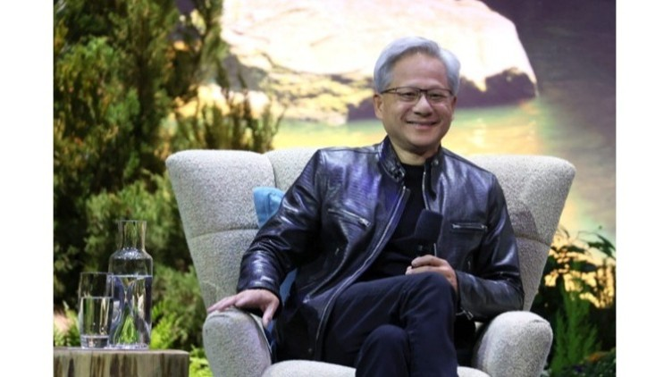](https://www.linkedin.com/pulse/jensen-huang-beyond-nvidia-ai-investments-vision-physical-hukkeri-2uule)](https://www.linkedin.com/pulse/jensen-huang-beyond-nvidia-ai-investments-vision-physical-hukkeri-2uule" \t "_self)**

**[Jensen Huang Beyond Nvidia: AI Investments, Philanthropy, and the Vision for Physical AI and Human-Digital Workforces](https://www.linkedin.com/pulse/jensen-huang-beyond-nvidia-ai-investments-vision-physical-hukkeri-2uule" \t "_self)**

[Girish Hukkeri](https://www.linkedin.com/pulse/jensen-huang-beyond-nvidia-ai-investments-vision-physical-hukkeri-2uule" \t "_self)

* 6Hrishikesh Hukkeri and 5 others

Feed post

Published 3 weeks ago

**[[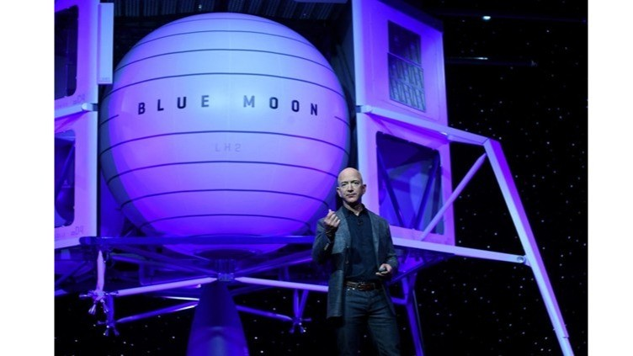](https://www.linkedin.com/pulse/jeff-bezos-ai-empire-from-expeditions-project-girish-hukkeri-ugf3e)](https://www.linkedin.com/pulse/jeff-bezos-ai-empire-from-expeditions-project-girish-hukkeri-ugf3e" \t "_self)**

**[Jeff Bezos' AI Empire: From Bezos Expeditions to Project Prometheus](https://www.linkedin.com/pulse/jeff-bezos-ai-empire-from-expeditions-project-girish-hukkeri-ugf3e" \t "_self)**

[Girish Hukkeri](https://www.linkedin.com/pulse/jeff-bezos-ai-empire-from-expeditions-project-girish-hukkeri-ugf3e" \t "_self)

* 7Kaushik Naarayan and 6 others
  + 1 comment

Feed post

Published 3 weeks ago

**[[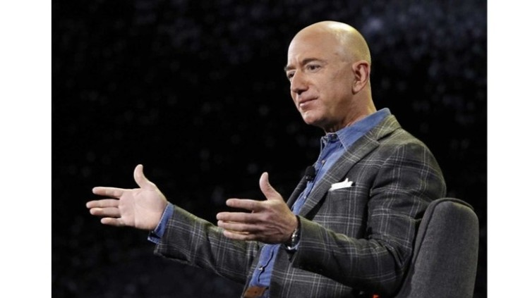](https://www.linkedin.com/pulse/bezos-executive-chairman-vision-next-era-2021present-girish-hukkeri-fjone)](https://www.linkedin.com/pulse/bezos-executive-chairman-vision-next-era-2021present-girish-hukkeri-fjone" \t "_self)**

**[Bezos as Executive Chairman and the Vision for the Next Era (2021-Present)](https://www.linkedin.com/pulse/bezos-executive-chairman-vision-next-era-2021present-girish-hukkeri-fjone" \t "_self)**

[Girish Hukkeri](https://www.linkedin.com/pulse/bezos-executive-chairman-vision-next-era-2021present-girish-hukkeri-fjone" \t "_self)

* 16Hrishikesh Hukkeri and 15 others
  + 3 comments

Feed post

Published 3 weeks ago

**[[](https://www.linkedin.com/pulse/aws-cloud-revolution-from-internal-project-515b-giant-girish-hukkeri-o8zde)](https://www.linkedin.com/pulse/aws-cloud-revolution-from-internal-project-515b-giant-girish-hukkeri-o8zde" \t "_self)**

**[AWS and the Cloud Revolution: From Internal Project to $51.5B Giant (2006–2021)](https://www.linkedin.com/pulse/aws-cloud-revolution-from-internal-project-515b-giant-girish-hukkeri-o8zde" \t "_self)**

[Girish Hukkeri](https://www.linkedin.com/pulse/aws-cloud-revolution-from-internal-project-515b-giant-girish-hukkeri-o8zde" \t "_self)

* 31Jabu Mkhungo and 30 others
  + 7 comments

Feed post

Published 3 weeks ago

**[[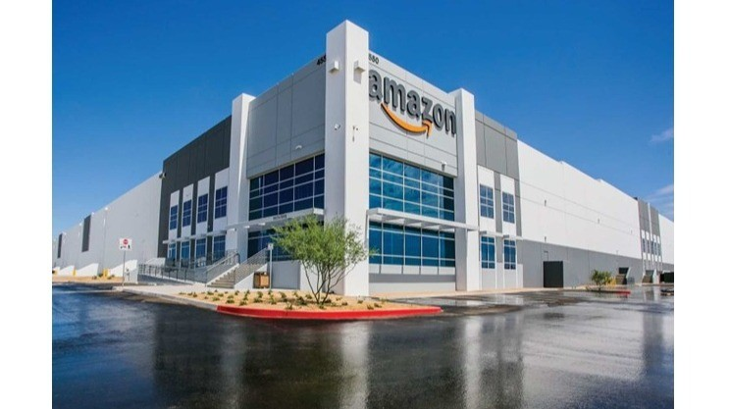](https://www.linkedin.com/pulse/amazons-global-expansion-e-commerce-dominance-20012010-girish-hukkeri-jzi1e)](https://www.linkedin.com/pulse/amazons-global-expansion-e-commerce-dominance-20012010-girish-hukkeri-jzi1e" \t "_self)**

**[Amazon's Global Expansion and E-Commerce Dominance (2001–2010): From Dot-Com Survivor to Retail Powerhouse](https://www.linkedin.com/pulse/amazons-global-expansion-e-commerce-dominance-20012010-girish-hukkeri-jzi1e" \t "_self)**

[Girish Hukkeri](https://www.linkedin.com/pulse/amazons-global-expansion-e-commerce-dominance-20012010-girish-hukkeri-jzi1e" \t "_self)

* 3Ajijia Diwa and 2 others
  + 3 comments

Feed post

Published 3 weeks ago

**[[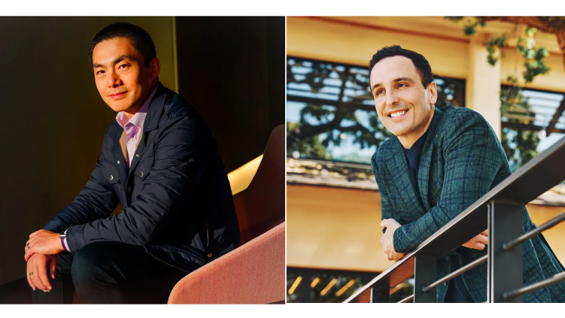](https://www.linkedin.com/pulse/new-architects-innovation-alfred-lin-pat-grady-take-helm-hukkeri-devie)](https://www.linkedin.com/pulse/new-architects-innovation-alfred-lin-pat-grady-take-helm-hukkeri-devie" \t "_self)**

**[The New Architects of Innovation: Alfred Lin and Pat Grady Take the Helm at Sequoia Capital](https://www.linkedin.com/pulse/new-architects-innovation-alfred-lin-pat-grady-take-helm-hukkeri-devie" \t "_self)**

[Girish Hukkeri](https://www.linkedin.com/pulse/new-architects-innovation-alfred-lin-pat-grady-take-helm-hukkeri-devie" \t "_self)

* 9SATISH HUKKERI and 8 others
  + 1 comment

Feed post

Published 3 weeks ago

**[[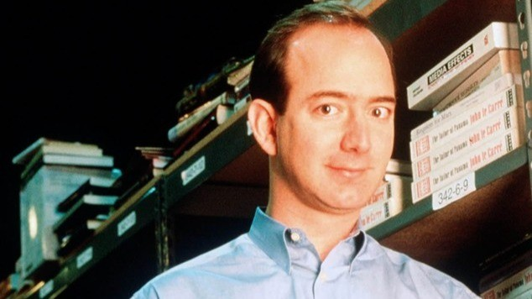](https://www.linkedin.com/pulse/jeff-bezos-early-years-struggle-build-amazon-who-bet-books-hukkeri-w7kce)](https://www.linkedin.com/pulse/jeff-bezos-early-years-struggle-build-amazon-who-bet-books-hukkeri-w7kce" \t "_self)**

**[Jeff Bezos' Early Years and the Struggle to Build Amazon: The Visionary Who Bet Everything on Books and the Internet](https://www.linkedin.com/pulse/jeff-bezos-early-years-struggle-build-amazon-who-bet-books-hukkeri-w7kce" \t "_self)**

[Girish Hukkeri](https://www.linkedin.com/pulse/jeff-bezos-early-years-struggle-build-amazon-who-bet-books-hukkeri-w7kce" \t "_self)

* 3Ajijia Diwa and 2 others

Feed post

Published 3 weeks ago

**[[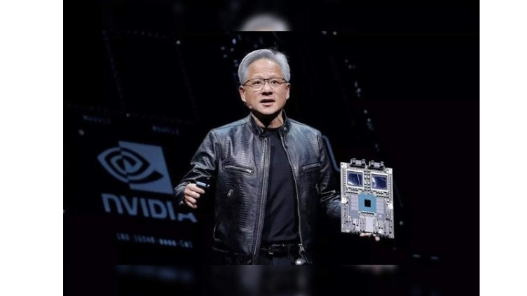](https://www.linkedin.com/pulse/nvidias-ai-era-dominance-chatgpt-catalyst-path-worlds-girish-hukkeri-tnbme)](https://www.linkedin.com/pulse/nvidias-ai-era-dominance-chatgpt-catalyst-path-worlds-girish-hukkeri-tnbme" \t "_self)**

**[Nvidia's AI Era Dominance: The ChatGPT Catalyst and the Path to the World's Most Valuable Company](https://www.linkedin.com/pulse/nvidias-ai-era-dominance-chatgpt-catalyst-path-worlds-girish-hukkeri-tnbme" \t "_self)**

[Girish Hukkeri](https://www.linkedin.com/pulse/nvidias-ai-era-dominance-chatgpt-catalyst-path-worlds-girish-hukkeri-tnbme" \t "_self)

* 9Pavan Goyal and 8 others
  + 1 comment

Feed post

Published 3 weeks ago

**[[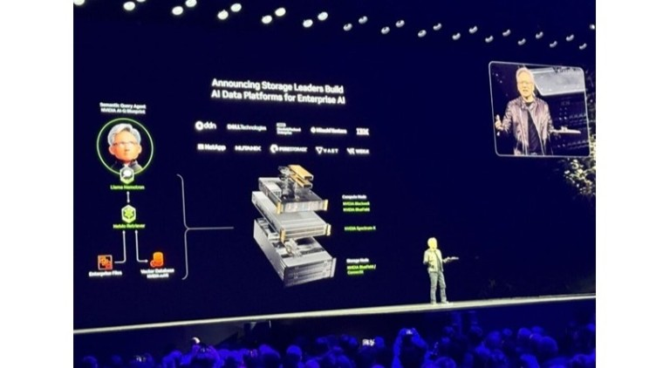](https://www.linkedin.com/pulse/nvidias-ai-foundation-from-cuda-de-facto-standard-before-hukkeri-fqhve)](https://www.linkedin.com/pulse/nvidias-ai-foundation-from-cuda-de-facto-standard-before-hukkeri-fqhve" \t "_self)**

**[Nvidia's AI Foundation: From CUDA to the De Facto Standard Before ChatGPT](https://www.linkedin.com/pulse/nvidias-ai-foundation-from-cuda-de-facto-standard-before-hukkeri-fqhve" \t "_self)**

[Girish Hukkeri](https://www.linkedin.com/pulse/nvidias-ai-foundation-from-cuda-de-facto-standard-before-hukkeri-fqhve" \t "_self)

* 4Claudia Drummond and 3 others
  + 2 comments

Feed post

Published 3 weeks ago

**[[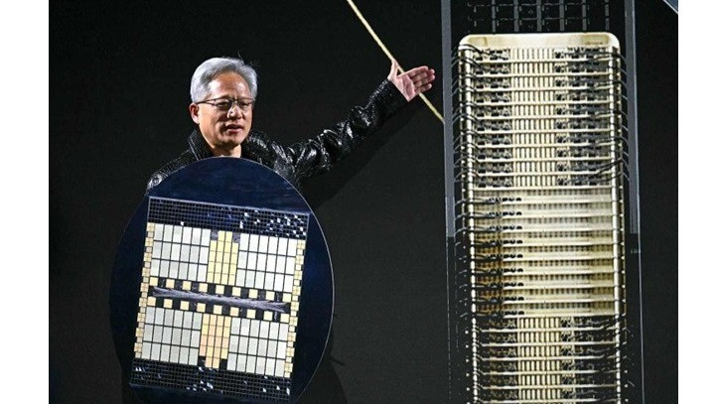](https://www.linkedin.com/pulse/nvidias-gaming-dominance-geforce-revolution-rise-gpu-girish-hukkeri-vegwe)](https://www.linkedin.com/pulse/nvidias-gaming-dominance-geforce-revolution-rise-gpu-girish-hukkeri-vegwe" \t "_self)**

**[Nvidia's Gaming Dominance: The GeForce Revolution and the Rise of GPU Leadership](https://www.linkedin.com/pulse/nvidias-gaming-dominance-geforce-revolution-rise-gpu-girish-hukkeri-vegwe" \t "_self)**

[Girish Hukkeri](https://www.linkedin.com/pulse/nvidias-gaming-dominance-geforce-revolution-rise-gpu-girish-hukkeri-vegwe" \t "_self)

* 9Pavan Goyal and 8 others

Feed post

Published 3 weeks ago

**[[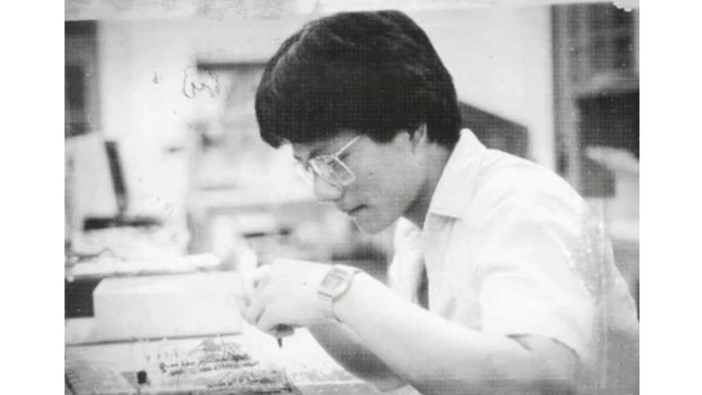](https://www.linkedin.com/pulse/jensen-huangs-gpu-vision-from-immigrant-dishwasher-silicon-hukkeri-jsyqe)](https://www.linkedin.com/pulse/jensen-huangs-gpu-vision-from-immigrant-dishwasher-silicon-hukkeri-jsyqe" \t "_self)**

**[Jensen Huang's GPU Vision: From Immigrant Dishwasher to Silicon Valley Visionary, The Founding and Survival of Nvidia](https://www.linkedin.com/pulse/jensen-huangs-gpu-vision-from-immigrant-dishwasher-silicon-hukkeri-jsyqe" \t "_self)**

[Girish Hukkeri](https://www.linkedin.com/pulse/jensen-huangs-gpu-vision-from-immigrant-dishwasher-silicon-hukkeri-jsyqe" \t "_self)

* 9Kaushik Naarayan and 8 others

Feed post

Published 3 weeks ago

**[[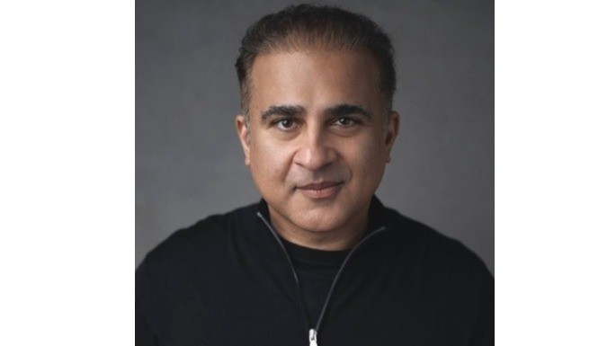](https://www.linkedin.com/pulse/dr-vik-bajaj-moonshot-architect-behind-project-girish-hukkeri-bkjie)](https://www.linkedin.com/pulse/dr-vik-bajaj-moonshot-architect-behind-project-girish-hukkeri-bkjie" \t "_self)**

**[Dr. Vik Bajaj: The Moonshot Architect Behind Project Prometheus](https://www.linkedin.com/pulse/dr-vik-bajaj-moonshot-architect-behind-project-girish-hukkeri-bkjie" \t "_self)**

[Girish Hukkeri](https://www.linkedin.com/pulse/dr-vik-bajaj-moonshot-architect-behind-project-girish-hukkeri-bkjie" \t "_self)

* 14Pavan Goyal and 13 others
  + 7 comments

Feed post

Published 3 weeks ago

**[[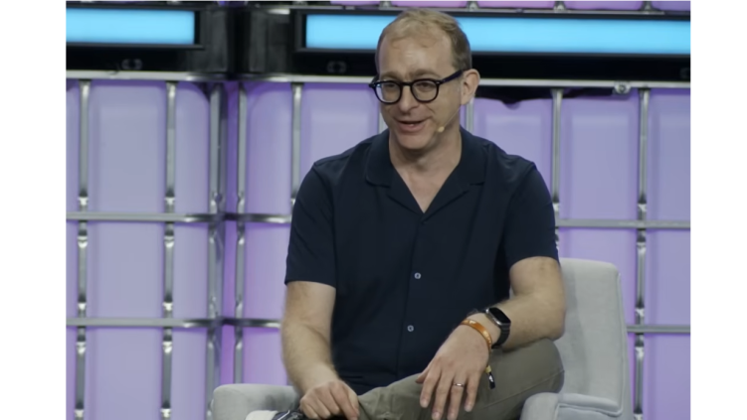](https://www.linkedin.com/pulse/avery-pennarun-tailscale-engineering-new-internet-through-hukkeri-nblxe)](https://www.linkedin.com/pulse/avery-pennarun-tailscale-engineering-new-internet-through-hukkeri-nblxe" \t "_self)**

**[Avery Pennarun & Tailscale: Engineering the New Internet Through Authenticity and Innovation](https://www.linkedin.com/pulse/avery-pennarun-tailscale-engineering-new-internet-through-hukkeri-nblxe" \t "_self)**

[Girish Hukkeri](https://www.linkedin.com/pulse/avery-pennarun-tailscale-engineering-new-internet-through-hukkeri-nblxe" \t "_self)

* 11MUH MASRI SARI and 10 others
  + 2 comments

Feed post

Published 3 weeks ago

**[[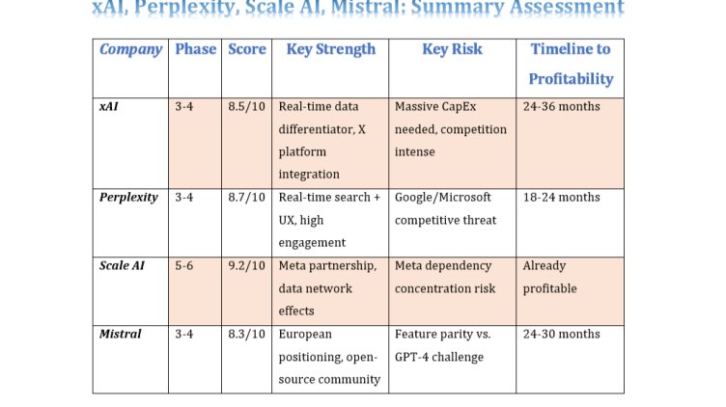](https://www.linkedin.com/pulse/applied-analysis-8-ai-unicorns-girish-hukkeri-1zwbf)](https://www.linkedin.com/pulse/applied-analysis-8-ai-unicorns-girish-hukkeri-1zwbf" \t "_self)**

**[Applied Analysis of 8 AI Unicorns](https://www.linkedin.com/pulse/applied-analysis-8-ai-unicorns-girish-hukkeri-1zwbf" \t "_self)**

[Girish Hukkeri](https://www.linkedin.com/pulse/applied-analysis-8-ai-unicorns-girish-hukkeri-1zwbf" \t "_self)

* 4Ajijia Diwa and 3 others

Feed post

Published 3 weeks ago

**[[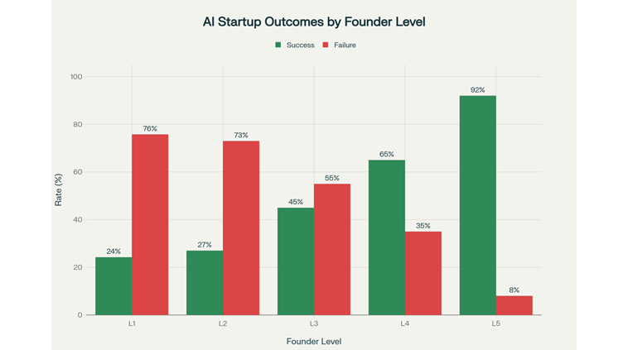](https://www.linkedin.com/pulse/ai-startup-ecosystem-bifurcates-winners-losers-new-era-girish-hukkeri-94oje)](https://www.linkedin.com/pulse/ai-startup-ecosystem-bifurcates-winners-losers-new-era-girish-hukkeri-94oje" \t "_self)**

**[The AI Startup Ecosystem Bifurcates: Winners and Losers in the New Era](https://www.linkedin.com/pulse/ai-startup-ecosystem-bifurcates-winners-losers-new-era-girish-hukkeri-94oje" \t "_self)**

[Girish Hukkeri](https://www.linkedin.com/pulse/ai-startup-ecosystem-bifurcates-winners-losers-new-era-girish-hukkeri-94oje" \t "_self)

* 7Kaushik Naarayan and 6 others
  + 2 comments

Feed post

Published 1 month ago

**[[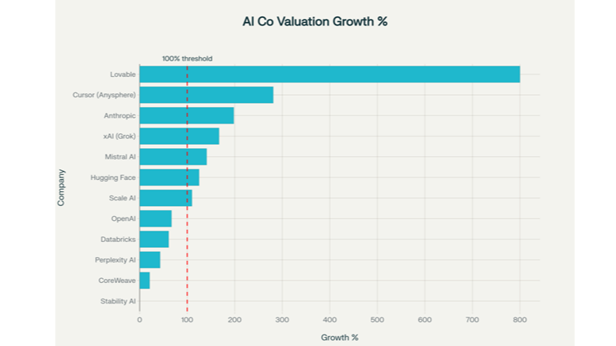](https://www.linkedin.com/pulse/ai-performance-paradox-how-market-leaders-exceeding-while-hukkeri-ygvqe)](https://www.linkedin.com/pulse/ai-performance-paradox-how-market-leaders-exceeding-while-hukkeri-ygvqe" \t "_self)**

**[The AI Performance Paradox: How Market Leaders Are Dramatically Exceeding Projections While the "Bubble Burst" Narrative Persists](https://www.linkedin.com/pulse/ai-performance-paradox-how-market-leaders-exceeding-while-hukkeri-ygvqe" \t "_self)**

[Girish Hukkeri](https://www.linkedin.com/pulse/ai-performance-paradox-how-market-leaders-exceeding-while-hukkeri-ygvqe" \t "_self)

* 6Pavan Goyal and 5 others
  + 1 comment

Feed post

Published 1 month ago

**[[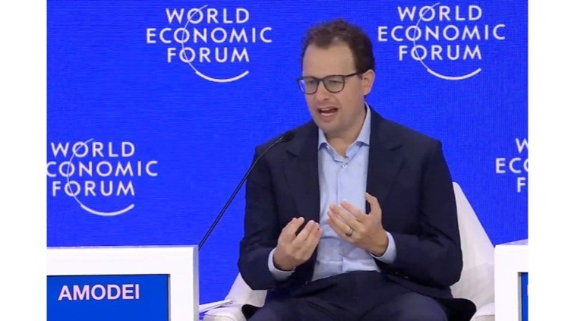](https://www.linkedin.com/pulse/amodei-ascendancy-how-two-siblings-steered-anthropic-from-hukkeri-3lu5e)](https://www.linkedin.com/pulse/amodei-ascendancy-how-two-siblings-steered-anthropic-from-hukkeri-3lu5e" \t "_self)**

**[The Amodei Ascendancy: How Two Siblings Steered Anthropic from $183B to a Potential $350B Giant](https://www.linkedin.com/pulse/amodei-ascendancy-how-two-siblings-steered-anthropic-from-hukkeri-3lu5e" \t "_self)**

[Girish Hukkeri](https://www.linkedin.com/pulse/amodei-ascendancy-how-two-siblings-steered-anthropic-from-hukkeri-3lu5e" \t "_self)

* 1

Feed post

Published 1 month ago

**[[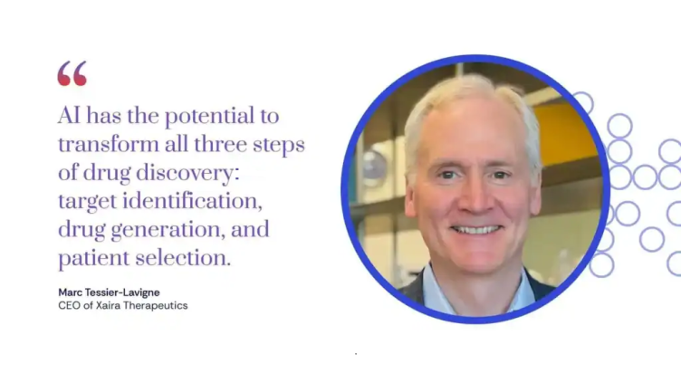](https://www.linkedin.com/pulse/marc-tessier-lavigne-david-baker-visionaries-drug-xaira-hukkeri-n6vte)](https://www.linkedin.com/pulse/marc-tessier-lavigne-david-baker-visionaries-drug-xaira-hukkeri-n6vte" \t "_self)**

**[Marc Tessier-Lavigne and David Baker: The Visionaries Reshaping Drug Discovery at Xaira Therapeutics](https://www.linkedin.com/pulse/marc-tessier-lavigne-david-baker-visionaries-drug-xaira-hukkeri-n6vte" \t "_self)**

[Girish Hukkeri](https://www.linkedin.com/pulse/marc-tessier-lavigne-david-baker-visionaries-drug-xaira-hukkeri-n6vte" \t "_self)

* 4Radhe Mishra and 3 others

Feed post

Published 1 month ago

**[[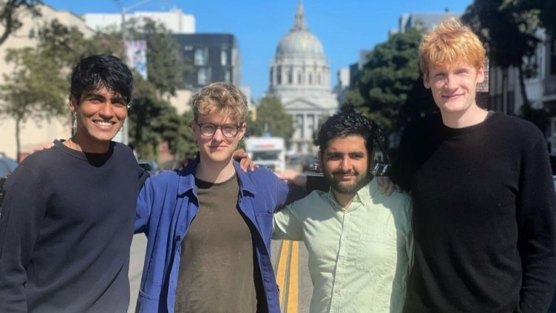](https://www.linkedin.com/pulse/visionary-quartet-behind-cursor-how-four-mit-students-girish-hukkeri-eweye)](https://www.linkedin.com/pulse/visionary-quartet-behind-cursor-how-four-mit-students-girish-hukkeri-eweye" \t "_self)**

**[The Visionary Quartet Behind Cursor: How Four MIT Students Built a $29.3 Billion AI Empire](https://www.linkedin.com/pulse/visionary-quartet-behind-cursor-how-four-mit-students-girish-hukkeri-eweye" \t "_self)**

[Girish Hukkeri](https://www.linkedin.com/pulse/visionary-quartet-behind-cursor-how-four-mit-students-girish-hukkeri-eweye" \t "_self)

* 7Hrishikesh Hukkeri and 6 others
  + 3 comments

Feed post

Published 1 month ago

**[[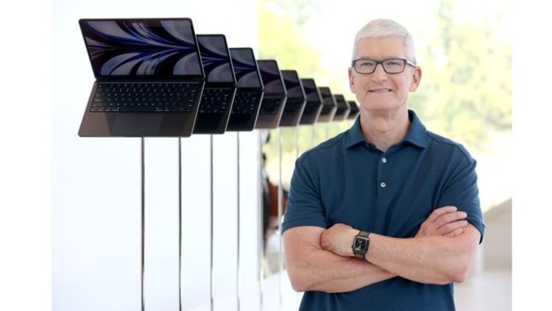](https://www.linkedin.com/pulse/apple-after-steve-jobs-legacy-sustained-vision-expanded-hukkeri-pciqe)](https://www.linkedin.com/pulse/apple-after-steve-jobs-legacy-sustained-vision-expanded-hukkeri-pciqe" \t "_self)**

**[Apple After Steve Jobs: A Legacy Sustained, A Vision Expanded, and a Company Transformed](https://www.linkedin.com/pulse/apple-after-steve-jobs-legacy-sustained-vision-expanded-hukkeri-pciqe" \t "_self)**

[Girish Hukkeri](https://www.linkedin.com/pulse/apple-after-steve-jobs-legacy-sustained-vision-expanded-hukkeri-pciqe" \t "_self)

* 12Pavan Goyal and 11 others
  + 4 comments

Feed post

Published 1 month ago

**[[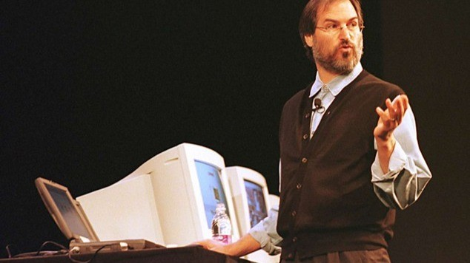](https://www.linkedin.com/pulse/steve-jobs-phoenix-returns-apples-resurrection-legacy-girish-hukkeri-ajyye)](https://www.linkedin.com/pulse/steve-jobs-phoenix-returns-apples-resurrection-legacy-girish-hukkeri-ajyye" \t "_self)**

**[Steve Jobs: The Phoenix Returns: Apple's Resurrection and a Legacy Sealed in Innovation](https://www.linkedin.com/pulse/steve-jobs-phoenix-returns-apples-resurrection-legacy-girish-hukkeri-ajyye" \t "_self)**

[Girish Hukkeri](https://www.linkedin.com/pulse/steve-jobs-phoenix-returns-apples-resurrection-legacy-girish-hukkeri-ajyye" \t "_self)

* 10Radhe Mishra and 9 others
  + 3 comments

Feed post

Published 1 month ago

**[[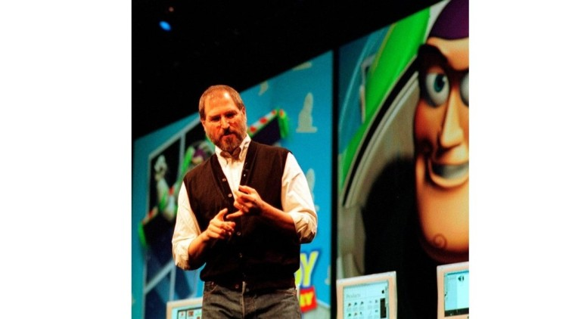](https://www.linkedin.com/pulse/steve-jobs-pixar-disney-renaissance-animation-years-between-hukkeri-zpgwe)](https://www.linkedin.com/pulse/steve-jobs-pixar-disney-renaissance-animation-years-between-hukkeri-zpgwe" \t "_self)**

**[Steve Jobs: Pixar, Disney, and the Renaissance of Animation, The Visionary Years Between Exile and Return](https://www.linkedin.com/pulse/steve-jobs-pixar-disney-renaissance-animation-years-between-hukkeri-zpgwe" \t "_self)**

[Girish Hukkeri](https://www.linkedin.com/pulse/steve-jobs-pixar-disney-renaissance-animation-years-between-hukkeri-zpgwe" \t "_self)

* 6Munir Machmud Ali and 5 others

Feed post

Published 1 month ago

**[[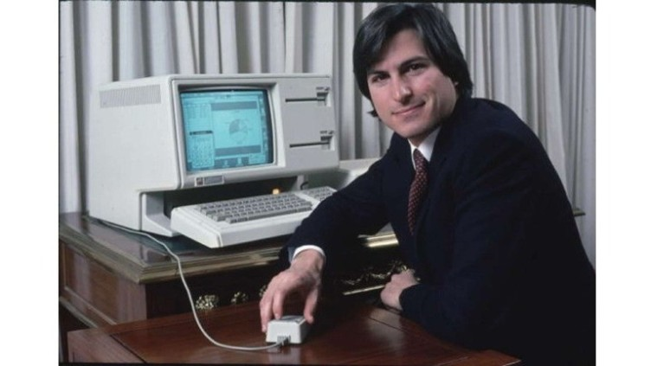](https://www.linkedin.com/pulse/steve-jobs-from-garage-dreams-expulsion-genesis-exodus-girish-hukkeri-ozene)](https://www.linkedin.com/pulse/steve-jobs-from-garage-dreams-expulsion-genesis-exodus-girish-hukkeri-ozene" \t "_self)**

**[Steve Jobs: From Garage Dreams to Expulsion, the Genesis and Exodus of Apple's Revolutionary Founder](https://www.linkedin.com/pulse/steve-jobs-from-garage-dreams-expulsion-genesis-exodus-girish-hukkeri-ozene" \t "_self)**

[Girish Hukkeri](https://www.linkedin.com/pulse/steve-jobs-from-garage-dreams-expulsion-genesis-exodus-girish-hukkeri-ozene" \t "_self)

* 6Vishwanath Sangoji and 5 others
  + 1 comment

Feed post

Published 1 month ago

**[[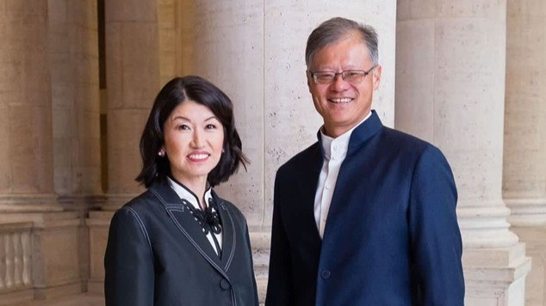](https://www.linkedin.com/pulse/jerry-yang-from-yahoo-pioneer-silicon-valley-girish-hukkeri-vwnhe)](https://www.linkedin.com/pulse/jerry-yang-from-yahoo-pioneer-silicon-valley-girish-hukkeri-vwnhe" \t "_self)**

**[Jerry Yang: From Yahoo! Pioneer to Silicon Valley Statesman](https://www.linkedin.com/pulse/jerry-yang-from-yahoo-pioneer-silicon-valley-girish-hukkeri-vwnhe" \t "_self)**

[Girish Hukkeri](https://www.linkedin.com/pulse/jerry-yang-from-yahoo-pioneer-silicon-valley-girish-hukkeri-vwnhe" \t "_self)

* 23Filadelfia RAKOTOMALALA ALIJAONA and 22 others
  + 5 comments

Feed post

Published 1 month ago

**[[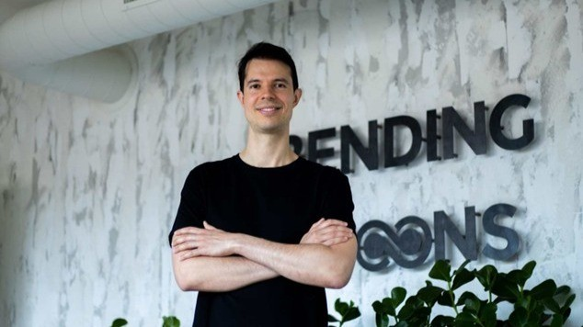](https://www.linkedin.com/pulse/architect-digital-transformation-luca-ferraris-building-hukkeri-x2ace)](https://www.linkedin.com/pulse/architect-digital-transformation-luca-ferraris-building-hukkeri-x2ace" \t "_self)**

**[The Architect of Digital Transformation: Luca Ferrari's Blueprint for Building an All-Time Great Company](https://www.linkedin.com/pulse/architect-digital-transformation-luca-ferraris-building-hukkeri-x2ace" \t "_self)**

[Girish Hukkeri](https://www.linkedin.com/pulse/architect-digital-transformation-luca-ferraris-building-hukkeri-x2ace" \t "_self)

* 5Munir Machmud Ali and 4 others
  + 1 comment

Feed post

Published 1 month ago

**[[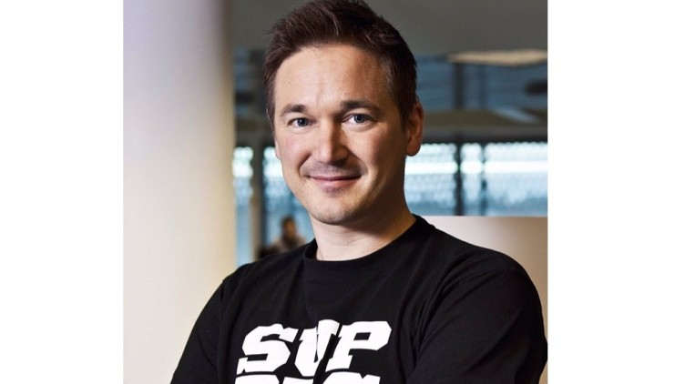](https://www.linkedin.com/pulse/ilkka-paananen-architect-forever-games-girish-hukkeri-jr6me)](https://www.linkedin.com/pulse/ilkka-paananen-architect-forever-games-girish-hukkeri-jr6me" \t "_self)**

**[Ilkka Paananen: The Architect of Forever Games](https://www.linkedin.com/pulse/ilkka-paananen-architect-forever-games-girish-hukkeri-jr6me" \t "_self)**

[Girish Hukkeri](https://www.linkedin.com/pulse/ilkka-paananen-architect-forever-games-girish-hukkeri-jr6me" \t "_self)

* 3Pavan Goyal and 2 others
  + 1 comment

Feed post

Published 1 month ago

**[[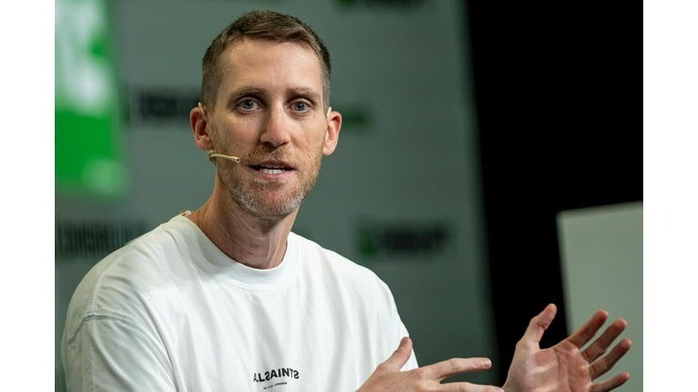](https://www.linkedin.com/pulse/assaf-rappaport-architect-cloud-securitys-fastest-unicorn-hukkeri-83tne)](https://www.linkedin.com/pulse/assaf-rappaport-architect-cloud-securitys-fastest-unicorn-hukkeri-83tne" \t "_self)**

**[Assaf Rappaport: The Architect of Cloud Security's Fastest Unicorn](https://www.linkedin.com/pulse/assaf-rappaport-architect-cloud-securitys-fastest-unicorn-hukkeri-83tne" \t "_self)**

[Girish Hukkeri](https://www.linkedin.com/pulse/assaf-rappaport-architect-cloud-securitys-fastest-unicorn-hukkeri-83tne" \t "_self)

* 8Amoni Finau and 7 others
  + 3 comments

Feed post

Published 1 month ago

**[[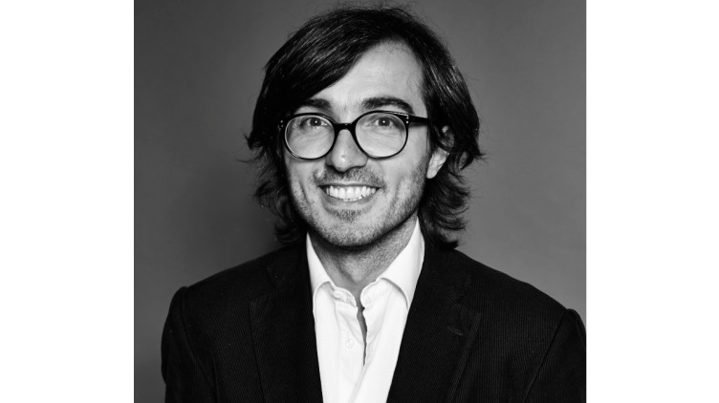](https://www.linkedin.com/pulse/efe-cakarel-mubi-curating-cinema-age-algorithms-girish-hukkeri-a747e)](https://www.linkedin.com/pulse/efe-cakarel-mubi-curating-cinema-age-algorithms-girish-hukkeri-a747e" \t "_self)**

**[Efe Cakarel of MUBI: Curating Cinema in the Age of Algorithms](https://www.linkedin.com/pulse/efe-cakarel-mubi-curating-cinema-age-algorithms-girish-hukkeri-a747e" \t "_self)**

[Girish Hukkeri](https://www.linkedin.com/pulse/efe-cakarel-mubi-curating-cinema-age-algorithms-girish-hukkeri-a747e" \t "_self)

* 9Pavan Goyal and 8 others
  + 3 comments

Feed post

Published 1 month ago

**[[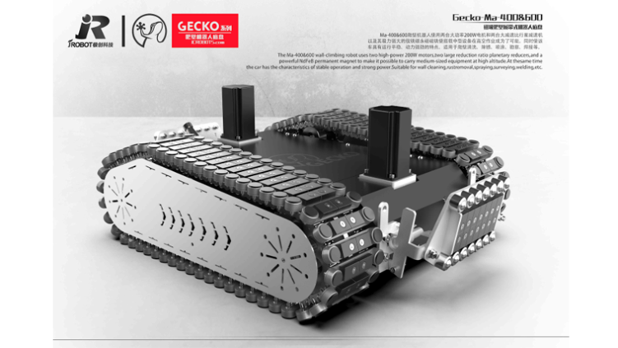](https://www.linkedin.com/pulse/jake-loosararian-resilient-visionary-building-girish-hukkeri-tmtfe)](https://www.linkedin.com/pulse/jake-loosararian-resilient-visionary-building-girish-hukkeri-tmtfe" \t "_self)**

**[Jake Loosararian: The Resilient Visionary Building Tomorrow's Infrastructure Intelligence](https://www.linkedin.com/pulse/jake-loosararian-resilient-visionary-building-girish-hukkeri-tmtfe" \t "_self)**

[Girish Hukkeri](https://www.linkedin.com/pulse/jake-loosararian-resilient-visionary-building-girish-hukkeri-tmtfe" \t "_self)

* 8Munir Machmud Ali and 7 others
  + 1 comment

Feed post

Published 1 month ago

**[[](https://www.linkedin.com/pulse/shalev-hulio-dream-from-offensive-cyber-operations-national-hukkeri-zujue)](https://www.linkedin.com/pulse/shalev-hulio-dream-from-offensive-cyber-operations-national-hukkeri-zujue" \t "_self)**

**[Shalev Hulio & Dream: From Offensive Cyber Operations to National Defense Strategy](https://www.linkedin.com/pulse/shalev-hulio-dream-from-offensive-cyber-operations-national-hukkeri-zujue" \t "_self)**

[Girish Hukkeri](https://www.linkedin.com/pulse/shalev-hulio-dream-from-offensive-cyber-operations-national-hukkeri-zujue" \t "_self)

* 9Pavan Goyal and 8 others
  + 3 comments

Feed post

Published 1 month ago

**[[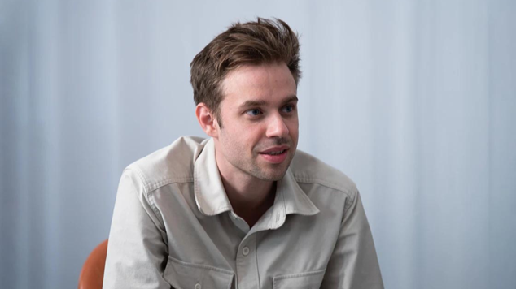](https://www.linkedin.com/pulse/anton-osika-swedish-physicist-democratizing-software-creation-girish-fy6ve)](https://www.linkedin.com/pulse/anton-osika-swedish-physicist-democratizing-software-creation-girish-fy6ve" \t "_self)**

**[Anton Osika: The Swedish Physicist Democratizing Software Creation Through Lovable](https://www.linkedin.com/pulse/anton-osika-swedish-physicist-democratizing-software-creation-girish-fy6ve" \t "_self)**

[Girish Hukkeri](https://www.linkedin.com/pulse/anton-osika-swedish-physicist-democratizing-software-creation-girish-fy6ve" \t "_self)

* 1

Feed post

Published 1 month ago

**[[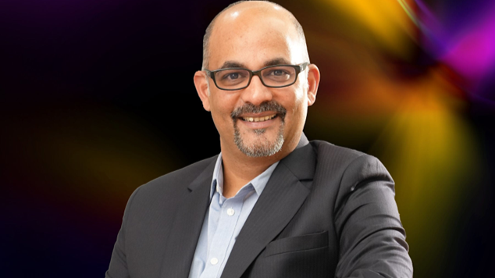](https://www.linkedin.com/pulse/sameer-nigam-architect-indias-digital-payments-girish-hukkeri-i7v0e)](https://www.linkedin.com/pulse/sameer-nigam-architect-indias-digital-payments-girish-hukkeri-i7v0e" \t "_self)**

**[Sameer Nigam: The Architect of India's Digital Payments Revolution](https://www.linkedin.com/pulse/sameer-nigam-architect-indias-digital-payments-girish-hukkeri-i7v0e" \t "_self)**

[Girish Hukkeri](https://www.linkedin.com/pulse/sameer-nigam-architect-indias-digital-payments-girish-hukkeri-i7v0e" \t "_self)

* 3Radhe Mishra and 2 others

Feed post

Published 1 month ago

**[[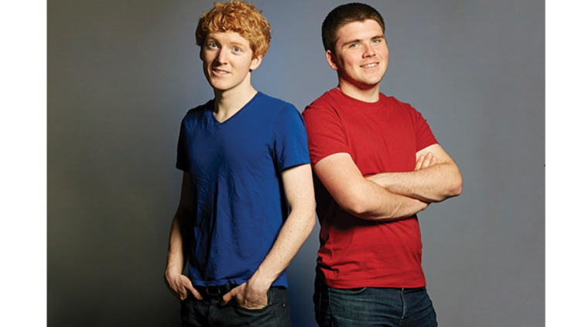](https://www.linkedin.com/pulse/collison-brothers-building-economic-infrastructure-internet-hukkeri-9y2le)](https://www.linkedin.com/pulse/collison-brothers-building-economic-infrastructure-internet-hukkeri-9y2le" \t "_self)**

**[The Collison Brothers: Building the Economic Infrastructure of the Internet](https://www.linkedin.com/pulse/collison-brothers-building-economic-infrastructure-internet-hukkeri-9y2le" \t "_self)**

[Girish Hukkeri](https://www.linkedin.com/pulse/collison-brothers-building-economic-infrastructure-internet-hukkeri-9y2le" \t "_self)

* 7Kaushik Naarayan and 6 others
  + 3 comments

Feed post

Published 1 month ago

**[[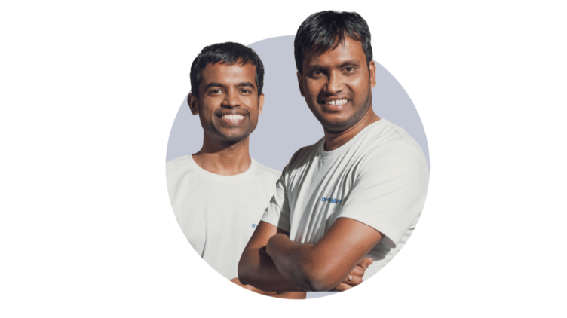](https://www.linkedin.com/pulse/moengage-crafting-future-ai-powered-customer-through-girish-hukkeri-rgq9e)](https://www.linkedin.com/pulse/moengage-crafting-future-ai-powered-customer-through-girish-hukkeri-rgq9e" \t "_self)**

**[MoEngage: Crafting the Future of AI-Powered Customer Engagement Through Innovation and Visionary Leadership](https://www.linkedin.com/pulse/moengage-crafting-future-ai-powered-customer-through-girish-hukkeri-rgq9e" \t "_self)**

[Girish Hukkeri](https://www.linkedin.com/pulse/moengage-crafting-future-ai-powered-customer-through-girish-hukkeri-rgq9e" \t "_self)

* 19Pavan Goyal and 18 others
  + 5 comments

Feed post

Published 1 month ago

**[[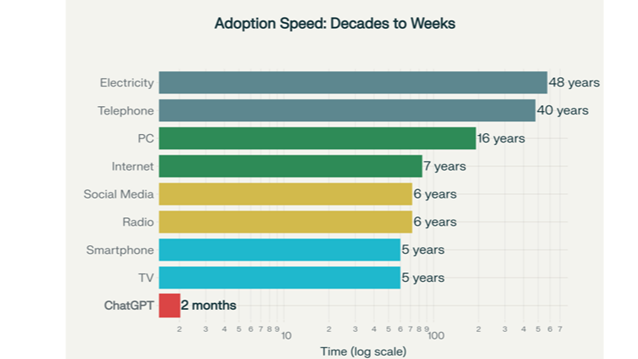](https://www.linkedin.com/pulse/ai-bubble-burst-why-instant-diffusion-makes-girish-hukkeri-iwwwe)](https://www.linkedin.com/pulse/ai-bubble-burst-why-instant-diffusion-makes-girish-hukkeri-iwwwe" \t "_self)**

**[AI Bubble Burst : Why Instant Diffusion Makes It Irrelevant](https://www.linkedin.com/pulse/ai-bubble-burst-why-instant-diffusion-makes-girish-hukkeri-iwwwe" \t "_self)**

[Girish Hukkeri](https://www.linkedin.com/pulse/ai-bubble-burst-why-instant-diffusion-makes-girish-hukkeri-iwwwe" \t "_self)

* 6Mohammed Alomar and 5 others
  + 2 comments

Feed post

Published 1 month ago

**[[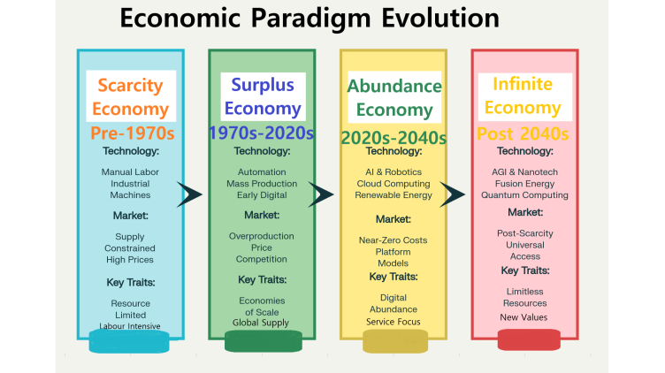](https://www.linkedin.com/pulse/christensens-enduring-wisdom-leveraging-disruptive-theory-hukkeri-exhde)](https://www.linkedin.com/pulse/christensens-enduring-wisdom-leveraging-disruptive-theory-hukkeri-exhde" \t "_self)**

**[Christensen's Enduring Wisdom: Leveraging Disruptive Innovation Theory for the Journey to Unicorn Status and Beyond](https://www.linkedin.com/pulse/christensens-enduring-wisdom-leveraging-disruptive-theory-hukkeri-exhde" \t "_self)**

[Girish Hukkeri](https://www.linkedin.com/pulse/christensens-enduring-wisdom-leveraging-disruptive-theory-hukkeri-exhde" \t "_self)

* 3Trevor Dawson and 2 others

Feed post

Published 1 month ago

**[[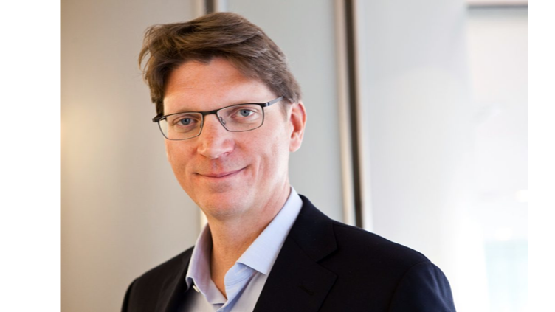](https://www.linkedin.com/pulse/niklas-zennstr%C3%B6m-visionary-who-connected-world-european-hukkeri-7n86e)](https://www.linkedin.com/pulse/niklas-zennstr%C3%B6m-visionary-who-connected-world-european-hukkeri-7n86e" \t "_self)**

**[Niklas Zennström: The Visionary Who Connected the World and Revolutionized European Tech](https://www.linkedin.com/pulse/niklas-zennstr%C3%B6m-visionary-who-connected-world-european-hukkeri-7n86e" \t "_self)**

[Girish Hukkeri](https://www.linkedin.com/pulse/niklas-zennstr%C3%B6m-visionary-who-connected-world-european-hukkeri-7n86e" \t "_self)

* 9SATISH HUKKERI and 8 others
  + 1 comment

Show more results

* [About](https://about.linkedin.com/)
* [Accessibility](https://www.linkedin.com/accessibility)
* [Help Center](https://www.linkedin.com/help/linkedin?trk=footer_d_flagship3_series_entity)
* Privacy & Terms
* [Ad Choices](https://www.linkedin.com/help/linkedin/answer/62931)
* [Advertising](https://www.linkedin.com/ad/start?trk=n_nav_ads_rr)
* Business Services
* Get the LinkedIn app
* More

Published 1 month ago

**[[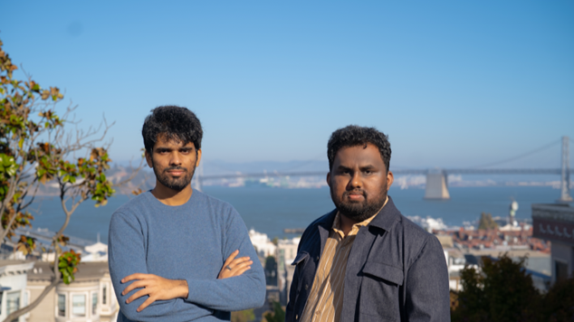](https://www.linkedin.com/pulse/giga-ai-from-iit-kharagpur-ais-customer-support-girish-hukkeri-updue)](https://www.linkedin.com/pulse/giga-ai-from-iit-kharagpur-ais-customer-support-girish-hukkeri-updue" \t "_self)**

**[Giga AI: From IIT Kharagpur to AI's Customer Support Revolution](https://www.linkedin.com/pulse/giga-ai-from-iit-kharagpur-ais-customer-support-girish-hukkeri-updue" \t "_self)**

[Girish Hukkeri](https://www.linkedin.com/pulse/giga-ai-from-iit-kharagpur-ais-customer-support-girish-hukkeri-updue" \t "_self)

* 4Pavan Goyal and 3 others
  + 1 comment

Feed post

Published 1 month ago

**[[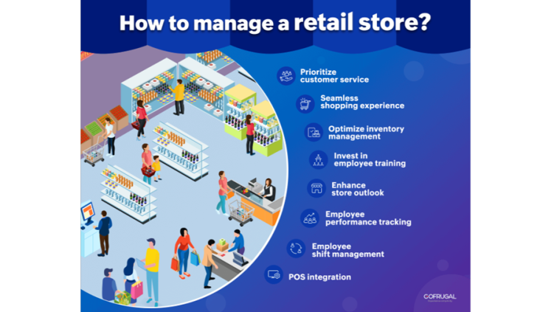](https://www.linkedin.com/pulse/transforming-retail-through-operational-ai-how-deep-domain-hukkeri-tamve)](https://www.linkedin.com/pulse/transforming-retail-through-operational-ai-how-deep-domain-hukkeri-tamve" \t "_self)**

**[Transforming Retail Through Operational AI: How Deep Domain Models Drive Competitive Advantage ... And Prepare for AGI](https://www.linkedin.com/pulse/transforming-retail-through-operational-ai-how-deep-domain-hukkeri-tamve" \t "_self)**

[Girish Hukkeri](https://www.linkedin.com/pulse/transforming-retail-through-operational-ai-how-deep-domain-hukkeri-tamve" \t "_self)

* 9Munir Machmud Ali and 8 others
  + 4 comments

Feed post

Published 1 month ago

**[[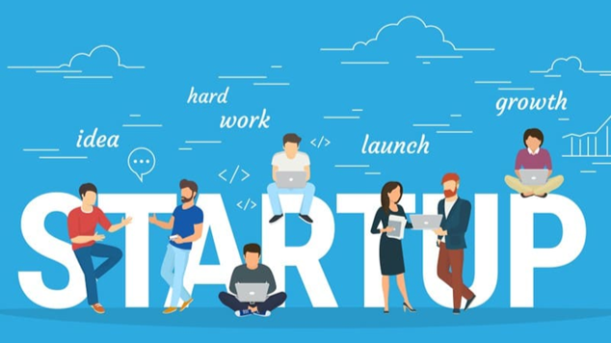](https://www.linkedin.com/pulse/i2uai-startup-ecosystem-booster-transforming-how-happens-hukkeri-qhtwe)](https://www.linkedin.com/pulse/i2uai-startup-ecosystem-booster-transforming-how-happens-hukkeri-qhtwe" \t "_self)**

**[i2u.ai: The Startup Ecosystem Booster, Transforming How Innovation Happens](https://www.linkedin.com/pulse/i2uai-startup-ecosystem-booster-transforming-how-happens-hukkeri-qhtwe" \t "_self)**

[Girish Hukkeri](https://www.linkedin.com/pulse/i2uai-startup-ecosystem-booster-transforming-how-happens-hukkeri-qhtwe" \t "_self)

* 8SATISH HUKKERI and 7 others
  + 4 comments

Feed post

Published 1 month ago

**[[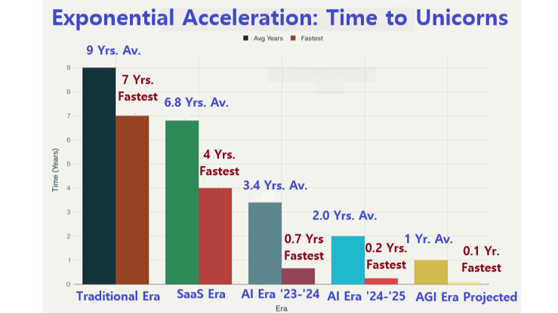](https://www.linkedin.com/pulse/renaissance-discontinuity-why-50x-growth-month-long-unicorns-hukkeri-8cwbe)](https://www.linkedin.com/pulse/renaissance-discontinuity-why-50x-growth-month-long-unicorns-hukkeri-8cwbe" \t "_self)**

**[The RenAIssance Discontinuity: Why 50X Growth and Month-Long Unicorns Define the AGI Era](https://www.linkedin.com/pulse/renaissance-discontinuity-why-50x-growth-month-long-unicorns-hukkeri-8cwbe" \t "_self)**

[Girish Hukkeri](https://www.linkedin.com/pulse/renaissance-discontinuity-why-50x-growth-month-long-unicorns-hukkeri-8cwbe" \t "_self)

* 13Pavan Goyal and 12 others
  + 1 comment

Feed post

Published 1 month ago

**[[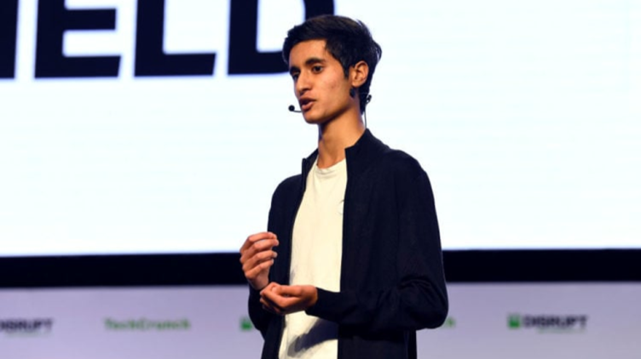](https://www.linkedin.com/pulse/visionary-builder-how-samir-vasavada-redefining-wealth-girish-hukkeri-igtre)](https://www.linkedin.com/pulse/visionary-builder-how-samir-vasavada-redefining-wealth-girish-hukkeri-igtre" \t "_self)**

**[The Visionary Builder: How Samir Vasavada is Redefining Wealth Management Through AI](https://www.linkedin.com/pulse/visionary-builder-how-samir-vasavada-redefining-wealth-girish-hukkeri-igtre" \t "_self)**

[Girish Hukkeri](https://www.linkedin.com/pulse/visionary-builder-how-samir-vasavada-redefining-wealth-girish-hukkeri-igtre" \t "_self)

* 14Munir Machmud Ali and 13 others
  + 2 comments

Feed post

Published 1 month ago

**[[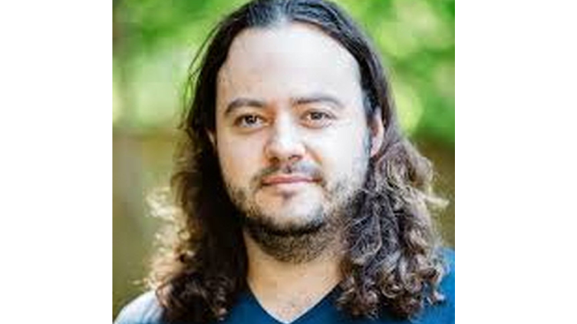](https://www.linkedin.com/pulse/dan-lorenc-architect-trust-software-supply-chain-girish-hukkeri-lruye)](https://www.linkedin.com/pulse/dan-lorenc-architect-trust-software-supply-chain-girish-hukkeri-lruye" \t "_self)**

**[Dan Lorenc: Architect of Trust in the Software Supply Chain](https://www.linkedin.com/pulse/dan-lorenc-architect-trust-software-supply-chain-girish-hukkeri-lruye" \t "_self)**

[Girish Hukkeri](https://www.linkedin.com/pulse/dan-lorenc-architect-trust-software-supply-chain-girish-hukkeri-lruye" \t "_self)

* 10Gaurav Tripathi and 9 others
  + 1 comment

Feed post

Published 1 month ago

**[[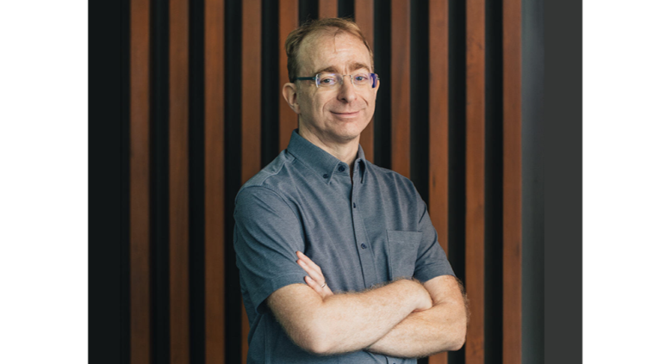](https://www.linkedin.com/pulse/avery-pennarun-architect-zero-trust-networking-who-dreamed-hukkeri-qwy6e)](https://www.linkedin.com/pulse/avery-pennarun-architect-zero-trust-networking-who-dreamed-hukkeri-qwy6e" \t "_self)**

**[Avery Pennarun: The Architect of Zero-Trust Networking Who Dreamed of Fixing the Internet](https://www.linkedin.com/pulse/avery-pennarun-architect-zero-trust-networking-who-dreamed-hukkeri-qwy6e" \t "_self)**

[Girish Hukkeri](https://www.linkedin.com/pulse/avery-pennarun-architect-zero-trust-networking-who-dreamed-hukkeri-qwy6e" \t "_self)

* 9Pavan Goyal and 8 others

Feed post

Published 1 month ago

**[[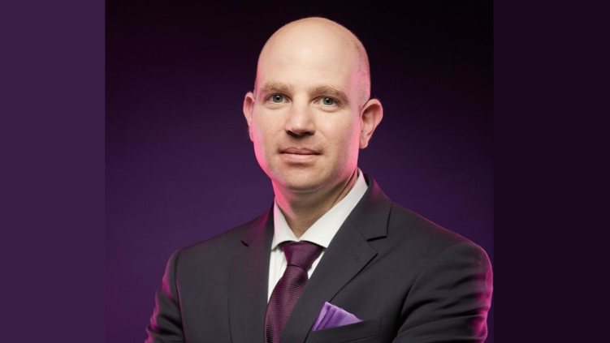](https://www.linkedin.com/pulse/liran-zvibel-architect-behind-ais-data-infrastructure-girish-hukkeri-21cge)](https://www.linkedin.com/pulse/liran-zvibel-architect-behind-ais-data-infrastructure-girish-hukkeri-21cge" \t "_self)**

**[Liran Zvibel: The Architect Behind AI's Data Infrastructure Revolution](https://www.linkedin.com/pulse/liran-zvibel-architect-behind-ais-data-infrastructure-girish-hukkeri-21cge" \t "_self)**

[Girish Hukkeri](https://www.linkedin.com/pulse/liran-zvibel-architect-behind-ais-data-infrastructure-girish-hukkeri-21cge" \t "_self)

* 8Pavan Goyal and 7 others
  + 5 comments

Feed post

Published 1 month ago

**[[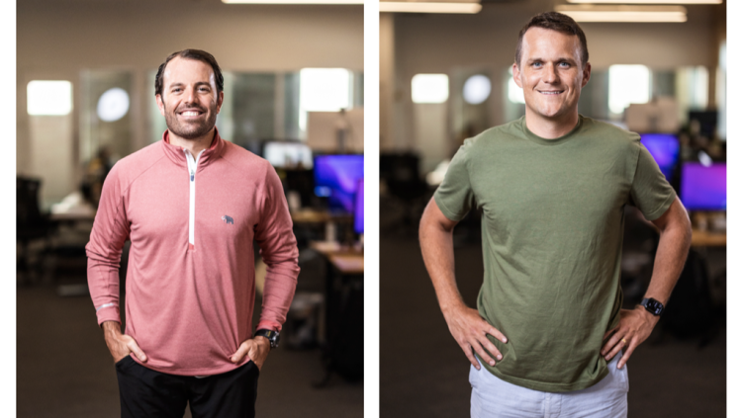](https://www.linkedin.com/pulse/dave-rogenmoser-john-philip-morgan-chris-hull-behind-jasper-hukkeri-ija2e)](https://www.linkedin.com/pulse/dave-rogenmoser-john-philip-morgan-chris-hull-behind-jasper-hukkeri-ija2e" \t "_self)**

**[Dave Rogenmoser, John Philip Morgan & Chris Hull: The Triumvirate Architects Behind Jasper AI's Ascent](https://www.linkedin.com/pulse/dave-rogenmoser-john-philip-morgan-chris-hull-behind-jasper-hukkeri-ija2e" \t "_self)**

[Girish Hukkeri](https://www.linkedin.com/pulse/dave-rogenmoser-john-philip-morgan-chris-hull-behind-jasper-hukkeri-ija2e" \t "_self)

* 9Munir Machmud Ali and 8 others
  + 10 comments

Feed post

Published 1 month ago

**[[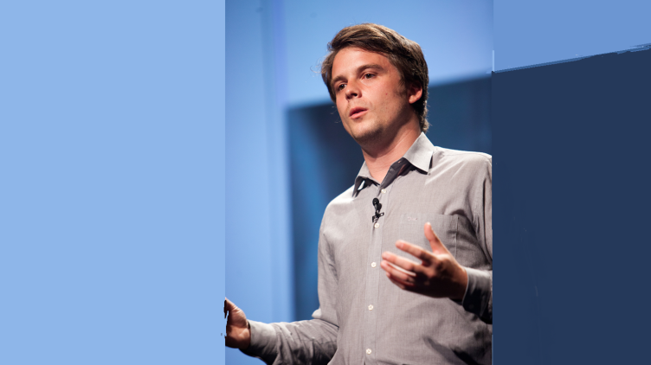](https://www.linkedin.com/pulse/visionary-architects-ai-infrastructure-lukas-biewald-chris-hukkeri-jvuze)](https://www.linkedin.com/pulse/visionary-architects-ai-infrastructure-lukas-biewald-chris-hukkeri-jvuze" \t "_self)**

**[The Visionary Architects of AI Infrastructure: Lukas Biewald and Chris Van Pelt Transform Machine Learning Operations](https://www.linkedin.com/pulse/visionary-architects-ai-infrastructure-lukas-biewald-chris-hukkeri-jvuze" \t "_self)**

[Girish Hukkeri](https://www.linkedin.com/pulse/visionary-architects-ai-infrastructure-lukas-biewald-chris-hukkeri-jvuze" \t "_self)

* 8Pavan Goyal and 7 others
  + 2 comments

Feed post

Published 1 month ago

**[[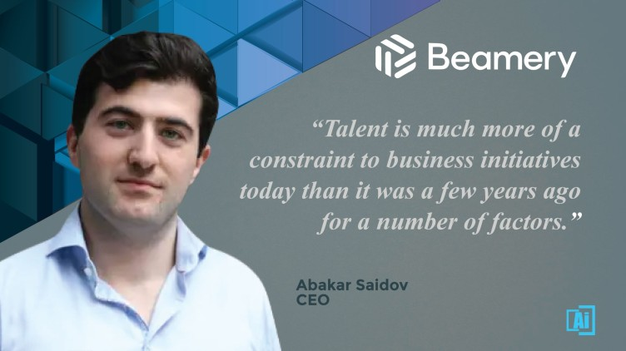](https://www.linkedin.com/pulse/from-dreams-digital-saidov-brothers-beamerys-rise-unicorn-hukkeri-zcqxe)](https://www.linkedin.com/pulse/from-dreams-digital-saidov-brothers-beamerys-rise-unicorn-hukkeri-zcqxe" \t "_self)**

**[From Dreams to Digital: The Saidov Brothers and Beamery's Rise to Unicorn Status](https://www.linkedin.com/pulse/from-dreams-digital-saidov-brothers-beamerys-rise-unicorn-hukkeri-zcqxe" \t "_self)**

[Girish Hukkeri](https://www.linkedin.com/pulse/from-dreams-digital-saidov-brothers-beamerys-rise-unicorn-hukkeri-zcqxe" \t "_self)

* 11Munir Machmud Ali and 10 others
  + 3 comments

Feed post

Published 1 month ago

**[[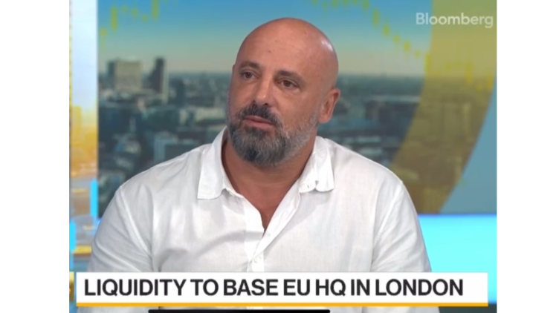](https://www.linkedin.com/pulse/ron-daniel-visionary-architect-behind-liquidity-groups-girish-hukkeri-wcrse)](https://www.linkedin.com/pulse/ron-daniel-visionary-architect-behind-liquidity-groups-girish-hukkeri-wcrse" \t "_self)**

**[Ron Daniel: The Visionary Architect Behind Liquidity Group's AI Revolution](https://www.linkedin.com/pulse/ron-daniel-visionary-architect-behind-liquidity-groups-girish-hukkeri-wcrse" \t "_self)**

[Girish Hukkeri](https://www.linkedin.com/pulse/ron-daniel-visionary-architect-behind-liquidity-groups-girish-hukkeri-wcrse" \t "_self)

* 5
  + 2 comments

Feed post

Published 1 month ago

**[[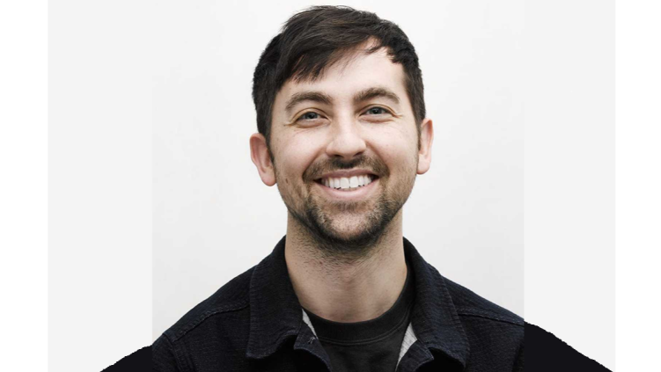](https://www.linkedin.com/pulse/nicholas-harris-engineering-light-power-future-ai-girish-hukkeri-gzf8e)](https://www.linkedin.com/pulse/nicholas-harris-engineering-light-power-future-ai-girish-hukkeri-gzf8e" \t "_self)**

**[Nicholas Harris: Engineering Light to Power the Future of AI](https://www.linkedin.com/pulse/nicholas-harris-engineering-light-power-future-ai-girish-hukkeri-gzf8e" \t "_self)**

[Girish Hukkeri](https://www.linkedin.com/pulse/nicholas-harris-engineering-light-power-future-ai-girish-hukkeri-gzf8e" \t "_self)

* 5Shivangi Sultania and 4 others
  + 2 comments

Feed post

Published 1 month ago

**[[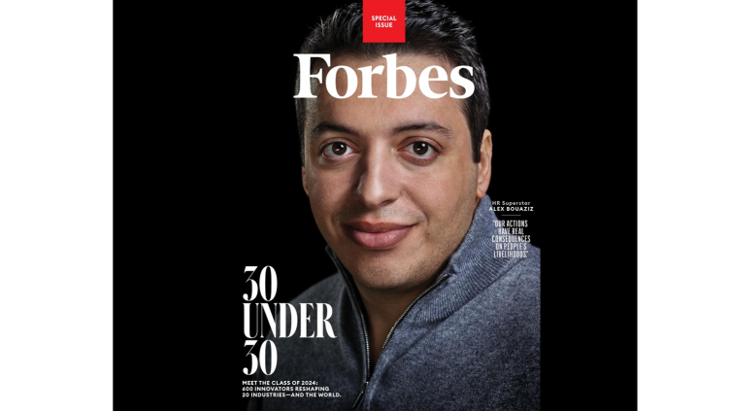](https://www.linkedin.com/pulse/alex-bouaziz-deels-visionary-ceo-engineering-global-girish-hukkeri-sz4se)](https://www.linkedin.com/pulse/alex-bouaziz-deels-visionary-ceo-engineering-global-girish-hukkeri-sz4se" \t "_self)**

**[Alex Bouaziz, Deel’s Visionary CEO: Engineering the Global Workforce Revolution](https://www.linkedin.com/pulse/alex-bouaziz-deels-visionary-ceo-engineering-global-girish-hukkeri-sz4se" \t "_self)**

[Girish Hukkeri](https://www.linkedin.com/pulse/alex-bouaziz-deels-visionary-ceo-engineering-global-girish-hukkeri-sz4se" \t "_self)

* 6Munir Machmud Ali and 5 others
  + 1 comment

Feed post

Published 1 month ago

**[[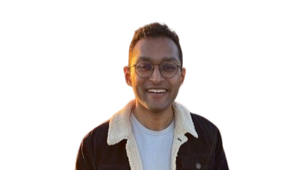](https://www.linkedin.com/pulse/architects-data-activation-kashish-gupta-tejas-manohars-hukkeri-s5aqe)](https://www.linkedin.com/pulse/architects-data-activation-kashish-gupta-tejas-manohars-hukkeri-s5aqe" \t "_self)**

**[The Architects of Data Activation: Kashish Gupta and Tejas Manohar's Journey to Building Hightouch](https://www.linkedin.com/pulse/architects-data-activation-kashish-gupta-tejas-manohars-hukkeri-s5aqe" \t "_self)**

[Girish Hukkeri](https://www.linkedin.com/pulse/architects-data-activation-kashish-gupta-tejas-manohars-hukkeri-s5aqe" \t "_self)

* 9Pavan Goyal and 8 others

Feed post

Published 1 month ago

**[[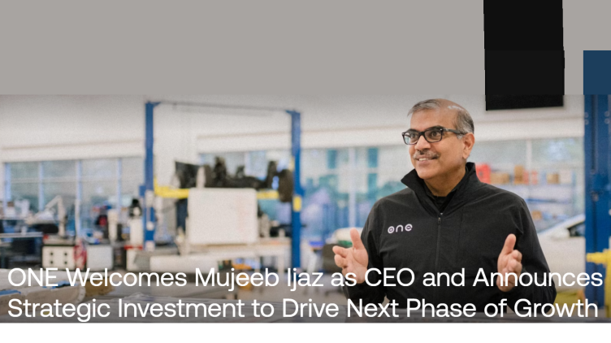](https://www.linkedin.com/pulse/mujeeb-ijaz-our-next-energy-visionary-leadership-impact-hukkeri-py5ie)](https://www.linkedin.com/pulse/mujeeb-ijaz-our-next-energy-visionary-leadership-impact-hukkeri-py5ie" \t "_self)**

**[Mujeeb Ijaz of Our Next Energy: Visionary Leadership, Breakthroughs, and Impact](https://www.linkedin.com/pulse/mujeeb-ijaz-our-next-energy-visionary-leadership-impact-hukkeri-py5ie" \t "_self)**

[Girish Hukkeri](https://www.linkedin.com/pulse/mujeeb-ijaz-our-next-energy-visionary-leadership-impact-hukkeri-py5ie" \t "_self)

* 5Munir Machmud Ali and 4 others
  + 2 comments

Feed post

Published 1 month ago

**[[](https://www.linkedin.com/pulse/grant-demaree-building-onebrief-transform-military-speed-hukkeri-ammee)](https://www.linkedin.com/pulse/grant-demaree-building-onebrief-transform-military-speed-hukkeri-ammee" \t "_self)**

**[Grant Demaree: Building OneBrief to Transform Military Decision-Making at the Speed of War](https://www.linkedin.com/pulse/grant-demaree-building-onebrief-transform-military-speed-hukkeri-ammee" \t "_self)**

[Girish Hukkeri](https://www.linkedin.com/pulse/grant-demaree-building-onebrief-transform-military-speed-hukkeri-ammee" \t "_self)

* 7Munir Machmud Ali and 6 others
  + 2 comments

Feed post

Published 1 month ago

**[[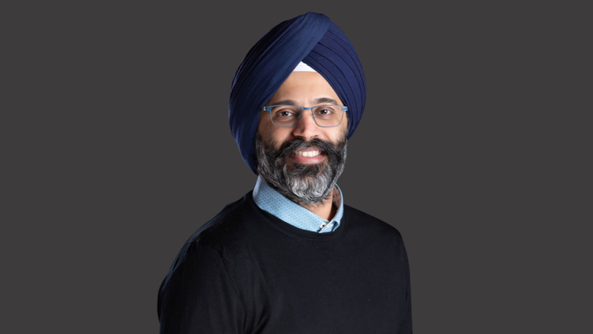](https://www.linkedin.com/pulse/karandeep-anand-architecting-ai-entertainments-next-chapter-hukkeri-1bqqe)](https://www.linkedin.com/pulse/karandeep-anand-architecting-ai-entertainments-next-chapter-hukkeri-1bqqe" \t "_self)**

**[Karandeep Anand: Architecting AI Entertainment's Next Chapter at Character.AI](https://www.linkedin.com/pulse/karandeep-anand-architecting-ai-entertainments-next-chapter-hukkeri-1bqqe" \t "_self)**

[Girish Hukkeri](https://www.linkedin.com/pulse/karandeep-anand-architecting-ai-entertainments-next-chapter-hukkeri-1bqqe" \t "_self)

* 10Pavan Goyal and 9 others
  + 2 comments

Feed post

Published 1 month ago

**[[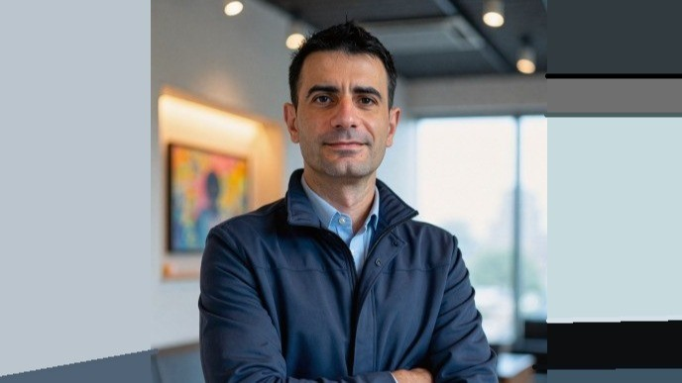](https://www.linkedin.com/pulse/iker-huerga-pioneering-future-ai-enabled-drug-girish-hukkeri-xzxge)](https://www.linkedin.com/pulse/iker-huerga-pioneering-future-ai-enabled-drug-girish-hukkeri-xzxge" \t "_self)**

**[Iker Huerga: Pioneering the Future of AI-Enabled Drug Development](https://www.linkedin.com/pulse/iker-huerga-pioneering-future-ai-enabled-drug-girish-hukkeri-xzxge" \t "_self)**

[Girish Hukkeri](https://www.linkedin.com/pulse/iker-huerga-pioneering-future-ai-enabled-drug-girish-hukkeri-xzxge" \t "_self)

* 11SATISH HUKKERI and 10 others
  + 2 comments

Feed post

Published 1 month ago

**[[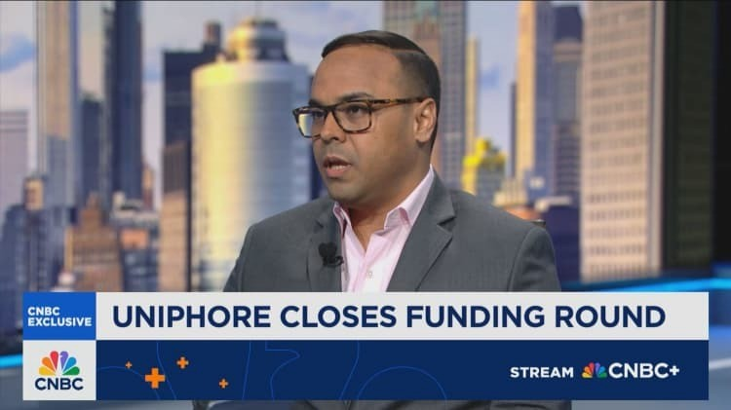](https://www.linkedin.com/pulse/umesh-sachdev-ravi-saraogi-architecting-enterprise-ais-girish-hukkeri-saxje)](https://www.linkedin.com/pulse/umesh-sachdev-ravi-saraogi-architecting-enterprise-ais-girish-hukkeri-saxje" \t "_self)**

**[Umesh Sachdev and Ravi Saraogi: Architecting Enterprise AI's Future](https://www.linkedin.com/pulse/umesh-sachdev-ravi-saraogi-architecting-enterprise-ais-girish-hukkeri-saxje" \t "_self)**

[Girish Hukkeri](https://www.linkedin.com/pulse/umesh-sachdev-ravi-saraogi-architecting-enterprise-ais-girish-hukkeri-saxje" \t "_self)

* 8SATISH HUKKERI and 7 others
  + 5 comments

Feed post

Published 1 month ago

**[[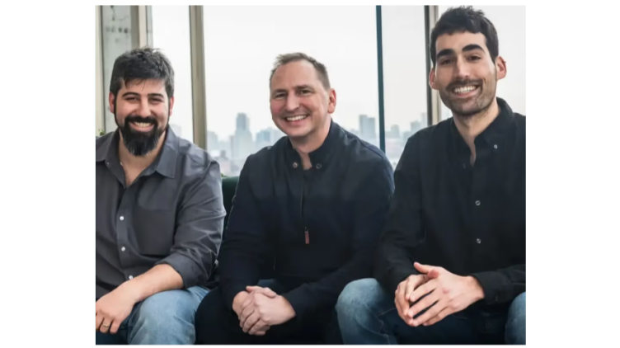](https://www.linkedin.com/pulse/visionary-leaders-age-ai-native-data-security-yotam-segev-hukkeri-bma8e)](https://www.linkedin.com/pulse/visionary-leaders-age-ai-native-data-security-yotam-segev-hukkeri-bma8e" \t "_self)**

**[Visionary Leaders in the Age of AI-Native Data Security: Yotam Segev and Tamar Bar-Ilan Transform Enterprise Data Protection](https://www.linkedin.com/pulse/visionary-leaders-age-ai-native-data-security-yotam-segev-hukkeri-bma8e" \t "_self)**

[Girish Hukkeri](https://www.linkedin.com/pulse/visionary-leaders-age-ai-native-data-security-yotam-segev-hukkeri-bma8e" \t "_self)

* 2Munir Machmud Ali and 1 other
  + 4 comments

Feed post

Published 1 month ago

**[[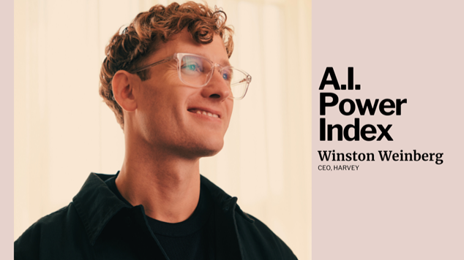](https://www.linkedin.com/pulse/winston-weinberg-lawyer-who-built-5-billion-ai-empire-girish-hukkeri-3v4ue)](https://www.linkedin.com/pulse/winston-weinberg-lawyer-who-built-5-billion-ai-empire-girish-hukkeri-3v4ue" \t "_self)**

**[Winston Weinberg: The Lawyer Who Built a $5 Billion AI Empire in Three Years](https://www.linkedin.com/pulse/winston-weinberg-lawyer-who-built-5-billion-ai-empire-girish-hukkeri-3v4ue" \t "_self)**

[Girish Hukkeri](https://www.linkedin.com/pulse/winston-weinberg-lawyer-who-built-5-billion-ai-empire-girish-hukkeri-3v4ue" \t "_self)

* 8Gaurav Tripathi and 7 others
  + 3 comments

Feed post

Published 1 month ago

**[[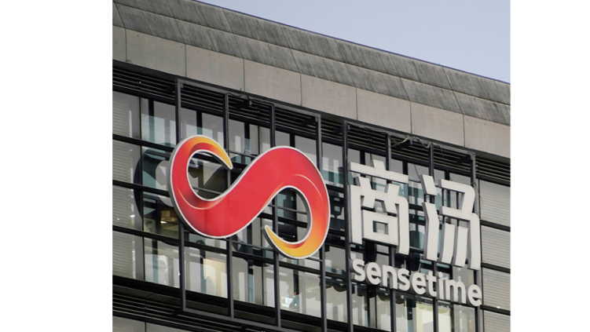](https://www.linkedin.com/pulse/xu-li-visionary-leading-sensetimes-ai-revolution-through-hukkeri-j0gwe)](https://www.linkedin.com/pulse/xu-li-visionary-leading-sensetimes-ai-revolution-through-hukkeri-j0gwe" \t "_self)**

**[Xu Li: The Visionary Leading SenseTime's AI Revolution Through Innovation and Resilience](https://www.linkedin.com/pulse/xu-li-visionary-leading-sensetimes-ai-revolution-through-hukkeri-j0gwe" \t "_self)**

[Girish Hukkeri](https://www.linkedin.com/pulse/xu-li-visionary-leading-sensetimes-ai-revolution-through-hukkeri-j0gwe" \t "_self)

* 3

Feed post

Published 1 month ago

**[[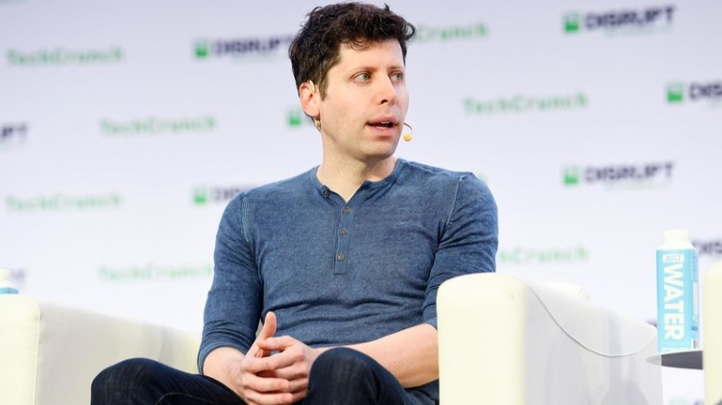](https://www.linkedin.com/pulse/sam-altman-architecting-future-ai-through-visionary-girish-hukkeri-rkx6e)](https://www.linkedin.com/pulse/sam-altman-architecting-future-ai-through-visionary-girish-hukkeri-rkx6e" \t "_self)**

**[Sam Altman: Architecting the Future of AI Through Visionary Leadership](https://www.linkedin.com/pulse/sam-altman-architecting-future-ai-through-visionary-girish-hukkeri-rkx6e" \t "_self)**

[Girish Hukkeri](https://www.linkedin.com/pulse/sam-altman-architecting-future-ai-through-visionary-girish-hukkeri-rkx6e" \t "_self)

* 17Arzu Uğur and 16 others
  + 4 comments

Feed post

Published 1 month ago

**[[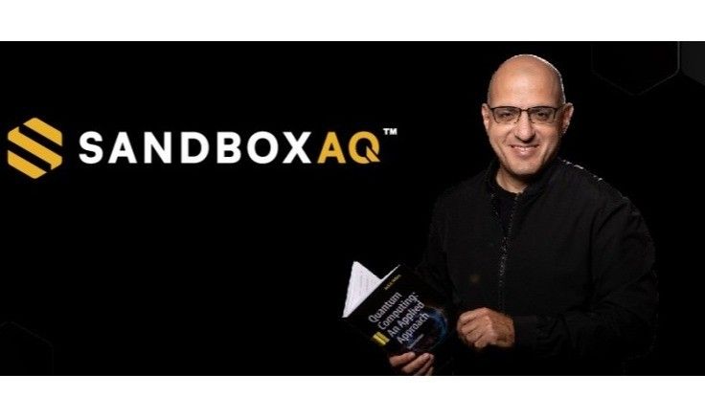](https://www.linkedin.com/pulse/jack-hidary-architecting-quantum-ai-renaissance-girish-hukkeri-d97be)](https://www.linkedin.com/pulse/jack-hidary-architecting-quantum-ai-renaissance-girish-hukkeri-d97be" \t "_self)**

**[Jack Hidary: Architecting the Quantum-AI Renaissance at SandboxAQ](https://www.linkedin.com/pulse/jack-hidary-architecting-quantum-ai-renaissance-girish-hukkeri-d97be" \t "_self)**

[Girish Hukkeri](https://www.linkedin.com/pulse/jack-hidary-architecting-quantum-ai-renaissance-girish-hukkeri-d97be" \t "_self)

* 2Mohammed Alomar and 1 other
  + 1 comment

Feed post

Published 1 month ago

**[[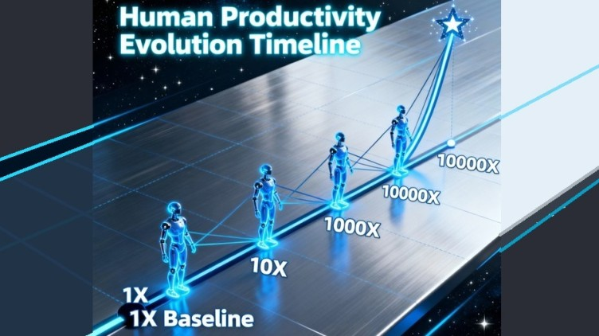](https://www.linkedin.com/pulse/ocean-intellect-living-era-1000000x-1mx-productivity-now-hukkeri-ihyke)](https://www.linkedin.com/pulse/ocean-intellect-living-era-1000000x-1mx-productivity-now-hukkeri-ihyke" \t "_self)**

**[The Ocean of Intellect: Living in an Era of 1,000,000X (1Mx) Productivity, Now Onwards](https://www.linkedin.com/pulse/ocean-intellect-living-era-1000000x-1mx-productivity-now-hukkeri-ihyke" \t "_self)**

[Girish Hukkeri](https://www.linkedin.com/pulse/ocean-intellect-living-era-1000000x-1mx-productivity-now-hukkeri-ihyke" \t "_self)

* 8Geetanshu Bhardwaj and 7 others
  + 3 comments

Feed post

Published 2 months ago

**[[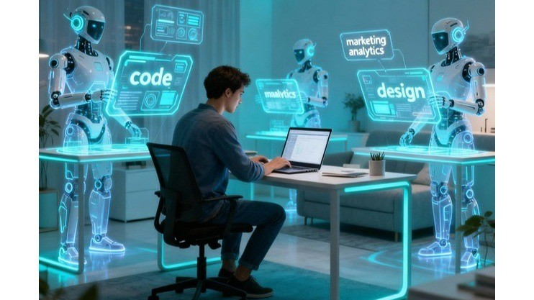](https://www.linkedin.com/pulse/startup-renaissance-how-ai-transforms-global-now-onwards-hukkeri-ab8ge)](https://www.linkedin.com/pulse/startup-renaissance-how-ai-transforms-global-now-onwards-hukkeri-ab8ge" \t "_self)**

**[The Startup RenAIssance: How AI Transforms Global Entrepreneurship, Now Onwards!](https://www.linkedin.com/pulse/startup-renaissance-how-ai-transforms-global-now-onwards-hukkeri-ab8ge" \t "_self)**

[Girish Hukkeri](https://www.linkedin.com/pulse/startup-renaissance-how-ai-transforms-global-now-onwards-hukkeri-ab8ge" \t "_self)

* 13Mohammed Alomar and 12 others
  + 9 comments

Feed post

Published 2 months ago

**[[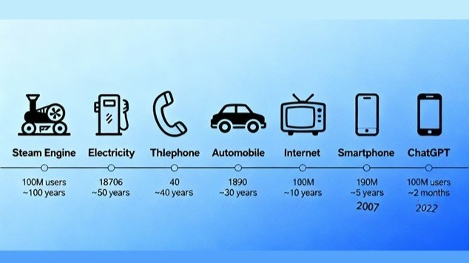](https://www.linkedin.com/pulse/ai-era-fastest-diffusion-general-purpose-technology-gpt-hukkeri-n7fme)](https://www.linkedin.com/pulse/ai-era-fastest-diffusion-general-purpose-technology-gpt-hukkeri-n7fme" \t "_self)**

**[The AI Era: The Fastest Diffusion of a General Purpose Technology (GPT)](https://www.linkedin.com/pulse/ai-era-fastest-diffusion-general-purpose-technology-gpt-hukkeri-n7fme" \t "_self)**

[Girish Hukkeri](https://www.linkedin.com/pulse/ai-era-fastest-diffusion-general-purpose-technology-gpt-hukkeri-n7fme" \t "_self)

* 10Mohammed Alomar and 9 others
  + 7 comments

Feed post

Published 2 months ago

**[[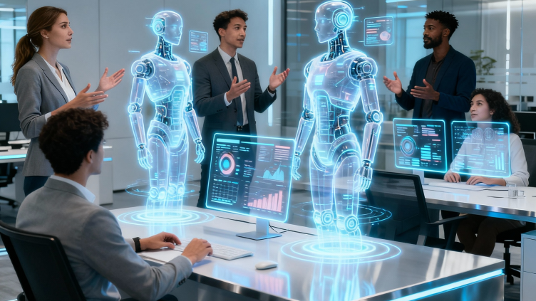](https://www.linkedin.com/pulse/autonomous-internet-when-ai-agents-run-every-digital-our-hukkeri-lcsge)](https://www.linkedin.com/pulse/autonomous-internet-when-ai-agents-run-every-digital-our-hukkeri-lcsge" \t "_self)**

**[The Autonomous Internet: When AI Agents Run Every Digital Touchpoint in Our Connected World](https://www.linkedin.com/pulse/autonomous-internet-when-ai-agents-run-every-digital-our-hukkeri-lcsge" \t "_self)**

[Girish Hukkeri](https://www.linkedin.com/pulse/autonomous-internet-when-ai-agents-run-every-digital-our-hukkeri-lcsge" \t "_self)

* 7Munir Machmud Ali and 6 others
  + 2 comments

Feed post

Published 2 months ago

**[[](https://www.linkedin.com/pulse/ai-agent-revolution-comprehensive-analysis-global-market-hukkeri-3bqee)](https://www.linkedin.com/pulse/ai-agent-revolution-comprehensive-analysis-global-market-hukkeri-3bqee" \t "_self)**

**[The AI Agent Revolution: A Comprehensive Analysis of Global Workforce Transformation and Market Demand (2025-2045)](https://www.linkedin.com/pulse/ai-agent-revolution-comprehensive-analysis-global-market-hukkeri-3bqee" \t "_self)**

[Girish Hukkeri](https://www.linkedin.com/pulse/ai-agent-revolution-comprehensive-analysis-global-market-hukkeri-3bqee" \t "_self)

* 11Gaurav Tripathi and 10 others
  + 11 comments

Feed post

Published 2 months ago

**[[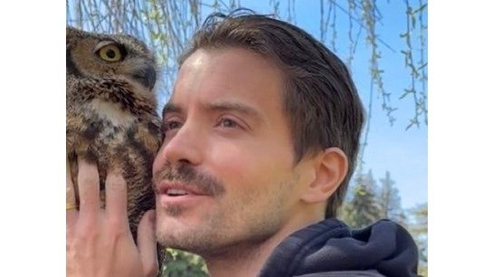](https://www.linkedin.com/pulse/architect-webs-future-guillermo-rauchs-journey-from-buenos-hukkeri-cfsfe)](https://www.linkedin.com/pulse/architect-webs-future-guillermo-rauchs-journey-from-buenos-hukkeri-cfsfe" \t "_self)**

**[The Architect of the Web's Future: Guillermo Rauch's Journey from Buenos Aires to Silicon Valley's Pinnacle](https://www.linkedin.com/pulse/architect-webs-future-guillermo-rauchs-journey-from-buenos-hukkeri-cfsfe" \t "_self)**

[Girish Hukkeri](https://www.linkedin.com/pulse/architect-webs-future-guillermo-rauchs-journey-from-buenos-hukkeri-cfsfe" \t "_self)

* 7Mohammed Alomar and 6 others
  + 2 comments

Feed post

Published 2 months ago

**[[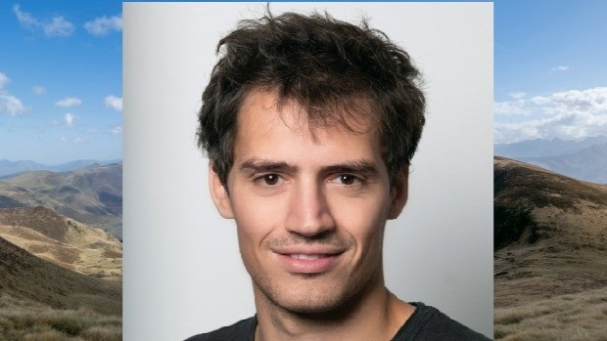](https://www.linkedin.com/pulse/arthur-mensch-architecting-europes-ai-renaissance-through-hukkeri-5thwe)](https://www.linkedin.com/pulse/arthur-mensch-architecting-europes-ai-renaissance-through-hukkeri-5thwe" \t "_self)**

**[Arthur Mensch: Architecting Europe's AI Renaissance Through Open Innovation](https://www.linkedin.com/pulse/arthur-mensch-architecting-europes-ai-renaissance-through-hukkeri-5thwe" \t "_self)**

[Girish Hukkeri](https://www.linkedin.com/pulse/arthur-mensch-architecting-europes-ai-renaissance-through-hukkeri-5thwe" \t "_self)

* 14Munir Machmud Ali and 13 others
  + 6 comments

Feed post

Published 2 months ago

**[[](https://www.linkedin.com/pulse/mercor-triad-how-three-22-year-old-debate-champions-built-hukkeri-mgs9e)](https://www.linkedin.com/pulse/mercor-triad-how-three-22-year-old-debate-champions-built-hukkeri-mgs9e" \t "_self)**

**[The Mercor Triad: How Three 22-Year-Old Debate Champions Built the Fastest-Growing Company in History](https://www.linkedin.com/pulse/mercor-triad-how-three-22-year-old-debate-champions-built-hukkeri-mgs9e" \t "_self)**

[Girish Hukkeri](https://www.linkedin.com/pulse/mercor-triad-how-three-22-year-old-debate-champions-built-hukkeri-mgs9e" \t "_self)

* 12Munir Machmud Ali and 11 others
  + 7 comments

Feed post

Published 2 months ago

**[[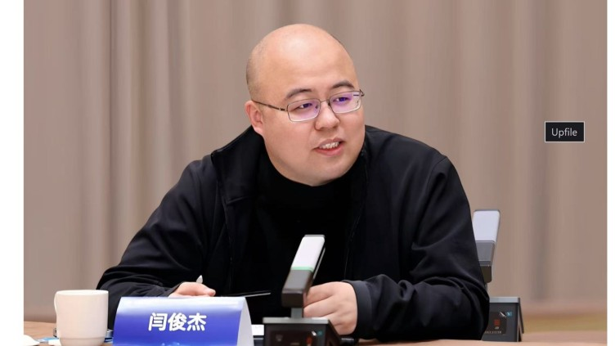](https://www.linkedin.com/pulse/yan-junjie-ai-visionary-redefining-chinas-path-general-girish-hukkeri-ozbge)](https://www.linkedin.com/pulse/yan-junjie-ai-visionary-redefining-chinas-path-general-girish-hukkeri-ozbge" \t "_self)**

**[Yan Junjie: The AI Visionary Redefining China's Path to Artificial General Intelligence](https://www.linkedin.com/pulse/yan-junjie-ai-visionary-redefining-chinas-path-general-girish-hukkeri-ozbge" \t "_self)**

[Girish Hukkeri](https://www.linkedin.com/pulse/yan-junjie-ai-visionary-redefining-chinas-path-general-girish-hukkeri-ozbge" \t "_self)

* 9Munir Machmud Ali and 8 others
  + 1 comment

Feed post

Published 2 months ago

**[[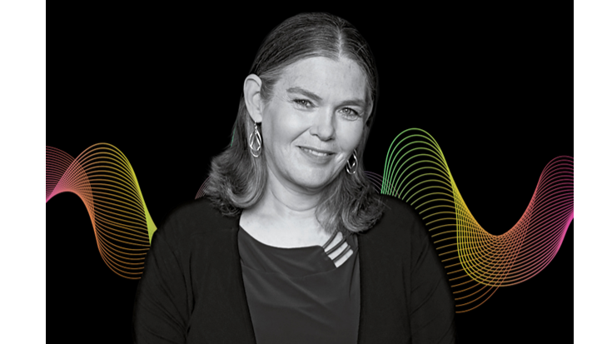](https://www.linkedin.com/pulse/daphne-koller-pioneering-future-ai-driven-drug-through-girish-hukkeri-xosee)](https://www.linkedin.com/pulse/daphne-koller-pioneering-future-ai-driven-drug-through-girish-hukkeri-xosee" \t "_self)**

**[Daphne Koller: Pioneering the Future of AI-Driven Drug Discovery Through Insitro](https://www.linkedin.com/pulse/daphne-koller-pioneering-future-ai-driven-drug-through-girish-hukkeri-xosee" \t "_self)**

[Girish Hukkeri](https://www.linkedin.com/pulse/daphne-koller-pioneering-future-ai-driven-drug-through-girish-hukkeri-xosee" \t "_self)

* 5Munir Machmud Ali and 4 others
  + 3 comments

Feed post

Published 2 months ago

**[[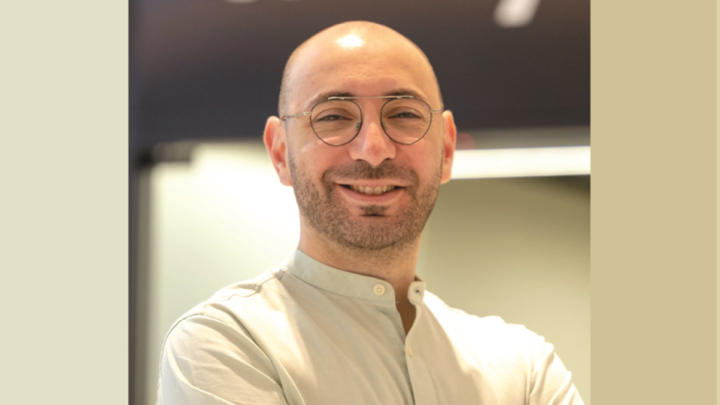](https://www.linkedin.com/pulse/hosam-arab-visionary-leading-tabbys-revolutionary-middle-hukkeri-4iwve)](https://www.linkedin.com/pulse/hosam-arab-visionary-leading-tabbys-revolutionary-middle-hukkeri-4iwve" \t "_self)**

**[Hosam Arab: The Visionary Leading Tabby's Revolutionary Transformation of Middle East Finance](https://www.linkedin.com/pulse/hosam-arab-visionary-leading-tabbys-revolutionary-middle-hukkeri-4iwve" \t "_self)**

[Girish Hukkeri](https://www.linkedin.com/pulse/hosam-arab-visionary-leading-tabbys-revolutionary-middle-hukkeri-4iwve" \t "_self)

* 10Munir Machmud Ali and 9 others
  + 8 comments

Feed post

Published 2 months ago

**[[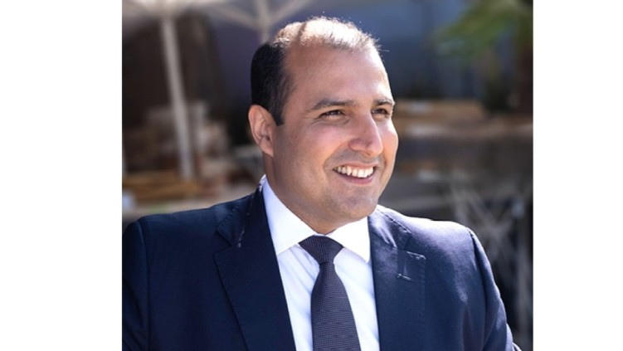](https://www.linkedin.com/pulse/vishal-marria-architect-decision-intelligence-girish-hukkeri-ttfcf)](https://www.linkedin.com/pulse/vishal-marria-architect-decision-intelligence-girish-hukkeri-ttfcf" \t "_self)**

**[Vishal Marria: The Architect of Decision Intelligence](https://www.linkedin.com/pulse/vishal-marria-architect-decision-intelligence-girish-hukkeri-ttfcf" \t "_self)**

[Girish Hukkeri](https://www.linkedin.com/pulse/vishal-marria-architect-decision-intelligence-girish-hukkeri-ttfcf" \t "_self)

* 9Munir Machmud Ali and 8 others
  + 5 comments

Feed post

Published 2 months ago

**[[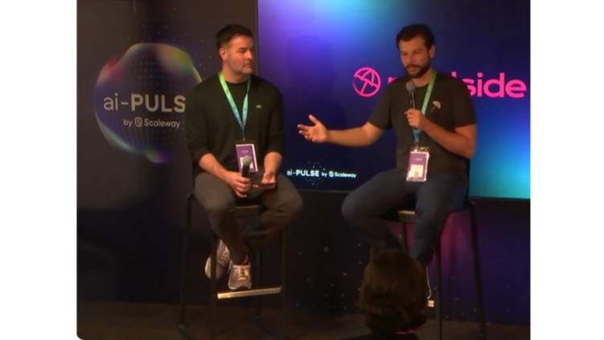](https://www.linkedin.com/pulse/pioneering-future-ai-driven-software-development-in-depth-hukkeri-yeeye)](https://www.linkedin.com/pulse/pioneering-future-ai-driven-software-development-in-depth-hukkeri-yeeye" \t "_self)**

**[Pioneering the Future of AI-Driven Software Development: An In-Depth Assessment of Jason Warner and Eiso Kant's Revolutionary Journey at Poolside](https://www.linkedin.com/pulse/pioneering-future-ai-driven-software-development-in-depth-hukkeri-yeeye" \t "_self)**

[Girish Hukkeri](https://www.linkedin.com/pulse/pioneering-future-ai-driven-software-development-in-depth-hukkeri-yeeye" \t "_self)

* 7Gaurav Tripathi and 6 others
  + 9 comments

Feed post

Published 2 months ago

**[[](https://www.linkedin.com/pulse/architect-programmable-ip-seung-yoon-lees-vision-creator-hukkeri-n2yze)](https://www.linkedin.com/pulse/architect-programmable-ip-seung-yoon-lees-vision-creator-hukkeri-n2yze" \t "_self)**

**[The Architect of Programmable IP: Seung Yoon Lee's Vision for Creator Rights in the AI Era](https://www.linkedin.com/pulse/architect-programmable-ip-seung-yoon-lees-vision-creator-hukkeri-n2yze" \t "_self)**

[Girish Hukkeri](https://www.linkedin.com/pulse/architect-programmable-ip-seung-yoon-lees-vision-creator-hukkeri-n2yze" \t "_self)

* 6Gaurav Tripathi and 5 others
  + 4 comments

Feed post

Published 2 months ago

**[[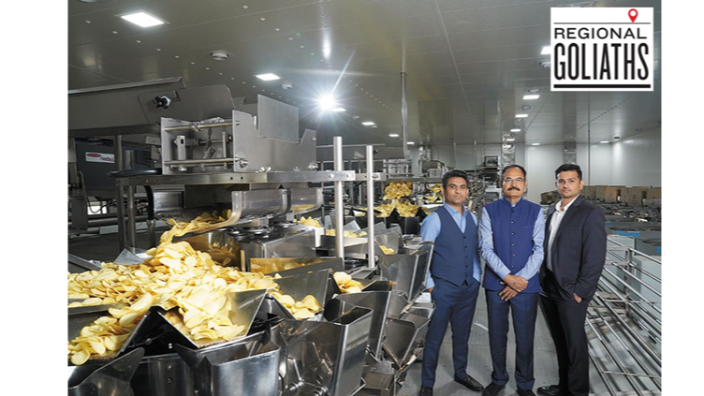](https://www.linkedin.com/pulse/virani-brothers-architects-indias-snack-empire-girish-hukkeri-xpbke)](https://www.linkedin.com/pulse/virani-brothers-architects-indias-snack-empire-girish-hukkeri-xpbke" \t "_self)**

**[The Virani Brothers: Architects of India's Snack Empire](https://www.linkedin.com/pulse/virani-brothers-architects-indias-snack-empire-girish-hukkeri-xpbke" \t "_self)**

[Girish Hukkeri](https://www.linkedin.com/pulse/virani-brothers-architects-indias-snack-empire-girish-hukkeri-xpbke" \t "_self)

* 12Vibula R and 11 others
  + 5 comments

Feed post

Published 2 months ago

**[[](https://www.linkedin.com/pulse/john-imah-visionary-architect-reshaping-fashions-ai-frontier-hukkeri-39rre)](https://www.linkedin.com/pulse/john-imah-visionary-architect-reshaping-fashions-ai-frontier-hukkeri-39rre" \t "_self)**

**[John Imah: The Visionary Architect Reshaping Fashion's AI Frontier](https://www.linkedin.com/pulse/john-imah-visionary-architect-reshaping-fashions-ai-frontier-hukkeri-39rre" \t "_self)**

[Girish Hukkeri](https://www.linkedin.com/pulse/john-imah-visionary-architect-reshaping-fashions-ai-frontier-hukkeri-39rre" \t "_self)

* 4CHENDU S and 3 others
  + 4 comments

Feed post

Published 2 months ago

**[[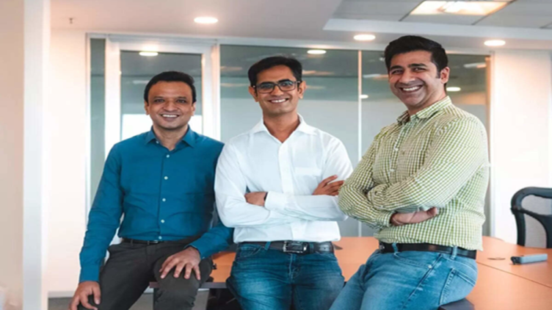](https://www.linkedin.com/pulse/visionary-disruptors-triad-transforming-indias-wealth-girish-hukkeri-gxqte)](https://www.linkedin.com/pulse/visionary-disruptors-triad-transforming-indias-wealth-girish-hukkeri-gxqte" \t "_self)**

**[Visionary Disruptors: The Triad Transforming India's Wealth Management Landscape](https://www.linkedin.com/pulse/visionary-disruptors-triad-transforming-indias-wealth-girish-hukkeri-gxqte" \t "_self)**

[Girish Hukkeri](https://www.linkedin.com/pulse/visionary-disruptors-triad-transforming-indias-wealth-girish-hukkeri-gxqte" \t "_self)

* 9Muhammad Ahmed Khan and 8 others
  + 1 comment

Feed post

Published 2 months ago

**[[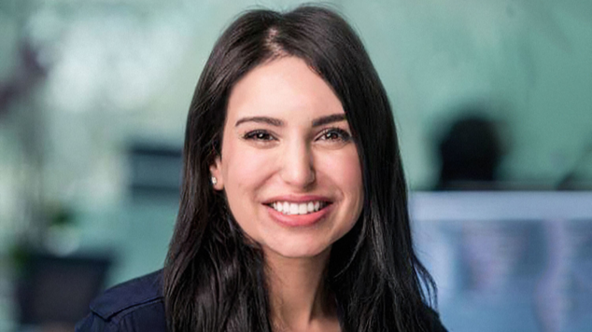](https://www.linkedin.com/pulse/visionary-duo-behind-writer-may-habib-waseem-alshikh-ai-hukkeri-sdtue)](https://www.linkedin.com/pulse/visionary-duo-behind-writer-may-habib-waseem-alshikh-ai-hukkeri-sdtue" \t "_self)**

**[The Visionary Duo Behind Writer: May Habib and Waseem AlShikh Transform Enterprise AI](https://www.linkedin.com/pulse/visionary-duo-behind-writer-may-habib-waseem-alshikh-ai-hukkeri-sdtue" \t "_self)**

[Girish Hukkeri](https://www.linkedin.com/pulse/visionary-duo-behind-writer-may-habib-waseem-alshikh-ai-hukkeri-sdtue" \t "_self)

* 14Vishwanath Sangoji and 13 others
  + 2 comments

Feed post

Published 2 months ago

**[[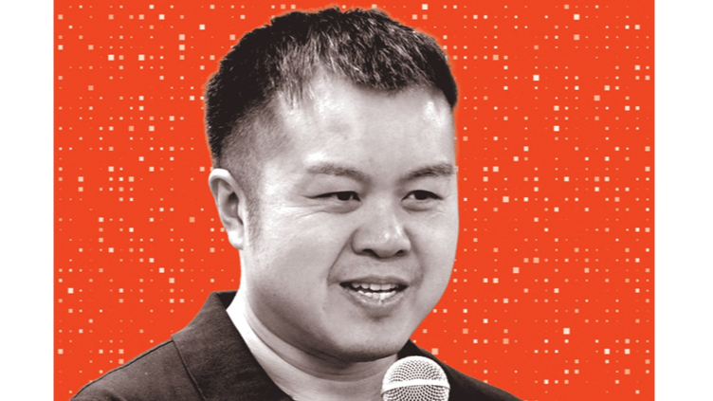](https://www.linkedin.com/pulse/sakana-ai-triumvirate-pioneering-nature-inspired-japan-girish-hukkeri-mkoqe)](https://www.linkedin.com/pulse/sakana-ai-triumvirate-pioneering-nature-inspired-japan-girish-hukkeri-mkoqe" \t "_self)**

**[The Sakana AI Triumvirate: Pioneering Nature-Inspired AI in Japan](https://www.linkedin.com/pulse/sakana-ai-triumvirate-pioneering-nature-inspired-japan-girish-hukkeri-mkoqe" \t "_self)**

[Girish Hukkeri](https://www.linkedin.com/pulse/sakana-ai-triumvirate-pioneering-nature-inspired-japan-girish-hukkeri-mkoqe" \t "_self)

* 7Gaurav Tripathi and 6 others
  + 9 comments

Feed post

Published 2 months ago

**[[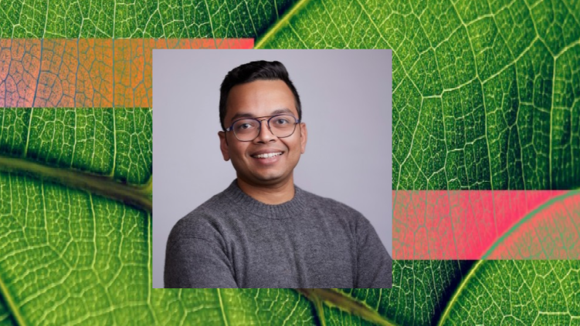](https://www.linkedin.com/pulse/viswa-colluru-architect-natures-digital-renaissance-girish-hukkeri-nt84e)](https://www.linkedin.com/pulse/viswa-colluru-architect-natures-digital-renaissance-girish-hukkeri-nt84e" \t "_self)**

**[Viswa Colluru: The Architect of Nature's Digital Renaissance](https://www.linkedin.com/pulse/viswa-colluru-architect-natures-digital-renaissance-girish-hukkeri-nt84e" \t "_self)**

[Girish Hukkeri](https://www.linkedin.com/pulse/viswa-colluru-architect-natures-digital-renaissance-girish-hukkeri-nt84e" \t "_self)

* 8Munir Machmud Ali and 7 others
  + 2 comments

Feed post

Published 2 months ago

**[[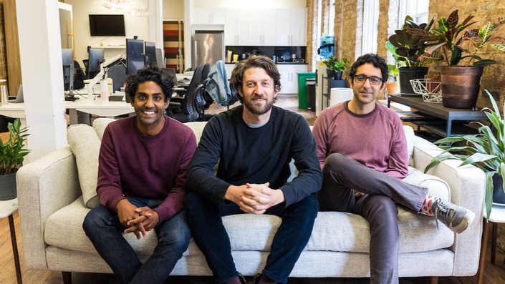](https://www.linkedin.com/pulse/tuhin-srivastava-building-foundation-ais-future-girish-hukkeri-tyahe)](https://www.linkedin.com/pulse/tuhin-srivastava-building-foundation-ais-future-girish-hukkeri-tyahe" \t "_self)**

**[Tuhin Srivastava: Building the Foundation of AI's Future](https://www.linkedin.com/pulse/tuhin-srivastava-building-foundation-ais-future-girish-hukkeri-tyahe" \t "_self)**

[Girish Hukkeri](https://www.linkedin.com/pulse/tuhin-srivastava-building-foundation-ais-future-girish-hukkeri-tyahe" \t "_self)

* 8SATISH HUKKERI and 7 others
  + 5 comments

Feed post

Published 2 months ago

**[[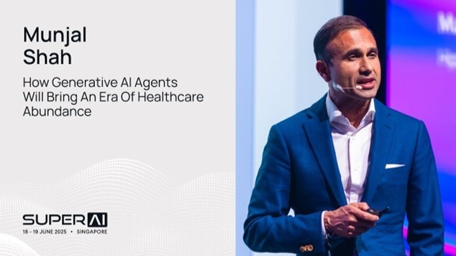](https://www.linkedin.com/pulse/munjal-shah-visionary-architect-healthcare-ai-girish-hukkeri-ofs2e)](https://www.linkedin.com/pulse/munjal-shah-visionary-architect-healthcare-ai-girish-hukkeri-ofs2e" \t "_self)**

**[Munjal Shah: The Visionary Architect of Healthcare AI Revolution](https://www.linkedin.com/pulse/munjal-shah-visionary-architect-healthcare-ai-girish-hukkeri-ofs2e" \t "_self)**

[Girish Hukkeri](https://www.linkedin.com/pulse/munjal-shah-visionary-architect-healthcare-ai-girish-hukkeri-ofs2e" \t "_self)

* 11Munir Machmud Ali and 10 others
  + 2 comments

Feed post

Published 2 months ago

**[[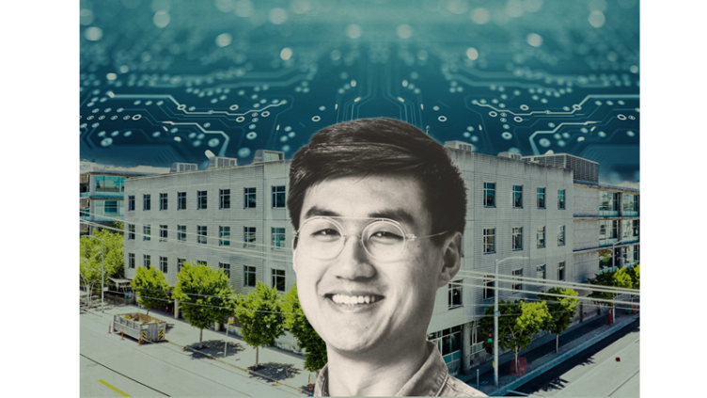](https://www.linkedin.com/pulse/david-luan-visionary-architect-artificial-general-girish-hukkeri-xbwxe)](https://www.linkedin.com/pulse/david-luan-visionary-architect-artificial-general-girish-hukkeri-xbwxe" \t "_self)**

**[David Luan: The Visionary Architect of Artificial General Intelligence](https://www.linkedin.com/pulse/david-luan-visionary-architect-artificial-general-girish-hukkeri-xbwxe" \t "_self)**

[Girish Hukkeri](https://www.linkedin.com/pulse/david-luan-visionary-architect-artificial-general-girish-hukkeri-xbwxe" \t "_self)

* 7CHENDU S and 6 others
  + 3 comments

Feed post

Published 2 months ago

**[[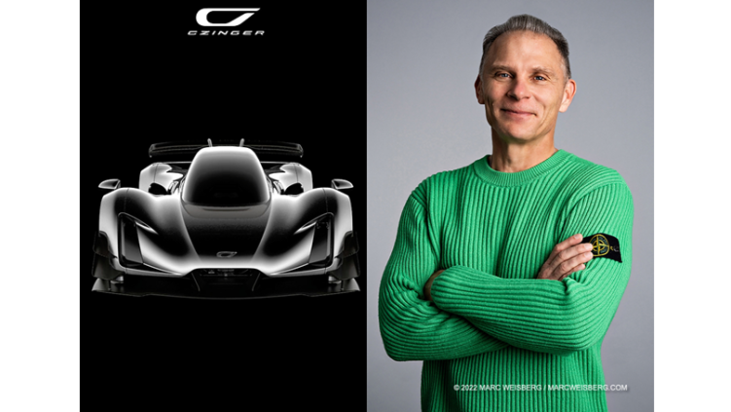](https://www.linkedin.com/pulse/kevin-czinger-visionary-architect-tomorrows-girish-hukkeri-qk1ne)](https://www.linkedin.com/pulse/kevin-czinger-visionary-architect-tomorrows-girish-hukkeri-qk1ne" \t "_self)**

**[Kevin Czinger: The Visionary Architect of Tomorrow's Manufacturing Revolution](https://www.linkedin.com/pulse/kevin-czinger-visionary-architect-tomorrows-girish-hukkeri-qk1ne" \t "_self)**

[Girish Hukkeri](https://www.linkedin.com/pulse/kevin-czinger-visionary-architect-tomorrows-girish-hukkeri-qk1ne" \t "_self)

* 6Munir Machmud Ali and 5 others
  + 5 comments

Feed post

Published 2 months ago

**[[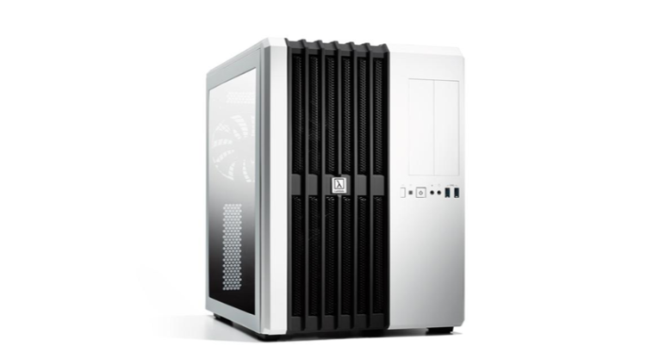](https://www.linkedin.com/pulse/balaban-brothers-twin-visionaries-powering-ai-through-girish-hukkeri-v0cff)](https://www.linkedin.com/pulse/balaban-brothers-twin-visionaries-powering-ai-through-girish-hukkeri-v0cff" \t "_self)**

**[The Balaban Brothers: Twin Visionaries Powering the AI Revolution Through Lambda Labs](https://www.linkedin.com/pulse/balaban-brothers-twin-visionaries-powering-ai-through-girish-hukkeri-v0cff" \t "_self)**

[Girish Hukkeri](https://www.linkedin.com/pulse/balaban-brothers-twin-visionaries-powering-ai-through-girish-hukkeri-v0cff" \t "_self)

* 8Gaurav Tripathi and 7 others
  + 6 comments

Feed post

Published 2 months ago

**[[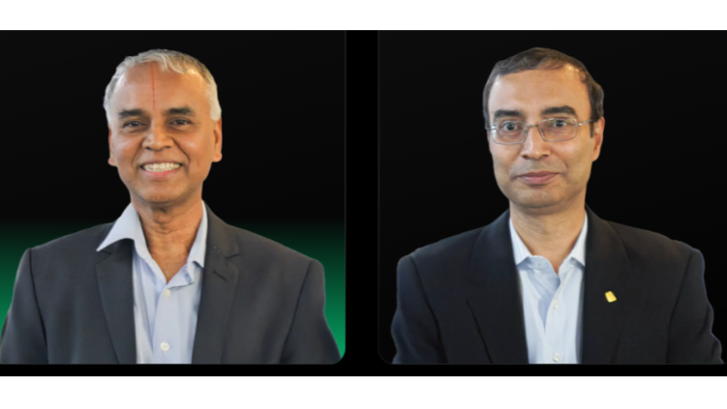](https://www.linkedin.com/pulse/fintech-architects-vr-govindarajan-debasish-transform-girish-hukkeri-iqj6e)](https://www.linkedin.com/pulse/fintech-architects-vr-govindarajan-debasish-transform-girish-hukkeri-iqj6e" \t "_self)**

**[The Fintech Architects: V.R. Govindarajan and Debasish Chakraborty Transform India's Financial Infrastructure Through Perfios](https://www.linkedin.com/pulse/fintech-architects-vr-govindarajan-debasish-transform-girish-hukkeri-iqj6e" \t "_self)**

[Girish Hukkeri](https://www.linkedin.com/pulse/fintech-architects-vr-govindarajan-debasish-transform-girish-hukkeri-iqj6e" \t "_self)

* 9Munir Machmud Ali and 8 others
  + 4 comments

Feed post

Published 2 months ago

**[[](https://www.linkedin.com/pulse/visionary-architects-ivan-zhao-simon-lasts-journey-notion-hukkeri-jytee)](https://www.linkedin.com/pulse/visionary-architects-ivan-zhao-simon-lasts-journey-notion-hukkeri-jytee" \t "_self)**

**[The Visionary Architects: Ivan Zhao and Simon Last's Revolutionary Journey at Notion](https://www.linkedin.com/pulse/visionary-architects-ivan-zhao-simon-lasts-journey-notion-hukkeri-jytee" \t "_self)**

[Girish Hukkeri](https://www.linkedin.com/pulse/visionary-architects-ivan-zhao-simon-lasts-journey-notion-hukkeri-jytee" \t "_self)

* 3Munir Machmud Ali and 2 others
  + 1 comment

Feed post

Published 2 months ago

**[[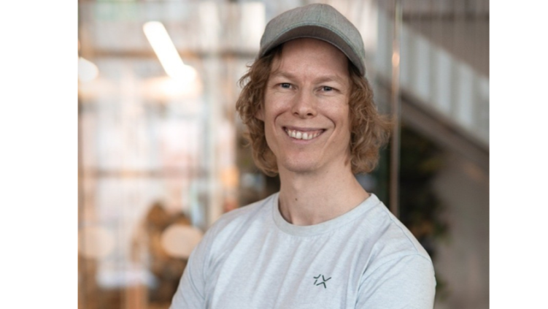](https://www.linkedin.com/pulse/visionary-architect-tomorrow-bernt-b%C3%B8rnich-humanoid-1x-girish-hukkeri-axxfe)](https://www.linkedin.com/pulse/visionary-architect-tomorrow-bernt-b%C3%B8rnich-humanoid-1x-girish-hukkeri-axxfe" \t "_self)**

**[The Visionary Architect of Tomorrow: Bernt Børnich and the Humanoid Revolution at 1X Technologies](https://www.linkedin.com/pulse/visionary-architect-tomorrow-bernt-b%C3%B8rnich-humanoid-1x-girish-hukkeri-axxfe" \t "_self)**

[Girish Hukkeri](https://www.linkedin.com/pulse/visionary-architect-tomorrow-bernt-b%C3%B8rnich-humanoid-1x-girish-hukkeri-axxfe" \t "_self)

* 5Varun Arora and 4 others
  + 1 comment

Feed post

Published 2 months ago

**[[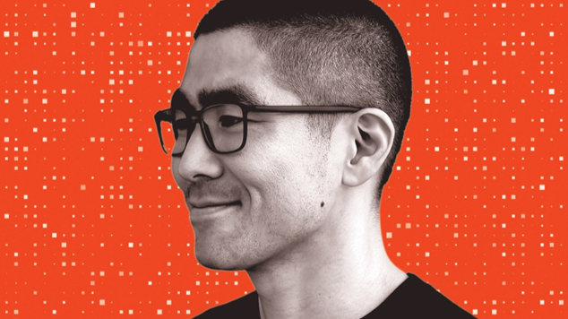](https://www.linkedin.com/pulse/edwin-chen-quiet-genius-who-built-ais-most-essential-empire-hukkeri-x4vhe)](https://www.linkedin.com/pulse/edwin-chen-quiet-genius-who-built-ais-most-essential-empire-hukkeri-x4vhe" \t "_self)**

**[Edwin Chen: The Quiet Genius Who Built AI's Most Essential Empire](https://www.linkedin.com/pulse/edwin-chen-quiet-genius-who-built-ais-most-essential-empire-hukkeri-x4vhe" \t "_self)**

[Girish Hukkeri](https://www.linkedin.com/pulse/edwin-chen-quiet-genius-who-built-ais-most-essential-empire-hukkeri-x4vhe" \t "_self)

* 11SATISH HUKKERI and 10 others
  + 8 comments

Feed post

Published 2 months ago

**[[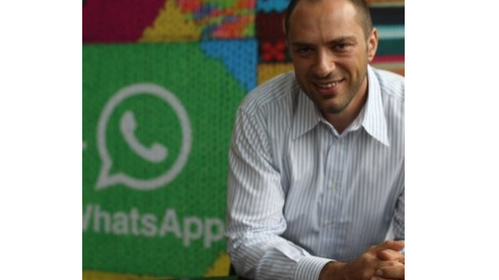](https://www.linkedin.com/pulse/jan-koum-privacy-pioneer-who-built-whatsapp-through-girish-hukkeri-epkle)](https://www.linkedin.com/pulse/jan-koum-privacy-pioneer-who-built-whatsapp-through-girish-hukkeri-epkle" \t "_self)**

**[Jan Koum: The Privacy Pioneer Who Built WhatsApp Through Adversity](https://www.linkedin.com/pulse/jan-koum-privacy-pioneer-who-built-whatsapp-through-girish-hukkeri-epkle" \t "_self)**

[Girish Hukkeri](https://www.linkedin.com/pulse/jan-koum-privacy-pioneer-who-built-whatsapp-through-girish-hukkeri-epkle" \t "_self)

* 5Munir Machmud Ali and 4 others
  + 4 comments

Feed post

Published 2 months ago

**[[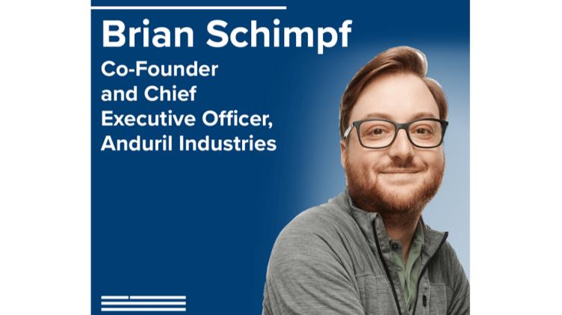](https://www.linkedin.com/pulse/modern-titans-defense-tech-palmer-luckey-brian-schimpf-girish-hukkeri-3jsie)](https://www.linkedin.com/pulse/modern-titans-defense-tech-palmer-luckey-brian-schimpf-girish-hukkeri-3jsie" \t "_self)**

**[The Modern Titans of Defense Tech: Palmer Luckey & Brian Schimpf Forge the Future of National Security](https://www.linkedin.com/pulse/modern-titans-defense-tech-palmer-luckey-brian-schimpf-girish-hukkeri-3jsie" \t "_self)**

[Girish Hukkeri](https://www.linkedin.com/pulse/modern-titans-defense-tech-palmer-luckey-brian-schimpf-girish-hukkeri-3jsie" \t "_self)

* 8Munir Machmud Ali and 7 others
  + 10 comments

Feed post

Published 2 months ago

**[[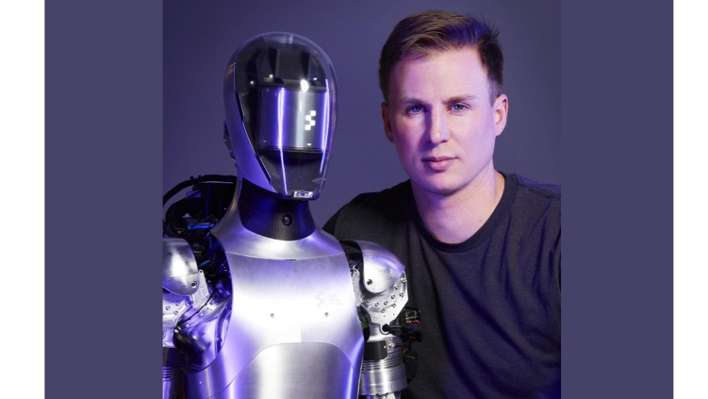](https://www.linkedin.com/pulse/brett-adcock-archer-aviation-engineering-tomorrows-sky-girish-hukkeri-begze)](https://www.linkedin.com/pulse/brett-adcock-archer-aviation-engineering-tomorrows-sky-girish-hukkeri-begze" \t "_self)**

**[Brett Adcock of Archer Aviation: Engineering Tomorrow's Sky Through Bold Vision and Strategic Leadership](https://www.linkedin.com/pulse/brett-adcock-archer-aviation-engineering-tomorrows-sky-girish-hukkeri-begze" \t "_self)**

[Girish Hukkeri](https://www.linkedin.com/pulse/brett-adcock-archer-aviation-engineering-tomorrows-sky-girish-hukkeri-begze" \t "_self)

* 4Munir Machmud Ali and 3 others
  + 5 comments

Feed post

Published 2 months ago

**[[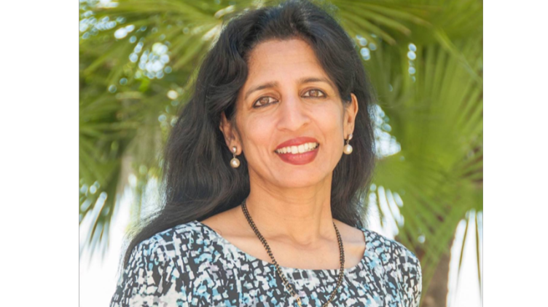](https://www.linkedin.com/pulse/architect-modern-ai-networking-jayashree-ullals-arista-girish-hukkeri-vsywe)](https://www.linkedin.com/pulse/architect-modern-ai-networking-jayashree-ullals-arista-girish-hukkeri-vsywe" \t "_self)**

**[The Architect of Modern AI Networking: Jayashree Ullal's Transformational Leadership at Arista Networks](https://www.linkedin.com/pulse/architect-modern-ai-networking-jayashree-ullals-arista-girish-hukkeri-vsywe" \t "_self)**

[Girish Hukkeri](https://www.linkedin.com/pulse/architect-modern-ai-networking-jayashree-ullals-arista-girish-hukkeri-vsywe" \t "_self)

* 5Dr Kavapatti Sundarkrishnaa and 4 others
  + 7 comments

Feed post

Published 2 months ago

**[[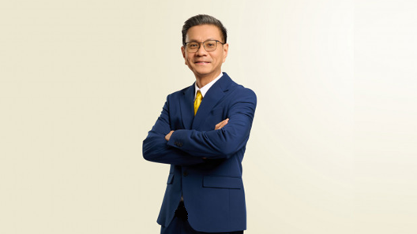](https://www.linkedin.com/pulse/munir-machmud-ali-data-intelligence-visionary-tech-girish-hukkeri-dvrxe)](https://www.linkedin.com/pulse/munir-machmud-ali-data-intelligence-visionary-tech-girish-hukkeri-dvrxe" \t "_self)**

**[Munir Machmud Ali: The Data Intelligence Visionary Reshaping Indonesia's Tech Landscape](https://www.linkedin.com/pulse/munir-machmud-ali-data-intelligence-visionary-tech-girish-hukkeri-dvrxe" \t "_self)**

[Girish Hukkeri](https://www.linkedin.com/pulse/munir-machmud-ali-data-intelligence-visionary-tech-girish-hukkeri-dvrxe" \t "_self)

* 10SATISH HUKKERI and 9 others
  + 8 comments

Feed post

Published 2 months ago

**[[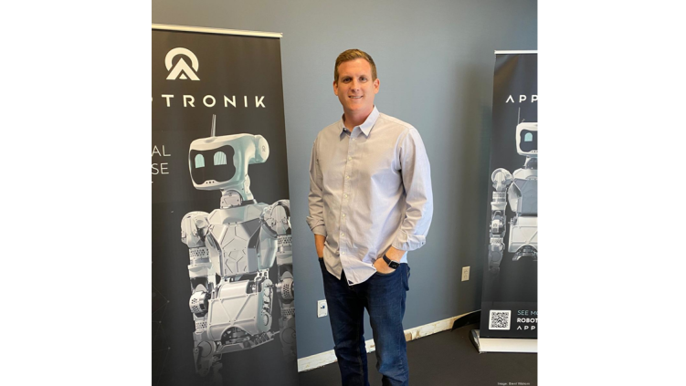](https://www.linkedin.com/pulse/jeffrey-cardenas-visionary-architect-humanoid-robotics-girish-hukkeri-k1hve)](https://www.linkedin.com/pulse/jeffrey-cardenas-visionary-architect-humanoid-robotics-girish-hukkeri-k1hve" \t "_self)**

**[Jeffrey Cardenas: The Visionary Architect of Humanoid Robotics](https://www.linkedin.com/pulse/jeffrey-cardenas-visionary-architect-humanoid-robotics-girish-hukkeri-k1hve" \t "_self)**

[Girish Hukkeri](https://www.linkedin.com/pulse/jeffrey-cardenas-visionary-architect-humanoid-robotics-girish-hukkeri-k1hve" \t "_self)

* 8Mohammed Alomar and 7 others
  + 3 comments

Feed post

Published 2 months ago

**[[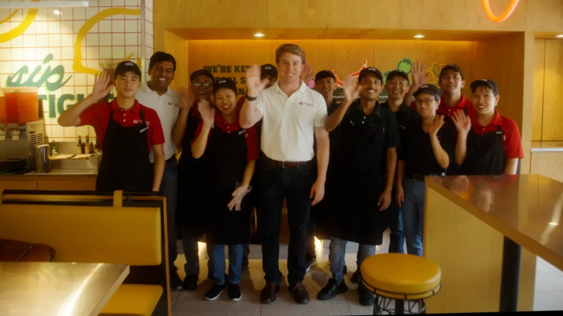](https://www.linkedin.com/pulse/burrito-pioneer-how-bert-mueller-built-indias-most-beloved-hukkeri-q78ke)](https://www.linkedin.com/pulse/burrito-pioneer-how-bert-mueller-built-indias-most-beloved-hukkeri-q78ke" \t "_self)**

**[The Burrito Pioneer: How Bert Mueller Built India's Most Beloved Mexican Food Empire](https://www.linkedin.com/pulse/burrito-pioneer-how-bert-mueller-built-indias-most-beloved-hukkeri-q78ke" \t "_self)**

[Girish Hukkeri](https://www.linkedin.com/pulse/burrito-pioneer-how-bert-mueller-built-indias-most-beloved-hukkeri-q78ke" \t "_self)

* 8Munir Machmud Ali and 7 others
  + 3 comments

Feed post

Published 2 months ago

**[[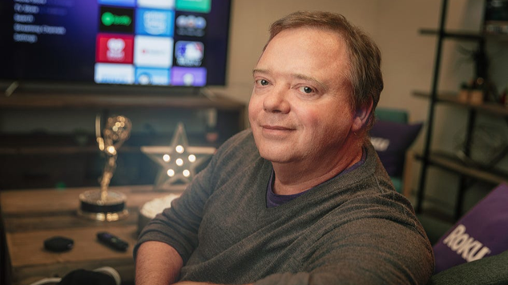](https://www.linkedin.com/pulse/streaming-visionary-anthony-woods-journey-from-dorm-room-hukkeri-w2jne)](https://www.linkedin.com/pulse/streaming-visionary-anthony-woods-journey-from-dorm-room-hukkeri-w2jne" \t "_self)**

**[The Streaming Visionary: Anthony Wood's Journey from Dorm Room Dreams to Roku Empire](https://www.linkedin.com/pulse/streaming-visionary-anthony-woods-journey-from-dorm-room-hukkeri-w2jne" \t "_self)**

[Girish Hukkeri](https://www.linkedin.com/pulse/streaming-visionary-anthony-woods-journey-from-dorm-room-hukkeri-w2jne" \t "_self)

* 4Munir Machmud Ali and 3 others
  + 4 comments

Feed post

Published 2 months ago

**[[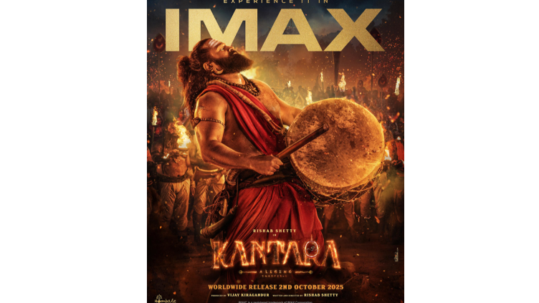](https://www.linkedin.com/pulse/kantara-visionary-rishab-shettys-revolutionary-journey-girish-hukkeri-toc7e)](https://www.linkedin.com/pulse/kantara-visionary-rishab-shettys-revolutionary-journey-girish-hukkeri-toc7e" \t "_self)**

**[The Kantara Visionary: Rishab Shetty's Revolutionary Journey Through the Lens of Entrepreneurial Excellence](https://www.linkedin.com/pulse/kantara-visionary-rishab-shettys-revolutionary-journey-girish-hukkeri-toc7e" \t "_self)**

[Girish Hukkeri](https://www.linkedin.com/pulse/kantara-visionary-rishab-shettys-revolutionary-journey-girish-hukkeri-toc7e" \t "_self)

* 6SATISH HUKKERI and 5 others
  + 4 comments

Feed post

Published 2 months ago

**[[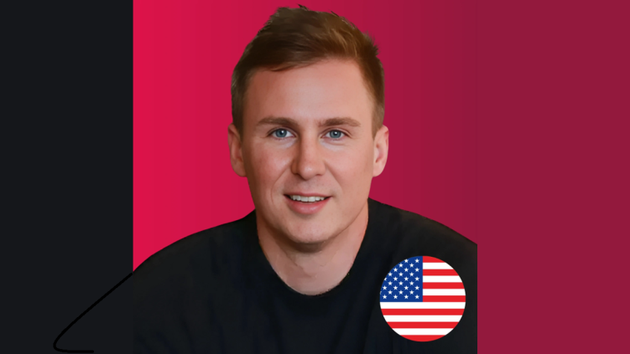](https://www.linkedin.com/pulse/brett-adcock-visionary-architect-ais-physical-future-girish-hukkeri-c1dfe)](https://www.linkedin.com/pulse/brett-adcock-visionary-architect-ais-physical-future-girish-hukkeri-c1dfe" \t "_self)**

**[Brett Adcock: The Visionary Architect of AI's Physical Future](https://www.linkedin.com/pulse/brett-adcock-visionary-architect-ais-physical-future-girish-hukkeri-c1dfe" \t "_self)**

[Girish Hukkeri](https://www.linkedin.com/pulse/brett-adcock-visionary-architect-ais-physical-future-girish-hukkeri-c1dfe" \t "_self)

* 6MUH MASRI SARI and 5 others
  + 3 comments

Feed post

Published 2 months ago

**[[](https://www.linkedin.com/pulse/visionary-leadership-humanoid-robotics-strategic-peggy-girish-hukkeri-ucwde)](https://www.linkedin.com/pulse/visionary-leadership-humanoid-robotics-strategic-peggy-girish-hukkeri-ucwde" \t "_self)**

**[Visionary Leadership in Humanoid Robotics: The Strategic Excellence of Peggy Johnson and Paras Velegapudi at Agility Robotics](https://www.linkedin.com/pulse/visionary-leadership-humanoid-robotics-strategic-peggy-girish-hukkeri-ucwde" \t "_self)**

[Girish Hukkeri](https://www.linkedin.com/pulse/visionary-leadership-humanoid-robotics-strategic-peggy-girish-hukkeri-ucwde" \t "_self)

* 5Munir Machmud Ali and 4 others
  + 2 comments

Feed post

Published 2 months ago

**[[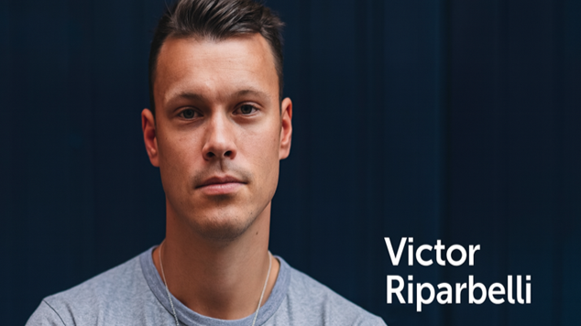](https://www.linkedin.com/pulse/victor-riparbelli-visionary-architect-ai-powered-video-girish-hukkeri-g8xbe)](https://www.linkedin.com/pulse/victor-riparbelli-visionary-architect-ai-powered-video-girish-hukkeri-g8xbe" \t "_self)**

**[Victor Riparbelli: The Visionary Architect of AI-Powered Video Revolution](https://www.linkedin.com/pulse/victor-riparbelli-visionary-architect-ai-powered-video-girish-hukkeri-g8xbe" \t "_self)**

[Girish Hukkeri](https://www.linkedin.com/pulse/victor-riparbelli-visionary-architect-ai-powered-video-girish-hukkeri-g8xbe" \t "_self)

* 4Munir Machmud Ali and 3 others
  + 7 comments

Feed post

Published 2 months ago

**[[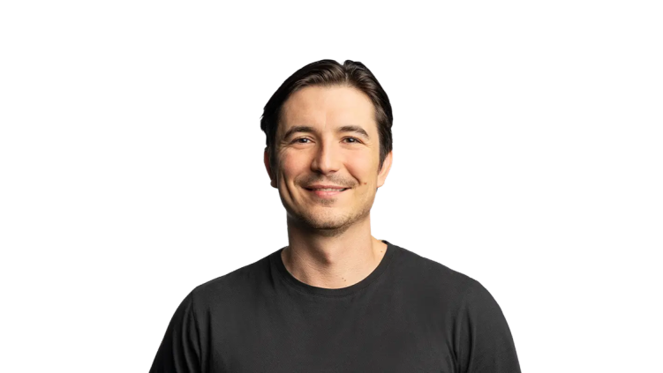](https://www.linkedin.com/pulse/visionaries-wall-street-democracy-vlad-tenev-baiju-bhatt-hukkeri-unvwe)](https://www.linkedin.com/pulse/visionaries-wall-street-democracy-vlad-tenev-baiju-bhatt-hukkeri-unvwe" \t "_self)**

**[The Visionaries of Wall Street Democracy: Vlad Tenev & Baiju Bhatt](https://www.linkedin.com/pulse/visionaries-wall-street-democracy-vlad-tenev-baiju-bhatt-hukkeri-unvwe" \t "_self)**

[Girish Hukkeri](https://www.linkedin.com/pulse/visionaries-wall-street-democracy-vlad-tenev-baiju-bhatt-hukkeri-unvwe" \t "_self)

* 6SATISH HUKKERI and 5 others
  + 1 comment

Feed post

Published 2 months ago

**[[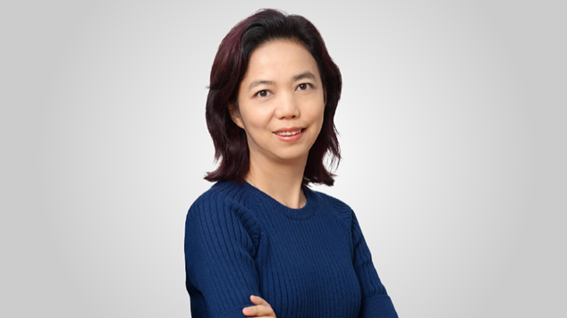](https://www.linkedin.com/pulse/visionary-behind-spatial-intelligence-fei-fei-lis-journey-hukkeri-rqzke)](https://www.linkedin.com/pulse/visionary-behind-spatial-intelligence-fei-fei-lis-journey-hukkeri-rqzke" \t "_self)**

**[The Visionary Behind Spatial Intelligence: Fei-Fei Li's Revolutionary Journey with World Labs](https://www.linkedin.com/pulse/visionary-behind-spatial-intelligence-fei-fei-lis-journey-hukkeri-rqzke" \t "_self)**

[Girish Hukkeri](https://www.linkedin.com/pulse/visionary-behind-spatial-intelligence-fei-fei-lis-journey-hukkeri-rqzke" \t "_self)

* 6Munir Machmud Ali and 5 others
  + 3 comments

Feed post

Published 2 months ago

**[[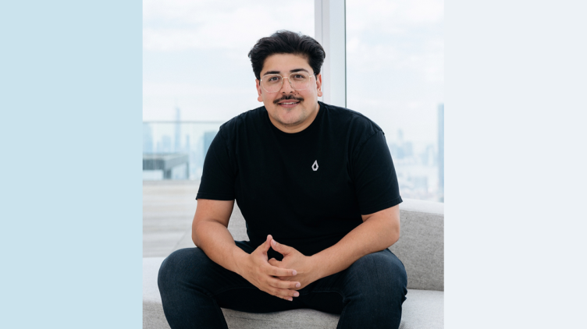](https://www.linkedin.com/pulse/visionary-architects-ais-future-ramin-hasani-mathias-lechner-hukkeri-qoqwe)](https://www.linkedin.com/pulse/visionary-architects-ais-future-ramin-hasani-mathias-lechner-hukkeri-qoqwe" \t "_self)**

**[The Visionary Architects of AI's Future: Ramin Hasani and Mathias Lechner of Liquid AI](https://www.linkedin.com/pulse/visionary-architects-ais-future-ramin-hasani-mathias-lechner-hukkeri-qoqwe" \t "_self)**

[Girish Hukkeri](https://www.linkedin.com/pulse/visionary-architects-ais-future-ramin-hasani-mathias-lechner-hukkeri-qoqwe" \t "_self)

* 9SATISH HUKKERI and 8 others
  + 9 comments

Feed post

Published 2 months ago

**[[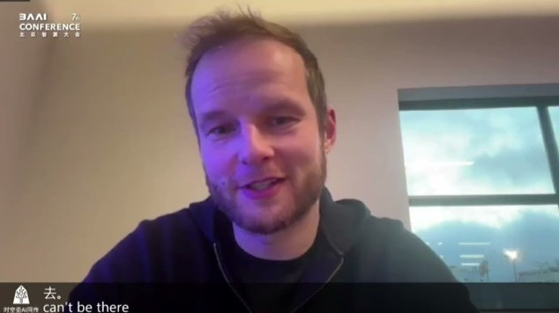](https://www.linkedin.com/pulse/karol-hausman-physical-intelligence-charting-future-robotic-hukkeri-svw2e)](https://www.linkedin.com/pulse/karol-hausman-physical-intelligence-charting-future-robotic-hukkeri-svw2e" \t "_self)**

**[Karol Hausman of Physical Intelligence: Charting the Future of Robotic Intelligence](https://www.linkedin.com/pulse/karol-hausman-physical-intelligence-charting-future-robotic-hukkeri-svw2e" \t "_self)**

[Girish Hukkeri](https://www.linkedin.com/pulse/karol-hausman-physical-intelligence-charting-future-robotic-hukkeri-svw2e" \t "_self)

* 10SATISH HUKKERI and 9 others
  + 2 comments

Feed post

Published 2 months ago

**[[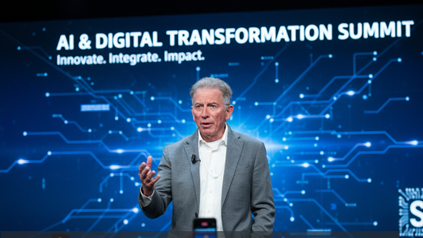](https://www.linkedin.com/pulse/tom-siebel-vision-architect-enterprise-ai-girish-hukkeri-u2oee)](https://www.linkedin.com/pulse/tom-siebel-vision-architect-enterprise-ai-girish-hukkeri-u2oee" \t "_self)**

**[Tom Siebel: Vision Architect of Enterprise AI](https://www.linkedin.com/pulse/tom-siebel-vision-architect-enterprise-ai-girish-hukkeri-u2oee" \t "_self)**

[Girish Hukkeri](https://www.linkedin.com/pulse/tom-siebel-vision-architect-enterprise-ai-girish-hukkeri-u2oee" \t "_self)

* 5SATISH HUKKERI and 4 others
  + 1 comment

Feed post

Published 2 months ago

**[[](https://www.linkedin.com/pulse/bezos-blueprint-visionarys-journey-from-garage-startup-girish-hukkeri-ujvte)](https://www.linkedin.com/pulse/bezos-blueprint-visionarys-journey-from-garage-startup-girish-hukkeri-ujvte" \t "_self)**

**[The Bezos Blueprint: A Visionary's Journey from Garage Startup to Global Empire](https://www.linkedin.com/pulse/bezos-blueprint-visionarys-journey-from-garage-startup-girish-hukkeri-ujvte" \t "_self)**

[Girish Hukkeri](https://www.linkedin.com/pulse/bezos-blueprint-visionarys-journey-from-garage-startup-girish-hukkeri-ujvte" \t "_self)

* 14SATISH HUKKERI and 13 others
  + 12 comments

Feed post

Published 2 months ago

**[[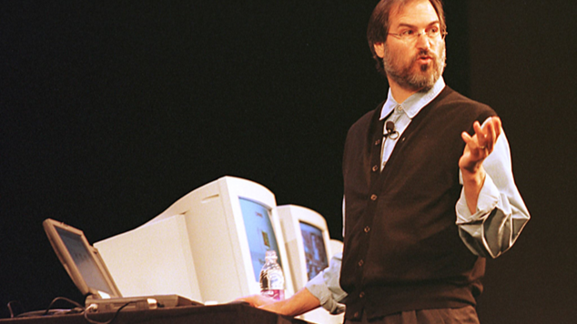](https://www.linkedin.com/pulse/architect-apple-steve-jobs-struggle-triumph-path-forward-hukkeri-ga3he)](https://www.linkedin.com/pulse/architect-apple-steve-jobs-struggle-triumph-path-forward-hukkeri-ga3he" \t "_self)**

**[The Architect of Apple: Steve Jobs' Struggle, Triumph, and the Path Forward](https://www.linkedin.com/pulse/architect-apple-steve-jobs-struggle-triumph-path-forward-hukkeri-ga3he" \t "_self)**

[Girish Hukkeri](https://www.linkedin.com/pulse/architect-apple-steve-jobs-struggle-triumph-path-forward-hukkeri-ga3he" \t "_self)

* 8SATISH HUKKERI and 7 others
  + 14 comments

Feed post

Published 2 months ago

**[[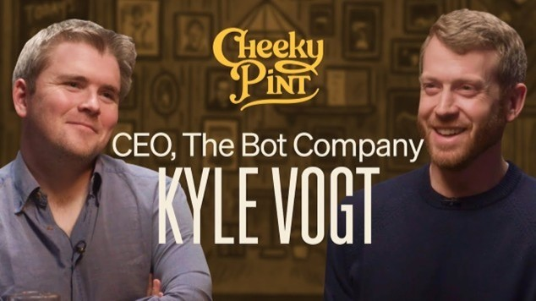](https://www.linkedin.com/pulse/visionary-duo-kyle-vogt-paril-jains-revolutionary-robotics-hukkeri-jfeke)](https://www.linkedin.com/pulse/visionary-duo-kyle-vogt-paril-jains-revolutionary-robotics-hukkeri-jfeke" \t "_self)**

**[The Visionary Duo: Kyle Vogt and Paril Jain's Revolutionary Robotics Journey](https://www.linkedin.com/pulse/visionary-duo-kyle-vogt-paril-jains-revolutionary-robotics-hukkeri-jfeke" \t "_self)**

[Girish Hukkeri](https://www.linkedin.com/pulse/visionary-duo-kyle-vogt-paril-jains-revolutionary-robotics-hukkeri-jfeke" \t "_self)

* 6SATISH HUKKERI and 5 others
  + 2 comments

Feed post

Published 2 months ago

**[[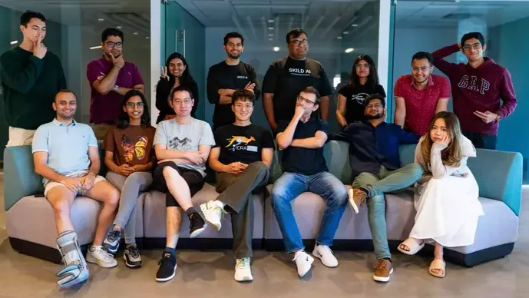](https://www.linkedin.com/pulse/skild-duo-how-deepak-pathak-abhinav-gupta-building-future-hukkeri-a13he)](https://www.linkedin.com/pulse/skild-duo-how-deepak-pathak-abhinav-gupta-building-future-hukkeri-a13he" \t "_self)**

**[The Skild Duo: How Deepak Pathak and Abhinav Gupta are Building the Future of Robotics Intelligence](https://www.linkedin.com/pulse/skild-duo-how-deepak-pathak-abhinav-gupta-building-future-hukkeri-a13he" \t "_self)**

[Girish Hukkeri](https://www.linkedin.com/pulse/skild-duo-how-deepak-pathak-abhinav-gupta-building-future-hukkeri-a13he" \t "_self)

* 16SATISH HUKKERI and 15 others
  + 8 comments

Feed post

Published 2 months ago

**[[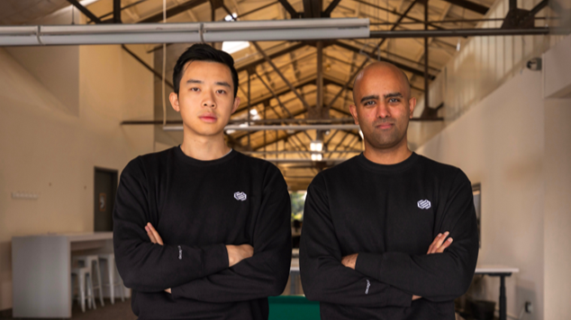](https://www.linkedin.com/pulse/visionaries-behind-decagon-jesse-zhang-ashwin-ai-customer-hukkeri-zbawe)](https://www.linkedin.com/pulse/visionaries-behind-decagon-jesse-zhang-ashwin-ai-customer-hukkeri-zbawe" \t "_self)**

**[The Visionaries Behind Decagon: Jesse Zhang and Ashwin Sreenivas Redefining AI Customer Experience](https://www.linkedin.com/pulse/visionaries-behind-decagon-jesse-zhang-ashwin-ai-customer-hukkeri-zbawe" \t "_self)**

[Girish Hukkeri](https://www.linkedin.com/pulse/visionaries-behind-decagon-jesse-zhang-ashwin-ai-customer-hukkeri-zbawe" \t "_self)

* 12SATISH HUKKERI and 11 others
  + 4 comments

Feed post

Published 2 months ago

**[[](https://www.linkedin.com/pulse/dynamic-duo-revolutionizing-drug-discovery-chris-gibson-hukkeri-up5oe)](https://www.linkedin.com/pulse/dynamic-duo-revolutionizing-drug-discovery-chris-gibson-hukkeri-up5oe" \t "_self)**

**[The Dynamic Duo Revolutionizing Drug Discovery: Chris Gibson and Dean Li's AI-Powered Vision at Recursion Pharmaceuticals](https://www.linkedin.com/pulse/dynamic-duo-revolutionizing-drug-discovery-chris-gibson-hukkeri-up5oe" \t "_self)**

[Girish Hukkeri](https://www.linkedin.com/pulse/dynamic-duo-revolutionizing-drug-discovery-chris-gibson-hukkeri-up5oe" \t "_self)

* 8SATISH HUKKERI and 7 others
  + 3 comments

Feed post

Published 2 months ago

**[[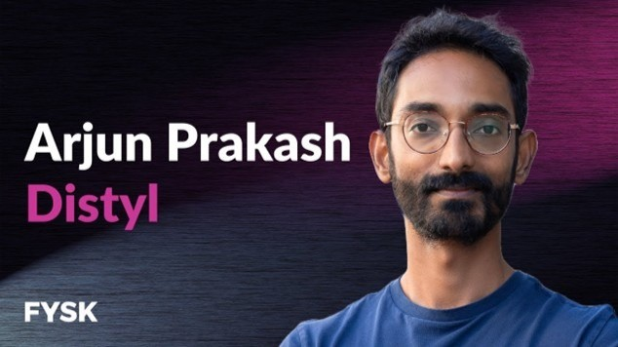](https://www.linkedin.com/pulse/ai-native-visionaries-arjun-prakash-derek-hos-journey-girish-hukkeri-kyede)](https://www.linkedin.com/pulse/ai-native-visionaries-arjun-prakash-derek-hos-journey-girish-hukkeri-kyede" \t "_self)**

**[The AI Native Visionaries: Arjun Prakash and Derek Ho's Revolutionary Journey with Distyl AI](https://www.linkedin.com/pulse/ai-native-visionaries-arjun-prakash-derek-hos-journey-girish-hukkeri-kyede" \t "_self)**

[Girish Hukkeri](https://www.linkedin.com/pulse/ai-native-visionaries-arjun-prakash-derek-hos-journey-girish-hukkeri-kyede" \t "_self)

* 6Munir Machmud Ali and 5 others
  + 1 comment

Feed post

Published 2 months ago

**[[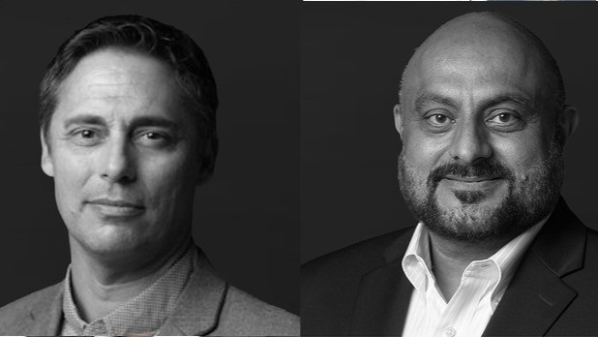](https://www.linkedin.com/pulse/visionaries-behind-light-david-lazovsky-preet-virks-journey-hukkeri-08p4e)](https://www.linkedin.com/pulse/visionaries-behind-light-david-lazovsky-preet-virks-journey-hukkeri-08p4e" \t "_self)**

**[The Visionaries Behind the Light: David Lazovsky and Preet Virk's Revolutionary Journey with Celestial AI](https://www.linkedin.com/pulse/visionaries-behind-light-david-lazovsky-preet-virks-journey-hukkeri-08p4e" \t "_self)**

[Girish Hukkeri](https://www.linkedin.com/pulse/visionaries-behind-light-david-lazovsky-preet-virks-journey-hukkeri-08p4e" \t "_self)

* 3Gurpreet Singh and 2 others
  + 4 comments

Feed post

Published 2 months ago

**[[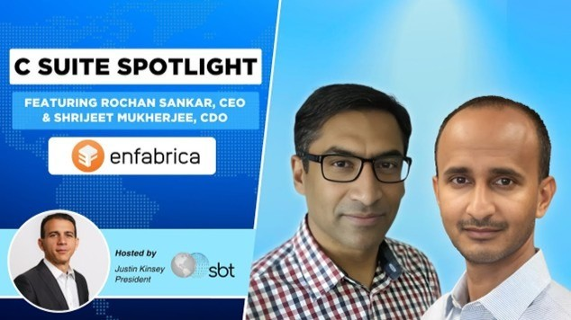](https://www.linkedin.com/pulse/architect-ai-infrastructure-rochan-sankars-journey-from-hukkeri-u1cwe)](https://www.linkedin.com/pulse/architect-ai-infrastructure-rochan-sankars-journey-from-hukkeri-u1cwe" \t "_self)**

**[The Architect of AI Infrastructure: Rochan Sankar's Journey from Silicon Dreams to Nvidia's $900 Million Bet](https://www.linkedin.com/pulse/architect-ai-infrastructure-rochan-sankars-journey-from-hukkeri-u1cwe" \t "_self)**

[Girish Hukkeri](https://www.linkedin.com/pulse/architect-ai-infrastructure-rochan-sankars-journey-from-hukkeri-u1cwe" \t "_self)

* 12SATISH HUKKERI and 11 others
  + 6 comments

Feed post

Published 2 months ago

**[[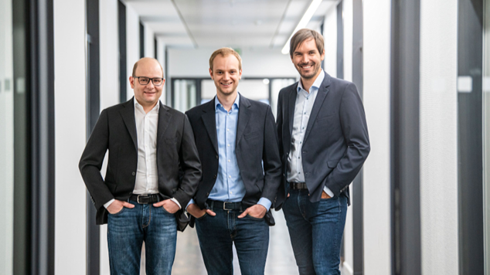](https://www.linkedin.com/pulse/celonis-process-intelligence-pioneer-transforming-scale-hukkeri-yunee)](https://www.linkedin.com/pulse/celonis-process-intelligence-pioneer-transforming-scale-hukkeri-yunee" \t "_self)**

**[Celonis: The Process Intelligence Pioneer Transforming Enterprise Operations at Scale](https://www.linkedin.com/pulse/celonis-process-intelligence-pioneer-transforming-scale-hukkeri-yunee" \t "_self)**

[Girish Hukkeri](https://www.linkedin.com/pulse/celonis-process-intelligence-pioneer-transforming-scale-hukkeri-yunee" \t "_self)

* 8SATISH HUKKERI and 7 others
  + 3 comments

Feed post

Published 2 months ago

**[[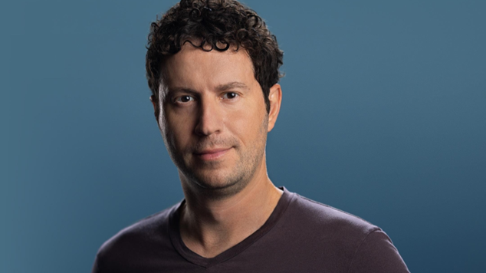](https://www.linkedin.com/pulse/polymath-pioneers-how-daniel-nadler-zachary-ziegler-medical-hukkeri-egise)](https://www.linkedin.com/pulse/polymath-pioneers-how-daniel-nadler-zachary-ziegler-medical-hukkeri-egise" \t "_self)**

**[The Polymath Pioneers: How Daniel Nadler and Zachary Ziegler are Revolutionizing Medical Knowledge through AI](https://www.linkedin.com/pulse/polymath-pioneers-how-daniel-nadler-zachary-ziegler-medical-hukkeri-egise" \t "_self)**

[Girish Hukkeri](https://www.linkedin.com/pulse/polymath-pioneers-how-daniel-nadler-zachary-ziegler-medical-hukkeri-egise" \t "_self)

* 6SATISH HUKKERI and 5 others
  + 5 comments

Feed post

Published 2 months ago

**[[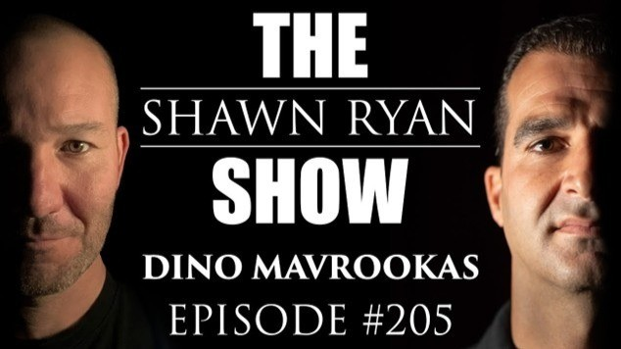](https://www.linkedin.com/pulse/saronic-quartet-maritime-visionaries-redefining-naval-girish-hukkeri-u19le)](https://www.linkedin.com/pulse/saronic-quartet-maritime-visionaries-redefining-naval-girish-hukkeri-u19le" \t "_self)**

**[The Saronic Quartet: Maritime Visionaries Redefining Naval Defense](https://www.linkedin.com/pulse/saronic-quartet-maritime-visionaries-redefining-naval-girish-hukkeri-u19le" \t "_self)**

[Girish Hukkeri](https://www.linkedin.com/pulse/saronic-quartet-maritime-visionaries-redefining-naval-girish-hukkeri-u19le" \t "_self)

* 7SATISH HUKKERI and 6 others
  + 2 comments

Feed post

Published 3 months ago

**[[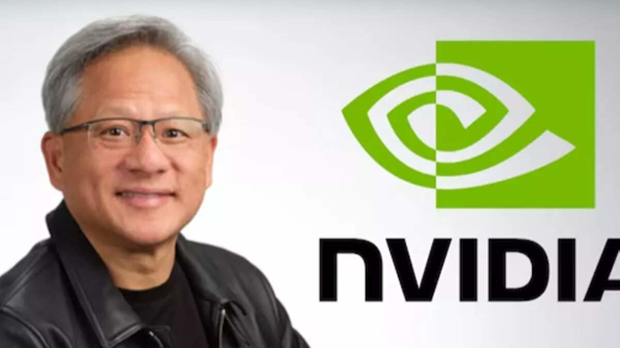](https://www.linkedin.com/pulse/jensen-huang-visionary-who-transformed-computing-girish-hukkeri-kwa9e)](https://www.linkedin.com/pulse/jensen-huang-visionary-who-transformed-computing-girish-hukkeri-kwa9e" \t "_self)**

**[Jensen Huang: The Visionary Who Transformed Computing and Redefined Leadership](https://www.linkedin.com/pulse/jensen-huang-visionary-who-transformed-computing-girish-hukkeri-kwa9e" \t "_self)**

[Girish Hukkeri](https://www.linkedin.com/pulse/jensen-huang-visionary-who-transformed-computing-girish-hukkeri-kwa9e" \t "_self)

* 14SATISH HUKKERI and 13 others
  + 8 comments

Feed post

Published 3 months ago

**[[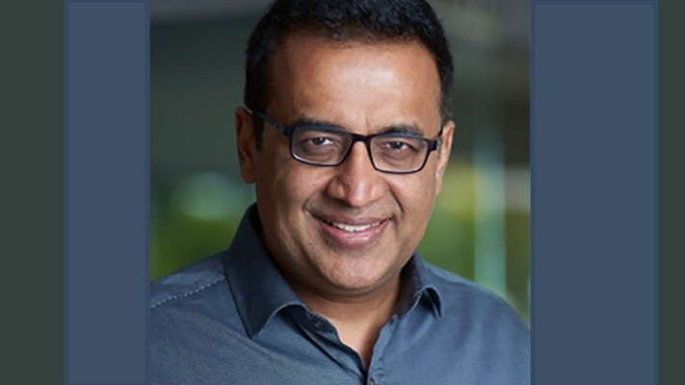](https://www.linkedin.com/pulse/visionary-behind-wheel-avneesh-agrawal-netradynes-fleet-hukkeri-6eh7e)](https://www.linkedin.com/pulse/visionary-behind-wheel-avneesh-agrawal-netradynes-fleet-hukkeri-6eh7e" \t "_self)**

**[The Visionary Behind the Wheel: Avneesh Agrawal and Netradyne's AI-Powered Revolution in Fleet Safety](https://www.linkedin.com/pulse/visionary-behind-wheel-avneesh-agrawal-netradynes-fleet-hukkeri-6eh7e" \t "_self)**

[Girish Hukkeri](https://www.linkedin.com/pulse/visionary-behind-wheel-avneesh-agrawal-netradynes-fleet-hukkeri-6eh7e" \t "_self)

* 13SATISH HUKKERI and 12 others
  + 5 comments

Feed post

Published 3 months ago

**[[](https://www.linkedin.com/pulse/visionary-triad-how-jeremy-achin-tom-de-godoy-debanjan-girish-hukkeri-g7xse)](https://www.linkedin.com/pulse/visionary-triad-how-jeremy-achin-tom-de-godoy-debanjan-girish-hukkeri-g7xse" \t "_self)**

**[The Visionary Triad: How Jeremy Achin, Tom De Godoy, and Debanjan Saha are Democratizing AI Through DataRobot](https://www.linkedin.com/pulse/visionary-triad-how-jeremy-achin-tom-de-godoy-debanjan-girish-hukkeri-g7xse" \t "_self)**

[Girish Hukkeri](https://www.linkedin.com/pulse/visionary-triad-how-jeremy-achin-tom-de-godoy-debanjan-girish-hukkeri-g7xse" \t "_self)

* 8SATISH HUKKERI and 7 others
  + 6 comments

Feed post

Published 3 months ago

**[[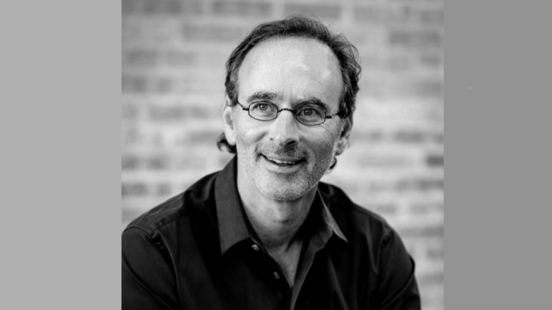](https://www.linkedin.com/pulse/copy-eric-lefkofsky-serial-entrepreneur-precision-medicine-hukkeri-qxike)](https://www.linkedin.com/pulse/copy-eric-lefkofsky-serial-entrepreneur-precision-medicine-hukkeri-qxike" \t "_self)**

**[Eric Lefkofsky: The Serial Entrepreneur Revolutionizing Precision Medicine](https://www.linkedin.com/pulse/copy-eric-lefkofsky-serial-entrepreneur-precision-medicine-hukkeri-qxike" \t "_self)**

[Girish Hukkeri](https://www.linkedin.com/pulse/copy-eric-lefkofsky-serial-entrepreneur-precision-medicine-hukkeri-qxike" \t "_self)

* 16SATISH HUKKERI and 15 others
  + 3 comments

Feed post

Published 3 months ago

**[[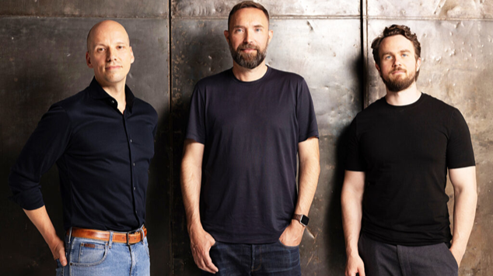](https://www.linkedin.com/pulse/helsing-trinity-architects-europes-ai-defense-girish-hukkeri-7zvqe)](https://www.linkedin.com/pulse/helsing-trinity-architects-europes-ai-defense-girish-hukkeri-7zvqe" \t "_self)**

**[The Helsing Trinity: Architects of Europe's AI Defense Revolution](https://www.linkedin.com/pulse/helsing-trinity-architects-europes-ai-defense-girish-hukkeri-7zvqe" \t "_self)**

[Girish Hukkeri](https://www.linkedin.com/pulse/helsing-trinity-architects-europes-ai-defense-girish-hukkeri-7zvqe" \t "_self)

* 14SATISH HUKKERI and 13 others
  + 1 comment

Feed post

Published 3 months ago

**[[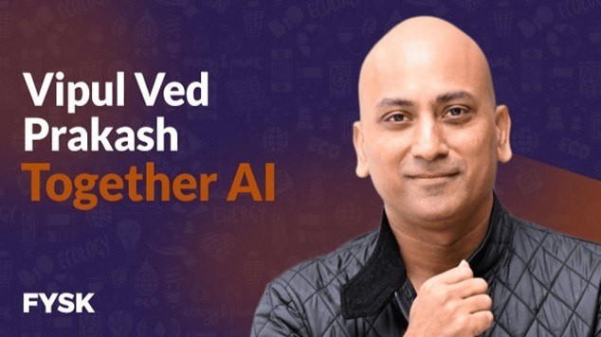](https://www.linkedin.com/pulse/visionary-duo-democratizing-ai-vipul-ved-prakash-ce-zhang-hukkeri-dfnge)](https://www.linkedin.com/pulse/visionary-duo-democratizing-ai-vipul-ved-prakash-ce-zhang-hukkeri-dfnge" \t "_self)**

**[The Visionary Duo Democratizing AI: Vipul Ved Prakash & Ce Zhang of Together AI](https://www.linkedin.com/pulse/visionary-duo-democratizing-ai-vipul-ved-prakash-ce-zhang-hukkeri-dfnge" \t "_self)**

[Girish Hukkeri](https://www.linkedin.com/pulse/visionary-duo-democratizing-ai-vipul-ved-prakash-ce-zhang-hukkeri-dfnge" \t "_self)

Feed post

Published 3 months ago

**[[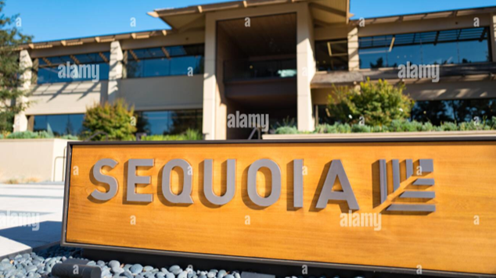](https://www.linkedin.com/pulse/venture-capital-titan-sequoia-through-lens-strategic-girish-hukkeri-n1gle)](https://www.linkedin.com/pulse/venture-capital-titan-sequoia-through-lens-strategic-girish-hukkeri-n1gle" \t "_self)**

**[The Venture Capital Titan: Sequoia Capital Through the Lens of Strategic Excellence](https://www.linkedin.com/pulse/venture-capital-titan-sequoia-through-lens-strategic-girish-hukkeri-n1gle" \t "_self)**

[Girish Hukkeri](https://www.linkedin.com/pulse/venture-capital-titan-sequoia-through-lens-strategic-girish-hukkeri-n1gle" \t "_self)

* 17Vishwanath Sangoji and 16 others
  + 11 comments

Feed post

Published 3 months ago

**[[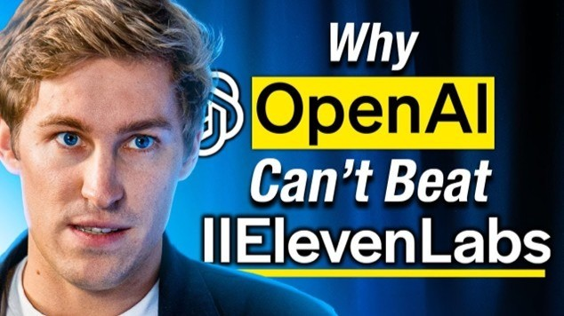](https://www.linkedin.com/pulse/voice-visionaries-mati-staniszewski-piotr-d%C4%85bkowski-ai-girish-hukkeri-rhaqe)](https://www.linkedin.com/pulse/voice-visionaries-mati-staniszewski-piotr-d%C4%85bkowski-ai-girish-hukkeri-rhaqe" \t "_self)**

**[The Voice Visionaries: Mati Staniszewski and Piotr Dąbkowski Revolutionizing AI Audio](https://www.linkedin.com/pulse/voice-visionaries-mati-staniszewski-piotr-d%C4%85bkowski-ai-girish-hukkeri-rhaqe" \t "_self)**

[Girish Hukkeri](https://www.linkedin.com/pulse/voice-visionaries-mati-staniszewski-piotr-d%C4%85bkowski-ai-girish-hukkeri-rhaqe" \t "_self)

* 1

Feed post

Published 3 months ago

**[[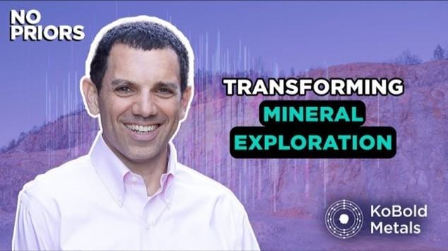](https://www.linkedin.com/pulse/visionary-leaders-revolutionizing-mineral-exploration-girish-hukkeri-fwbae)](https://www.linkedin.com/pulse/visionary-leaders-revolutionizing-mineral-exploration-girish-hukkeri-fwbae" \t "_self)**

**[The Pioneering Leaders Revolutionizing Mineral Exploration: Kurt House, Josh Goldman, and Mfikeyi Makayi of KoBold Metals](https://www.linkedin.com/pulse/visionary-leaders-revolutionizing-mineral-exploration-girish-hukkeri-fwbae" \t "_self)**

[Girish Hukkeri](https://www.linkedin.com/pulse/visionary-leaders-revolutionizing-mineral-exploration-girish-hukkeri-fwbae" \t "_self)

* 6Munir Machmud Ali and 5 others
  + 6 comments

Feed post

Published 3 months ago

**[[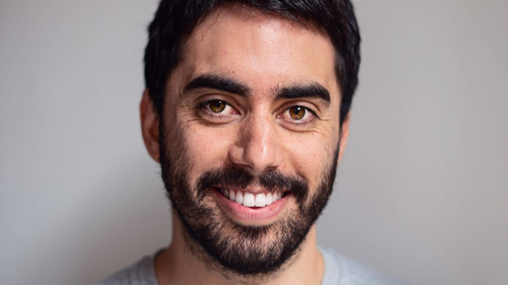](https://www.linkedin.com/pulse/visionary-trio-behind-runway-ai-revolutionizing-creative-hukkeri-buhde)](https://www.linkedin.com/pulse/visionary-trio-behind-runway-ai-revolutionizing-creative-hukkeri-buhde" \t "_self)**

**[The Visionary Trio Behind Runway AI: Revolutionizing Creative Technology Through Generative Intelligence](https://www.linkedin.com/pulse/visionary-trio-behind-runway-ai-revolutionizing-creative-hukkeri-buhde" \t "_self)**

[Girish Hukkeri](https://www.linkedin.com/pulse/visionary-trio-behind-runway-ai-revolutionizing-creative-hukkeri-buhde" \t "_self)

* 4CHENDU S and 3 others
  + 2 comments

Feed post

Published 3 months ago

**[[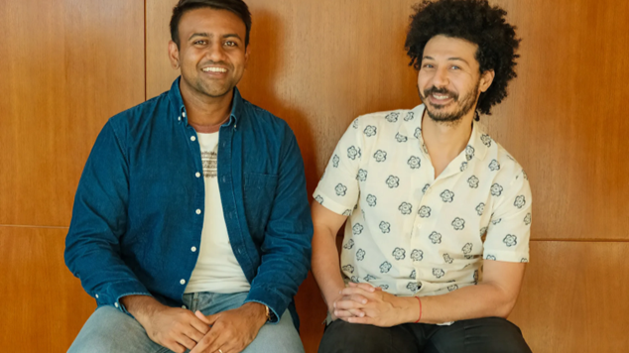](https://www.linkedin.com/pulse/kareem-amin-varun-anand-visionary-duo-revolutionizing-girish-hukkeri-eraoe)](https://www.linkedin.com/pulse/kareem-amin-varun-anand-visionary-duo-revolutionizing-girish-hukkeri-eraoe" \t "_self)**

**[Kareem Amin & Varun Anand: The Visionary Duo Revolutionizing Go-to-Market with Clay AI](https://www.linkedin.com/pulse/kareem-amin-varun-anand-visionary-duo-revolutionizing-girish-hukkeri-eraoe" \t "_self)**

[Girish Hukkeri](https://www.linkedin.com/pulse/kareem-amin-varun-anand-visionary-duo-revolutionizing-girish-hukkeri-eraoe" \t "_self)

* 8SATISH HUKKERI and 7 others
  + 8 comments

Feed post

Published 3 months ago

**[[](https://www.linkedin.com/pulse/matt-zeiler-visionary-behind-clarifais-ai-revolution-girish-hukkeri-c6mje)](https://www.linkedin.com/pulse/matt-zeiler-visionary-behind-clarifais-ai-revolution-girish-hukkeri-c6mje" \t "_self)**

**[Matt Zeiler: The Visionary Behind Clarifai's AI Revolution](https://www.linkedin.com/pulse/matt-zeiler-visionary-behind-clarifais-ai-revolution-girish-hukkeri-c6mje" \t "_self)**

[Girish Hukkeri](https://www.linkedin.com/pulse/matt-zeiler-visionary-behind-clarifais-ai-revolution-girish-hukkeri-c6mje" \t "_self)

* 2MyongHak Jung and 1 other
  + 1 comment

Feed post

Published 3 months ago

**[[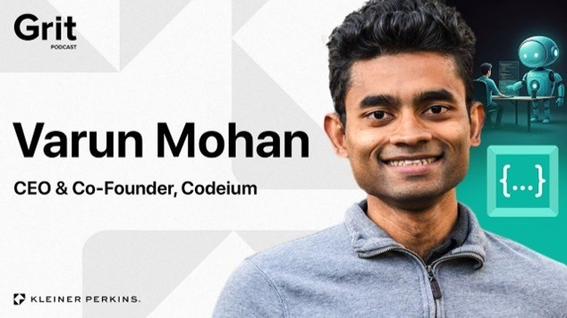](https://www.linkedin.com/pulse/visionary-duo-varun-mohan-douglas-chens-journey-ai-coding-hukkeri-ymdxe)](https://www.linkedin.com/pulse/visionary-duo-varun-mohan-douglas-chens-journey-ai-coding-hukkeri-ymdxe" \t "_self)**

**[The Visionary Duo: Varun Mohan and Douglas Chen's Journey to AI Coding Supremacy](https://www.linkedin.com/pulse/visionary-duo-varun-mohan-douglas-chens-journey-ai-coding-hukkeri-ymdxe" \t "_self)**

[Girish Hukkeri](https://www.linkedin.com/pulse/visionary-duo-varun-mohan-douglas-chens-journey-ai-coding-hukkeri-ymdxe" \t "_self)

* 2✡︎ Elazar Lebedev and 1 other

Feed post

Published 3 months ago

**[[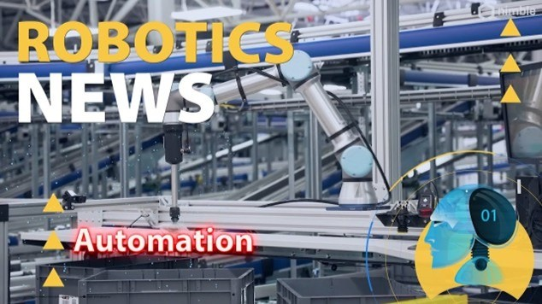](https://www.linkedin.com/pulse/vision-ingenuity-industry-simon-kalouche-nimble-story-girish-hukkeri-33gie)](https://www.linkedin.com/pulse/vision-ingenuity-industry-simon-kalouche-nimble-story-girish-hukkeri-33gie" \t "_self)**

**[Vision, Ingenuity, and Industry: The Simon Kalouche & Nimble Story](https://www.linkedin.com/pulse/vision-ingenuity-industry-simon-kalouche-nimble-story-girish-hukkeri-33gie" \t "_self)**

[Girish Hukkeri](https://www.linkedin.com/pulse/vision-ingenuity-industry-simon-kalouche-nimble-story-girish-hukkeri-33gie" \t "_self)

* 4CHENDU S and 3 others
  + 1 comment

Feed post

Published 3 months ago

**[[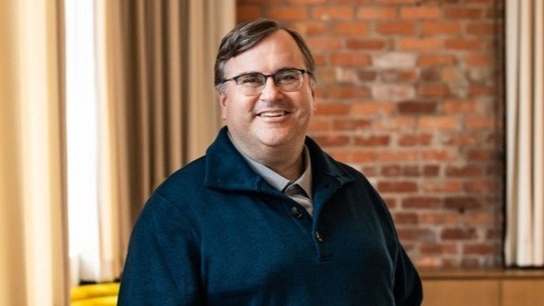](https://www.linkedin.com/pulse/trinity-innovation-mustafa-suleyman-kar%C3%A9n-simonyan-reid-hukkeri-9bvre)](https://www.linkedin.com/pulse/trinity-innovation-mustafa-suleyman-kar%C3%A9n-simonyan-reid-hukkeri-9bvre" \t "_self)**

**[The Trinity of Innovation: Mustafa Suleyman, Karén Simonyan, and Reid Hoffman's Journey Through AI's Next Frontier](https://www.linkedin.com/pulse/trinity-innovation-mustafa-suleyman-kar%C3%A9n-simonyan-reid-hukkeri-9bvre" \t "_self)**

[Girish Hukkeri](https://www.linkedin.com/pulse/trinity-innovation-mustafa-suleyman-kar%C3%A9n-simonyan-reid-hukkeri-9bvre" \t "_self)

* 1
  + 4 comments

Feed post

Published 3 months ago

**[[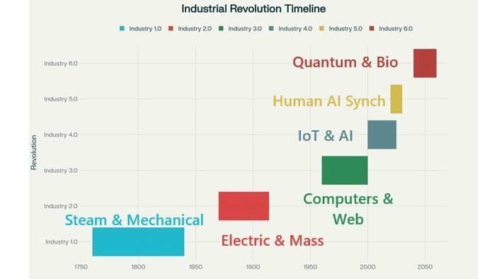](https://www.linkedin.com/pulse/evolution-industry-from-steam-power-quantum-girish-hukkeri-hpxie)](https://www.linkedin.com/pulse/evolution-industry-from-steam-power-quantum-girish-hukkeri-hpxie" \t "_self)**

**[The Evolution of Industry: From Steam Power to Quantum Intelligence](https://www.linkedin.com/pulse/evolution-industry-from-steam-power-quantum-girish-hukkeri-hpxie" \t "_self)**

[Girish Hukkeri](https://www.linkedin.com/pulse/evolution-industry-from-steam-power-quantum-girish-hukkeri-hpxie" \t "_self)

* 1
  + 1 comment

Feed post

Published 3 months ago

**[[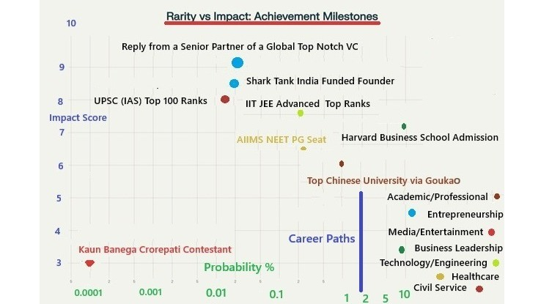](https://www.linkedin.com/pulse/when-tier-1-vc-validation-becomes-ecosystem-fuel-girish-hukkeri-dtzme)](https://www.linkedin.com/pulse/when-tier-1-vc-validation-becomes-ecosystem-fuel-girish-hukkeri-dtzme" \t "_self)**

**[When Tier-1 VC Validation Becomes Ecosystem Fuel](https://www.linkedin.com/pulse/when-tier-1-vc-validation-becomes-ecosystem-fuel-girish-hukkeri-dtzme" \t "_self)**

[Girish Hukkeri](https://www.linkedin.com/pulse/when-tier-1-vc-validation-becomes-ecosystem-fuel-girish-hukkeri-dtzme" \t "_self)

* 3SATISH HUKKERI and 2 others
  + 1 comment

Feed post

Published 3 months ago

**[[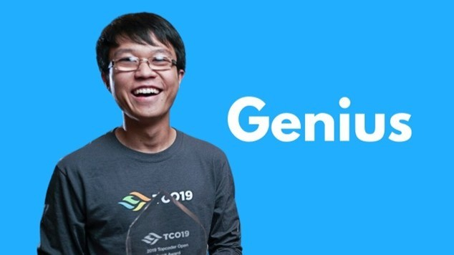](https://www.linkedin.com/pulse/scott-wu-mathematical-prodigy-revolutionizing-ai-software-hukkeri-rsefe)](https://www.linkedin.com/pulse/scott-wu-mathematical-prodigy-revolutionizing-ai-software-hukkeri-rsefe" \t "_self)**

**[Scott Wu: The Mathematical Prodigy Revolutionizing AI Software Engineering](https://www.linkedin.com/pulse/scott-wu-mathematical-prodigy-revolutionizing-ai-software-hukkeri-rsefe" \t "_self)**

[Girish Hukkeri](https://www.linkedin.com/pulse/scott-wu-mathematical-prodigy-revolutionizing-ai-software-hukkeri-rsefe" \t "_self)

* 11SATISH HUKKERI and 10 others
  + 5 comments

Feed post

Published 3 months ago

**[[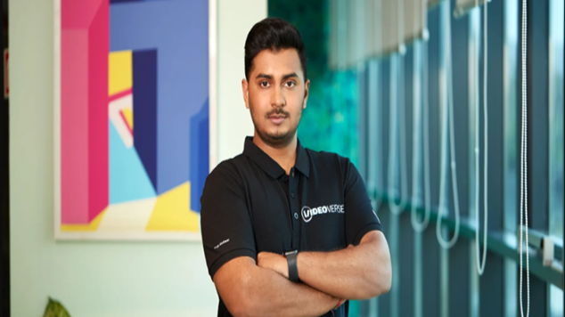](https://www.linkedin.com/pulse/videoverse-visionaries-transforming-ai-powered-video-girish-hukkeri-wrehe)](https://www.linkedin.com/pulse/videoverse-visionaries-transforming-ai-powered-video-girish-hukkeri-wrehe" \t "_self)**

**[The VideoVerse Visionaries: Transforming AI-Powered Video Technology](https://www.linkedin.com/pulse/videoverse-visionaries-transforming-ai-powered-video-girish-hukkeri-wrehe" \t "_self)**

[Girish Hukkeri](https://www.linkedin.com/pulse/videoverse-visionaries-transforming-ai-powered-video-girish-hukkeri-wrehe" \t "_self)

* 8Gaurav Tripathi and 7 others
  + 5 comments

Feed post

Published 3 months ago

**[[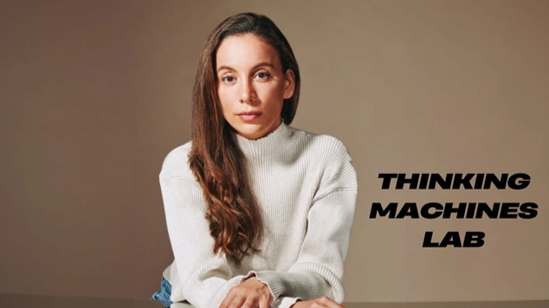](https://www.linkedin.com/pulse/mira-murati-thinking-machines-lab-pioneering-frontier-girish-hukkeri-dksne)](https://www.linkedin.com/pulse/mira-murati-thinking-machines-lab-pioneering-frontier-girish-hukkeri-dksne" \t "_self)**

**[Mira Murati and Thinking Machines Lab: Pioneering Human-Centric Frontier AI](https://www.linkedin.com/pulse/mira-murati-thinking-machines-lab-pioneering-frontier-girish-hukkeri-dksne" \t "_self)**

[Girish Hukkeri](https://www.linkedin.com/pulse/mira-murati-thinking-machines-lab-pioneering-frontier-girish-hukkeri-dksne" \t "_self)

* 193SATISH HUKKERI and 192 others
  + 74 comments

Feed post

Published 3 months ago

**[[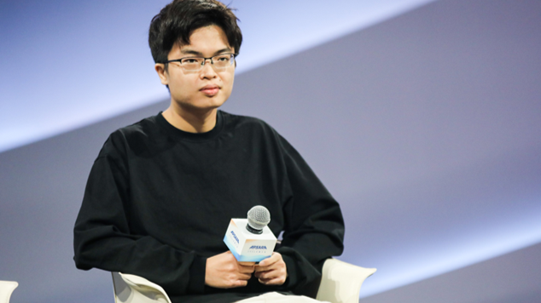](https://www.linkedin.com/pulse/moonshot-visionary-yang-zhilin-pioneering-chinas-ai-girish-hukkeri-nodhe)](https://www.linkedin.com/pulse/moonshot-visionary-yang-zhilin-pioneering-chinas-ai-girish-hukkeri-nodhe" \t "_self)**

**[The Moonshot Visionary: Yang Zhilin - Pioneering China's AI Renaissance](https://www.linkedin.com/pulse/moonshot-visionary-yang-zhilin-pioneering-chinas-ai-girish-hukkeri-nodhe" \t "_self)**

[Girish Hukkeri](https://www.linkedin.com/pulse/moonshot-visionary-yang-zhilin-pioneering-chinas-ai-girish-hukkeri-nodhe" \t "_self)

* 4CHENDU S and 3 others

Feed post

Published 3 months ago

**[[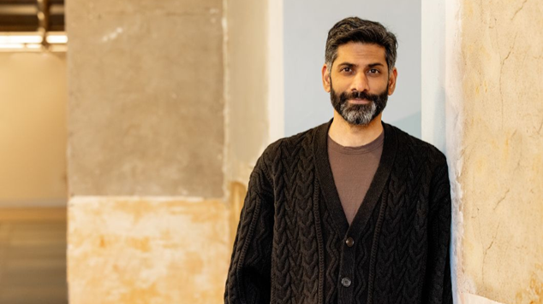](https://www.linkedin.com/pulse/dr-shiv-rao-cardiologist-ceo-transforming-healthcare-ai-hukkeri-c59fe)](https://www.linkedin.com/pulse/dr-shiv-rao-cardiologist-ceo-transforming-healthcare-ai-hukkeri-c59fe" \t "_self)**

**[Dr. Shiv Rao: The Cardiologist-CEO Transforming Healthcare with AI](https://www.linkedin.com/pulse/dr-shiv-rao-cardiologist-ceo-transforming-healthcare-ai-hukkeri-c59fe" \t "_self)**

[Girish Hukkeri](https://www.linkedin.com/pulse/dr-shiv-rao-cardiologist-ceo-transforming-healthcare-ai-hukkeri-c59fe" \t "_self)

* 1

Feed post

Published 3 months ago

**[[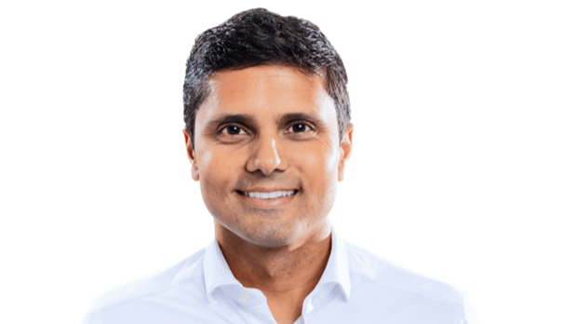](https://www.linkedin.com/pulse/moveworks-quartet-how-4-visionaries-built-285-billion-girish-hukkeri-hqpee)](https://www.linkedin.com/pulse/moveworks-quartet-how-4-visionaries-built-285-billion-girish-hukkeri-hqpee" \t "_self)**

**[The Moveworks Quartet: How 4 Visionaries Built a $2.85 Billion AI Empire](https://www.linkedin.com/pulse/moveworks-quartet-how-4-visionaries-built-285-billion-girish-hukkeri-hqpee" \t "_self)**

[Girish Hukkeri](https://www.linkedin.com/pulse/moveworks-quartet-how-4-visionaries-built-285-billion-girish-hukkeri-hqpee" \t "_self)

* 1
  + 2 comments

Feed post

Published 3 months ago

**[[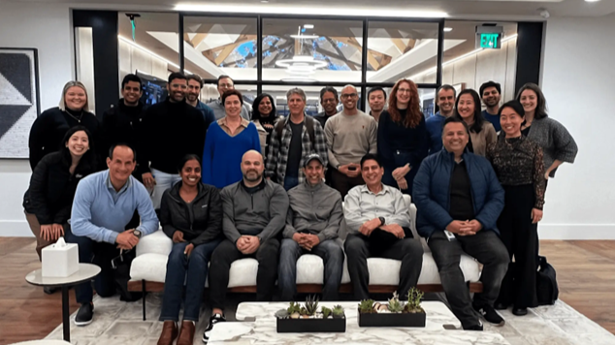](https://www.linkedin.com/pulse/glean-quartet-visionary-leadership-transforming-ai-girish-hukkeri-66ose)](https://www.linkedin.com/pulse/glean-quartet-visionary-leadership-transforming-ai-girish-hukkeri-66ose" \t "_self)**

**[The Glean Quartet: Visionary Leadership Transforming Enterprise AI](https://www.linkedin.com/pulse/glean-quartet-visionary-leadership-transforming-ai-girish-hukkeri-66ose" \t "_self)**

[Girish Hukkeri](https://www.linkedin.com/pulse/glean-quartet-visionary-leadership-transforming-ai-girish-hukkeri-66ose" \t "_self)

* 5SATISH HUKKERI and 4 others
  + 3 comments

Feed post

Published 3 months ago

**[[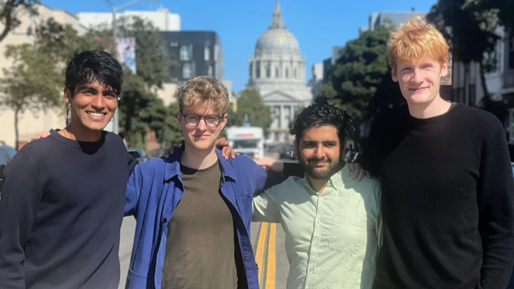](https://www.linkedin.com/pulse/visionary-quartet-behind-cursor-ai-girish-hukkeri-3pwze)](https://www.linkedin.com/pulse/visionary-quartet-behind-cursor-ai-girish-hukkeri-3pwze" \t "_self)**

**[The Visionary Quartet Behind Cursor AI](https://www.linkedin.com/pulse/visionary-quartet-behind-cursor-ai-girish-hukkeri-3pwze" \t "_self)**

[Girish Hukkeri](https://www.linkedin.com/pulse/visionary-quartet-behind-cursor-ai-girish-hukkeri-3pwze" \t "_self)

* 16Pratibha Bhadranavar and 15 others
  + 7 comments

Feed post

Published 3 months ago

**[[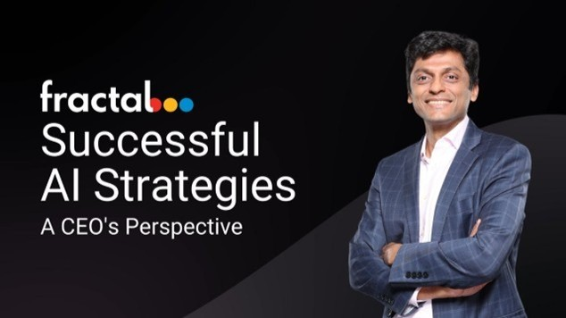](https://www.linkedin.com/pulse/from-mathematics-market-mastery-fractal-analytics-trinity-hukkeri-jbxce)](https://www.linkedin.com/pulse/from-mathematics-market-mastery-fractal-analytics-trinity-hukkeri-jbxce" \t "_self)**

**[From Mathematics to Market Mastery: The Fractal Analytics Trinity](https://www.linkedin.com/pulse/from-mathematics-market-mastery-fractal-analytics-trinity-hukkeri-jbxce" \t "_self)**

[Girish Hukkeri](https://www.linkedin.com/pulse/from-mathematics-market-mastery-fractal-analytics-trinity-hukkeri-jbxce" \t "_self)

* 2Amit Shukla and 1 other
  + 6 comments

Feed post

Published 3 months ago

**[[](https://www.linkedin.com/pulse/grammarly-triumvirate-how-three-ukrainian-visionaries-girish-hukkeri-lwofe)](https://www.linkedin.com/pulse/grammarly-triumvirate-how-three-ukrainian-visionaries-girish-hukkeri-lwofe" \t "_self)**

**[The Grammarly Triumvirate: How Three Ukrainian Visionaries Built a $13 Billion AI Empire](https://www.linkedin.com/pulse/grammarly-triumvirate-how-three-ukrainian-visionaries-girish-hukkeri-lwofe" \t "_self)**

[Girish Hukkeri](https://www.linkedin.com/pulse/grammarly-triumvirate-how-three-ukrainian-visionaries-girish-hukkeri-lwofe" \t "_self)

* 3
  + 9 comments

Feed post

Published 3 months ago

**[[](https://www.linkedin.com/pulse/tim-schumacher-domain-visionary-who-became-europes-climate-hukkeri-agwge)](https://www.linkedin.com/pulse/tim-schumacher-domain-visionary-who-became-europes-climate-hukkeri-agwge" \t "_self)**

**[Tim Schumacher: The Domain Visionary Who Became Europe's Climate Tech Champion](https://www.linkedin.com/pulse/tim-schumacher-domain-visionary-who-became-europes-climate-hukkeri-agwge" \t "_self)**

[Girish Hukkeri](https://www.linkedin.com/pulse/tim-schumacher-domain-visionary-who-became-europes-climate-hukkeri-agwge" \t "_self)

* 2
  + 2 comments

Feed post

Published 3 months ago

**[[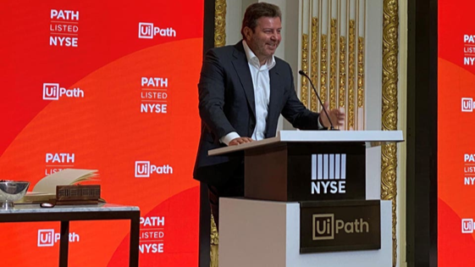](https://www.linkedin.com/pulse/automation-architects-how-daniel-dines-marius-t%C3%AErc%C4%83-rahul-hukkeri-80uae)](https://www.linkedin.com/pulse/automation-architects-how-daniel-dines-marius-t%C3%AErc%C4%83-rahul-hukkeri-80uae" \t "_self)**

**[The Automation Architects: How Daniel Dines, Marius Tîrcă & Rahul Sood Built UiPath's $36 Billion Empire](https://www.linkedin.com/pulse/automation-architects-how-daniel-dines-marius-t%C3%AErc%C4%83-rahul-hukkeri-80uae" \t "_self)**

[Girish Hukkeri](https://www.linkedin.com/pulse/automation-architects-how-daniel-dines-marius-t%C3%AErc%C4%83-rahul-hukkeri-80uae" \t "_self)

* 3
  + 6 comments

Feed post

Published 3 months ago

**[[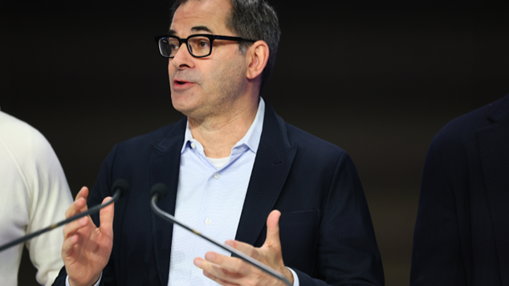](https://www.linkedin.com/pulse/meteoric-rise-michael-intrator-from-wall-street-trader-girish-hukkeri-z3ule)](https://www.linkedin.com/pulse/meteoric-rise-michael-intrator-from-wall-street-trader-girish-hukkeri-z3ule" \t "_self)**

**[The Meteoric Rise of Michael Intrator: From Wall Street Trader to AI Empire Builder](https://www.linkedin.com/pulse/meteoric-rise-michael-intrator-from-wall-street-trader-girish-hukkeri-z3ule" \t "_self)**

[Girish Hukkeri](https://www.linkedin.com/pulse/meteoric-rise-michael-intrator-from-wall-street-trader-girish-hukkeri-z3ule" \t "_self)

* 1
  + 3 comments

Feed post

Published 3 months ago

**[[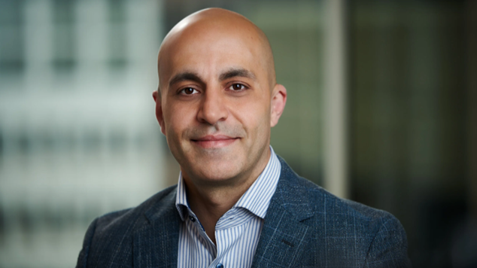](https://www.linkedin.com/pulse/professional-portrait-ali-ghodsi-ceo-databricks-suitable-hukkeri-zibue)](https://www.linkedin.com/pulse/professional-portrait-ali-ghodsi-ceo-databricks-suitable-hukkeri-zibue" \t "_self)**

**[The Visionary Behind the $100+ Billion Data Revolution](https://www.linkedin.com/pulse/professional-portrait-ali-ghodsi-ceo-databricks-suitable-hukkeri-zibue" \t "_self)**

[Girish Hukkeri](https://www.linkedin.com/pulse/professional-portrait-ali-ghodsi-ceo-databricks-suitable-hukkeri-zibue" \t "_self)

* 3Datta Ghadge and 2 others
  + 4 comments

Feed post

Published 3 months ago

**[[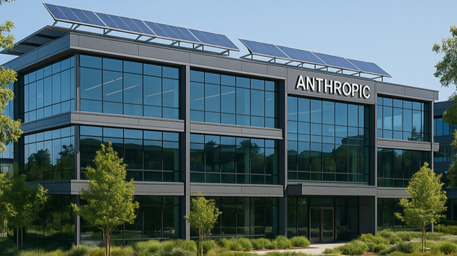](https://www.linkedin.com/pulse/amodei-siblings-transforming-ai-through-innovation-girish-hukkeri-shmse)](https://www.linkedin.com/pulse/amodei-siblings-transforming-ai-through-innovation-girish-hukkeri-shmse" \t "_self)**

**[The Amodei Siblings: Transforming AI Through Constitutional Innovation](https://www.linkedin.com/pulse/amodei-siblings-transforming-ai-through-innovation-girish-hukkeri-shmse" \t "_self)**

[Girish Hukkeri](https://www.linkedin.com/pulse/amodei-siblings-transforming-ai-through-innovation-girish-hukkeri-shmse" \t "_self)

* 5
  + 7 comments

Feed post

Published 3 months ago

**[[](https://www.linkedin.com/pulse/visionary-who-democratized-design-melanie-perkins-journey-hukkeri-ub6be)](https://www.linkedin.com/pulse/visionary-who-democratized-design-melanie-perkins-journey-hukkeri-ub6be" \t "_self)**

**[The Visionary Who Democratized Design: Melanie Perkins' Extraordinary Journey](https://www.linkedin.com/pulse/visionary-who-democratized-design-melanie-perkins-journey-hukkeri-ub6be" \t "_self)**

[Girish Hukkeri](https://www.linkedin.com/pulse/visionary-who-democratized-design-melanie-perkins-journey-hukkeri-ub6be" \t "_self)

* 4
  + 5 comments

Feed post

Published 3 months ago

**[[](https://www.linkedin.com/pulse/liang-wenfeng-maverick-who-disrupted-ai-deepseek-girish-hukkeri-krdoe)](https://www.linkedin.com/pulse/liang-wenfeng-maverick-who-disrupted-ai-deepseek-girish-hukkeri-krdoe" \t "_self)**

**[Liang Wenfeng: The Maverick Who Disrupted AI with DeepSeek](https://www.linkedin.com/pulse/liang-wenfeng-maverick-who-disrupted-ai-deepseek-girish-hukkeri-krdoe" \t "_self)**

[Girish Hukkeri](https://www.linkedin.com/pulse/liang-wenfeng-maverick-who-disrupted-ai-deepseek-girish-hukkeri-krdoe" \t "_self)

* 4Gaurav Tripathi and 3 others
  + 3 comments

Feed post

Published 3 months ago

**[[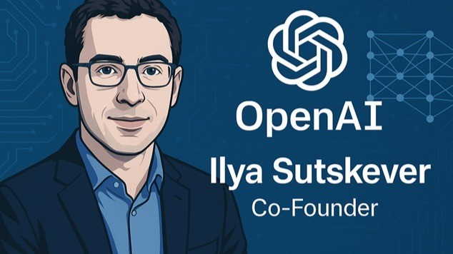](https://www.linkedin.com/pulse/ilya-sutskever-neural-network-visionary-who-ai-girish-hukkeri-tcjye)](https://www.linkedin.com/pulse/ilya-sutskever-neural-network-visionary-who-ai-girish-hukkeri-tcjye" \t "_self)**

**[Ilya Sutskever: The Neural Network Visionary Who Architected the AI Revolution](https://www.linkedin.com/pulse/ilya-sutskever-neural-network-visionary-who-ai-girish-hukkeri-tcjye" \t "_self)**

[Girish Hukkeri](https://www.linkedin.com/pulse/ilya-sutskever-neural-network-visionary-who-ai-girish-hukkeri-tcjye" \t "_self)

* 8Pathan Sumer Khan and 7 others
  + 6 comments

Feed post

Published 3 months ago

**[[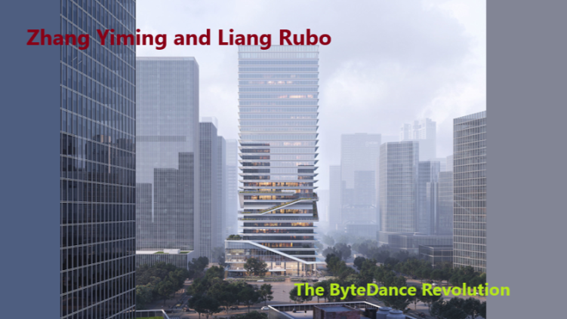](https://www.linkedin.com/pulse/zhang-yiming-liang-rubo-bytedance-revolution-girish-hukkeri-deiae)](https://www.linkedin.com/pulse/zhang-yiming-liang-rubo-bytedance-revolution-girish-hukkeri-deiae" \t "_self)**

**[Zhang Yiming and Liang Rubo: The ByteDance Revolution](https://www.linkedin.com/pulse/zhang-yiming-liang-rubo-bytedance-revolution-girish-hukkeri-deiae" \t "_self)**

[Girish Hukkeri](https://www.linkedin.com/pulse/zhang-yiming-liang-rubo-bytedance-revolution-girish-hukkeri-deiae" \t "_self)

* 5
  + 4 comments

Feed post

Published 3 months ago

**[[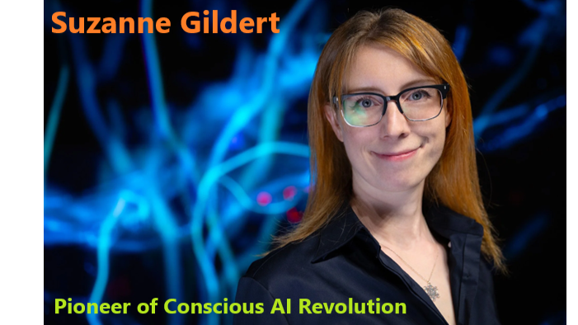](https://www.linkedin.com/pulse/suzanne-gildert-pioneer-conscious-ai-revolution-girish-hukkeri-r6vfe)](https://www.linkedin.com/pulse/suzanne-gildert-pioneer-conscious-ai-revolution-girish-hukkeri-r6vfe" \t "_self)**

**[Suzanne Gildert: Pioneer of Conscious AI Revolution](https://www.linkedin.com/pulse/suzanne-gildert-pioneer-conscious-ai-revolution-girish-hukkeri-r6vfe" \t "_self)**

[Girish Hukkeri](https://www.linkedin.com/pulse/suzanne-gildert-pioneer-conscious-ai-revolution-girish-hukkeri-r6vfe" \t "_self)

* 7Munir Machmud Ali and 6 others
  + 3 comments

Feed post

Published 3 months ago

**[[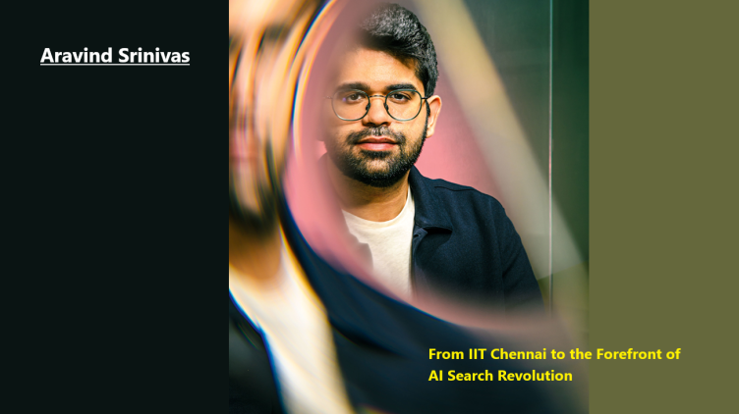](https://www.linkedin.com/pulse/aravind-srinivas-from-iit-chennai-forefront-ai-search-girish-hukkeri-otiwe)](https://www.linkedin.com/pulse/aravind-srinivas-from-iit-chennai-forefront-ai-search-girish-hukkeri-otiwe" \t "_self)**

**[Aravind Srinivas: From IIT Chennai to the Forefront of AI Search Revolution](https://www.linkedin.com/pulse/aravind-srinivas-from-iit-chennai-forefront-ai-search-girish-hukkeri-otiwe" \t "_self)**

[Girish Hukkeri](https://www.linkedin.com/pulse/aravind-srinivas-from-iit-chennai-forefront-ai-search-girish-hukkeri-otiwe" \t "_self)

* 6
  + 1 comment

Feed post

Published 3 months ago

**[[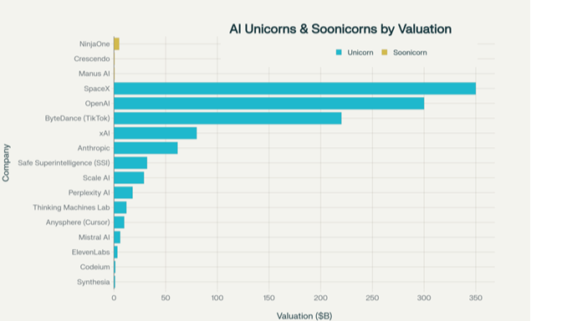](https://www.linkedin.com/pulse/ai-unicorns-soonicorns-11-trillion-revolution-global-business-girish-jvcne)](https://www.linkedin.com/pulse/ai-unicorns-soonicorns-11-trillion-revolution-global-business-girish-jvcne" \t "_self)**

**[AI Unicorns & Soonicorns: The $1.1 Trillion AI Revolution Reshaping Global Business](https://www.linkedin.com/pulse/ai-unicorns-soonicorns-11-trillion-revolution-global-business-girish-jvcne" \t "_self)**

[Girish Hukkeri](https://www.linkedin.com/pulse/ai-unicorns-soonicorns-11-trillion-revolution-global-business-girish-jvcne" \t "_self)

* 2
  + 1 comment

Feed post

Published 3 months ago

**[[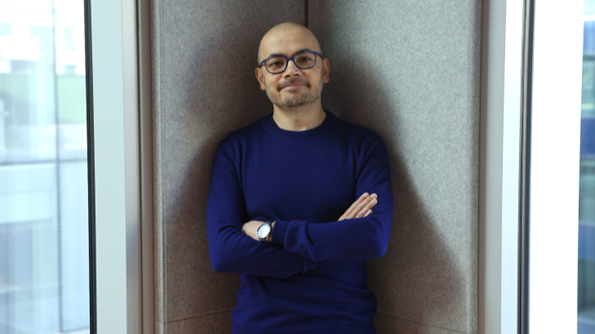](https://www.linkedin.com/pulse/demis-hassabis-from-chess-prodigy-nobel-laureate-girish-hukkeri-1rdpe)](https://www.linkedin.com/pulse/demis-hassabis-from-chess-prodigy-nobel-laureate-girish-hukkeri-1rdpe" \t "_self)**

**[Demis Hassabis: From Chess Prodigy to Nobel Laureate](https://www.linkedin.com/pulse/demis-hassabis-from-chess-prodigy-nobel-laureate-girish-hukkeri-1rdpe" \t "_self)**

[Girish Hukkeri](https://www.linkedin.com/pulse/demis-hassabis-from-chess-prodigy-nobel-laureate-girish-hukkeri-1rdpe" \t "_self)

* 13Munir Machmud Ali and 12 others
  + 6 comments

Feed post

Published 3 months ago

**[[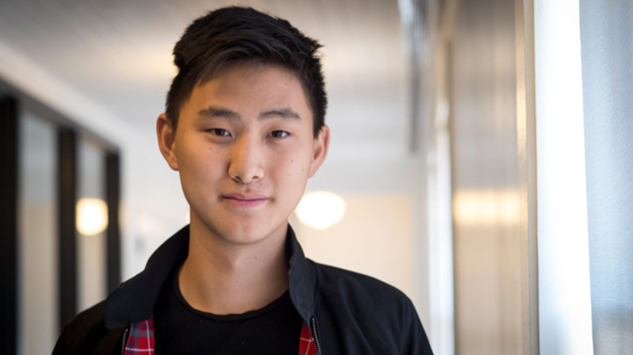](https://www.linkedin.com/pulse/alexandr-wang-from-math-prodigy-metas-ai-visionary-girish-hukkeri-wyooe)](https://www.linkedin.com/pulse/alexandr-wang-from-math-prodigy-metas-ai-visionary-girish-hukkeri-wyooe" \t "_self)**

**[Alexandr Wang: From Math Prodigy to Meta's AI Visionary](https://www.linkedin.com/pulse/alexandr-wang-from-math-prodigy-metas-ai-visionary-girish-hukkeri-wyooe" \t "_self)**

[Girish Hukkeri](https://www.linkedin.com/pulse/alexandr-wang-from-math-prodigy-metas-ai-visionary-girish-hukkeri-wyooe" \t "_self)

* 4
  + 5 comments

Feed post

Published 4 months ago

**[[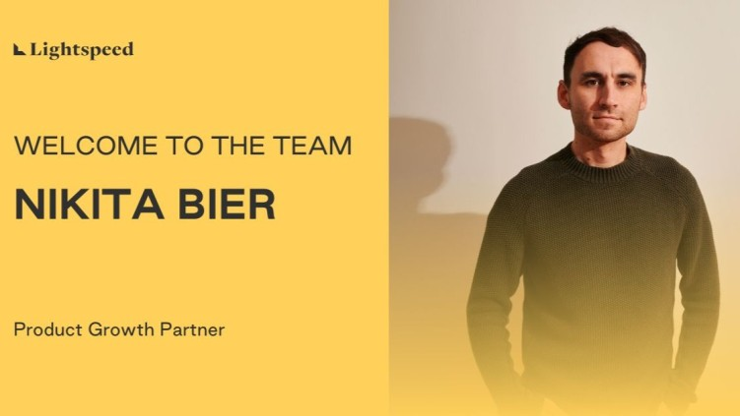](https://www.linkedin.com/pulse/nikita-bier-master-viral-app-creation-future-growth-girish-hukkeri-kdhhe)](https://www.linkedin.com/pulse/nikita-bier-master-viral-app-creation-future-growth-girish-hukkeri-kdhhe" \t "_self)**

**[Nikita Bier: The Master of Viral App Creation and the Future of Growth](https://www.linkedin.com/pulse/nikita-bier-master-viral-app-creation-future-growth-girish-hukkeri-kdhhe" \t "_self)**

[Girish Hukkeri](https://www.linkedin.com/pulse/nikita-bier-master-viral-app-creation-future-growth-girish-hukkeri-kdhhe" \t "_self)

* 4
  + 2 comments

Feed post

Published 4 months ago

**[[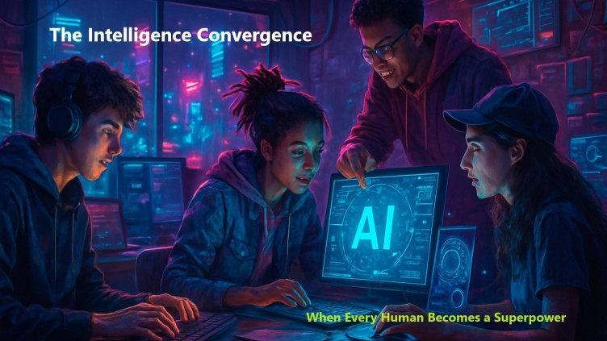](https://www.linkedin.com/pulse/intelligence-convergence-when-every-human-becomes-girish-hukkeri-sef7e)](https://www.linkedin.com/pulse/intelligence-convergence-when-every-human-becomes-girish-hukkeri-sef7e" \t "_self)**

**[The Intelligence Convergence: When Every Human Becomes a Superpower](https://www.linkedin.com/pulse/intelligence-convergence-when-every-human-becomes-girish-hukkeri-sef7e" \t "_self)**

[Girish Hukkeri](https://www.linkedin.com/pulse/intelligence-convergence-when-every-human-becomes-girish-hukkeri-sef7e" \t "_self)

* 3
  + 6 comments

Feed post

Published 4 months ago

**[[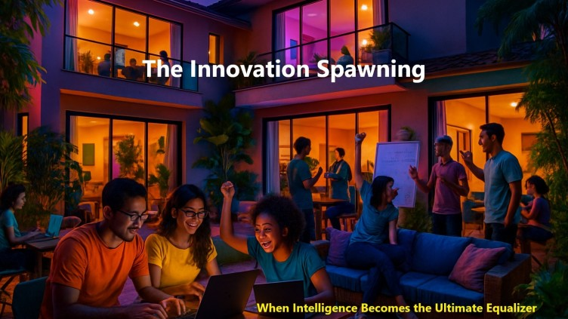](https://www.linkedin.com/pulse/innovation-spawning-girish-hukkeri-tefve)](https://www.linkedin.com/pulse/innovation-spawning-girish-hukkeri-tefve" \t "_self)**

**[The Innovation Spawning](https://www.linkedin.com/pulse/innovation-spawning-girish-hukkeri-tefve" \t "_self)**

[Girish Hukkeri](https://www.linkedin.com/pulse/innovation-spawning-girish-hukkeri-tefve" \t "_self)

* 2
  + 1 comment

Feed post

Published 4 months ago

**[[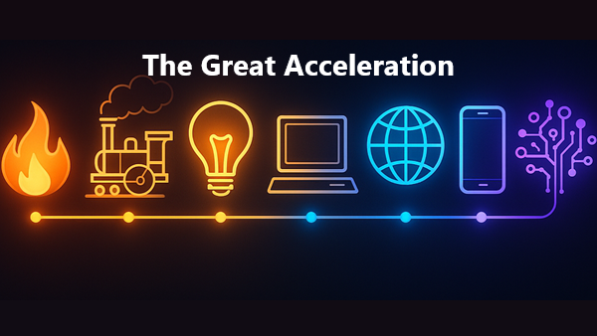](https://www.linkedin.com/pulse/great-acceleration-girish-hukkeri-islce)](https://www.linkedin.com/pulse/great-acceleration-girish-hukkeri-islce" \t "_self)**

**[The Great Acceleration](https://www.linkedin.com/pulse/great-acceleration-girish-hukkeri-islce" \t "_self)**

[Girish Hukkeri](https://www.linkedin.com/pulse/great-acceleration-girish-hukkeri-islce" \t "_self)

* 5Zouhir Alichane and 4 others
  + 6 comments

Feed post

Published 4 months ago

**[[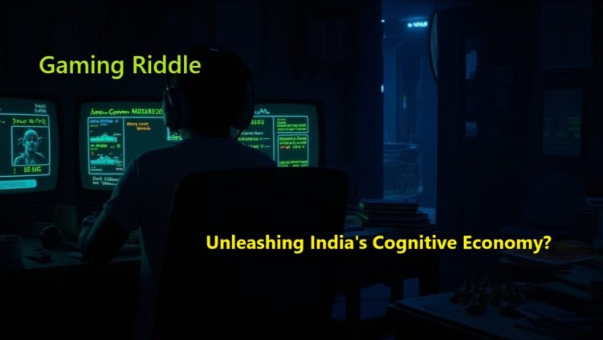](https://www.linkedin.com/pulse/gaming-riddle-unleashing-indias-cognitive-economy-girish-hukkeri-fysye)](https://www.linkedin.com/pulse/gaming-riddle-unleashing-indias-cognitive-economy-girish-hukkeri-fysye" \t "_self)**

**[Gaming Riddle: Unleashing India's Cognitive Economy?](https://www.linkedin.com/pulse/gaming-riddle-unleashing-indias-cognitive-economy-girish-hukkeri-fysye" \t "_self)**

[Girish Hukkeri](https://www.linkedin.com/pulse/gaming-riddle-unleashing-indias-cognitive-economy-girish-hukkeri-fysye" \t "_self)

* 2
  + 3 comments

Feed post

Published 4 months ago

**[[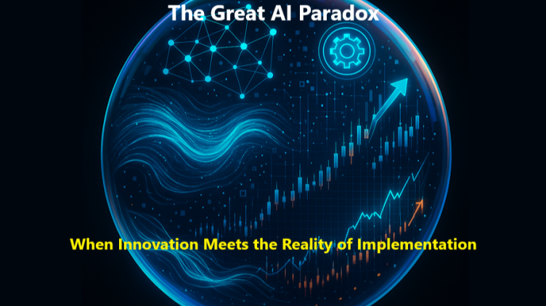](https://www.linkedin.com/pulse/great-ai-paradox-when-innovation-meets-reality-girish-hukkeri-ohz5e)](https://www.linkedin.com/pulse/great-ai-paradox-when-innovation-meets-reality-girish-hukkeri-ohz5e" \t "_self)**

**[The Great AI Paradox: When Innovation Meets the Reality of Implementation](https://www.linkedin.com/pulse/great-ai-paradox-when-innovation-meets-reality-girish-hukkeri-ohz5e" \t "_self)**

[Girish Hukkeri](https://www.linkedin.com/pulse/great-ai-paradox-when-innovation-meets-reality-girish-hukkeri-ohz5e" \t "_self)

* 1
  + 3 comments

Feed post

Published 4 months ago

**[[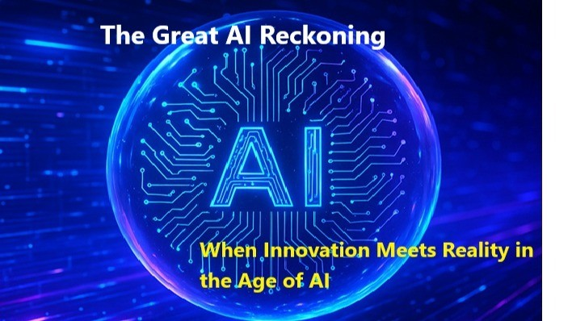](https://www.linkedin.com/pulse/great-ai-reckoning-when-innovation-meets-reality-age-girish-hukkeri-m8y6e)](https://www.linkedin.com/pulse/great-ai-reckoning-when-innovation-meets-reality-age-girish-hukkeri-m8y6e" \t "_self)**

**[The Great AI Reckoning: When Innovation Meets Reality in the Age of AI](https://www.linkedin.com/pulse/great-ai-reckoning-when-innovation-meets-reality-age-girish-hukkeri-m8y6e" \t "_self)**

[Girish Hukkeri](https://www.linkedin.com/pulse/great-ai-reckoning-when-innovation-meets-reality-age-girish-hukkeri-m8y6e" \t "_self)

Feed post

Published 4 months ago

**[[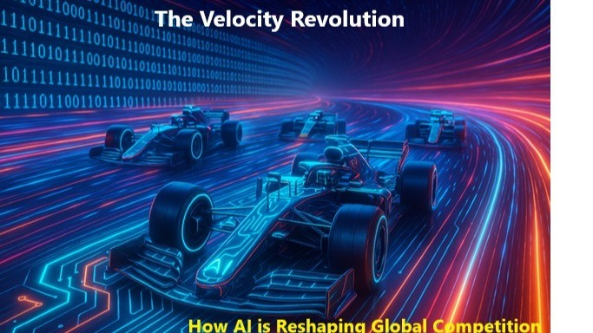](https://www.linkedin.com/pulse/velocity-revolution-how-ai-reshaping-global-girish-hukkeri-7qzhe)](https://www.linkedin.com/pulse/velocity-revolution-how-ai-reshaping-global-girish-hukkeri-7qzhe" \t "_self)**

**[The Velocity Revolution: How AI is Reshaping Global Competition](https://www.linkedin.com/pulse/velocity-revolution-how-ai-reshaping-global-girish-hukkeri-7qzhe" \t "_self)**

[Girish Hukkeri](https://www.linkedin.com/pulse/velocity-revolution-how-ai-reshaping-global-girish-hukkeri-7qzhe" \t "_self)

Feed post

Published 4 months ago

**[[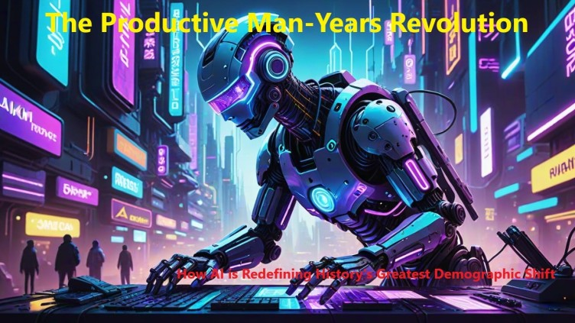](https://www.linkedin.com/pulse/productive-man-years-revolution-how-ai-redefining-historys-hukkeri-945ye)](https://www.linkedin.com/pulse/productive-man-years-revolution-how-ai-redefining-historys-hukkeri-945ye" \t "_self)**

**[The Productive Man-Years Revolution: How AI is Redefining History's Greatest Demographic Shift](https://www.linkedin.com/pulse/productive-man-years-revolution-how-ai-redefining-historys-hukkeri-945ye" \t "_self)**

[Girish Hukkeri](https://www.linkedin.com/pulse/productive-man-years-revolution-how-ai-redefining-historys-hukkeri-945ye" \t "_self)

* 2
  + 2 comments

Feed post

Published 4 months ago

**[[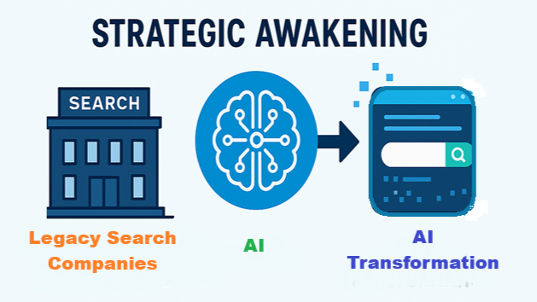](https://www.linkedin.com/pulse/strategic-awakening-legacy-giants-face-agentic-ai-girish-hukkeri-ies6f)](https://www.linkedin.com/pulse/strategic-awakening-legacy-giants-face-agentic-ai-girish-hukkeri-ies6f" \t "_self)**

**[The Strategic Awakening: Legacy Giants Face the Agentic AI Revolution](https://www.linkedin.com/pulse/strategic-awakening-legacy-giants-face-agentic-ai-girish-hukkeri-ies6f" \t "_self)**

[Girish Hukkeri](https://www.linkedin.com/pulse/strategic-awakening-legacy-giants-face-agentic-ai-girish-hukkeri-ies6f" \t "_self)

Feed post

Published 4 months ago

**[[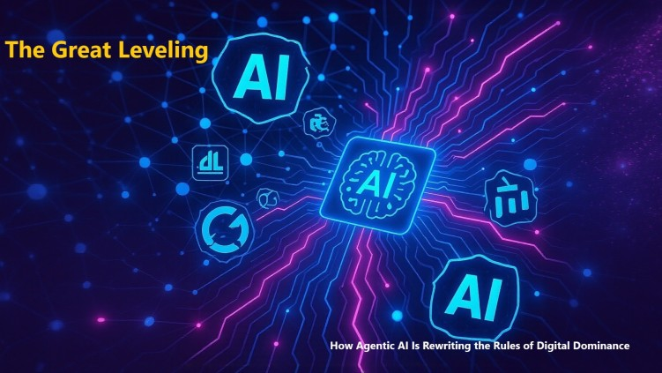](https://www.linkedin.com/pulse/great-leveling-how-agentic-ai-rewriting-rules-digital-girish-hukkeri-75ree)](https://www.linkedin.com/pulse/great-leveling-how-agentic-ai-rewriting-rules-digital-girish-hukkeri-75ree" \t "_self)**

**[The Great Leveling: How Agentic AI Is Rewriting the Rules of Digital Dominance](https://www.linkedin.com/pulse/great-leveling-how-agentic-ai-rewriting-rules-digital-girish-hukkeri-75ree" \t "_self)**

[Girish Hukkeri](https://www.linkedin.com/pulse/great-leveling-how-agentic-ai-rewriting-rules-digital-girish-hukkeri-75ree" \t "_self)

* 2
  + 1 comment

Feed post

Published 4 months ago

**[[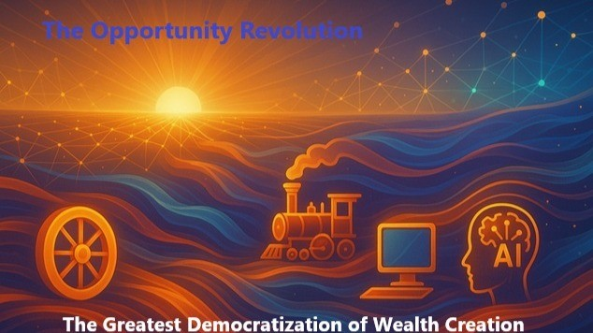](https://www.linkedin.com/pulse/opportunity-revolution-greatest-democratization-wealth-girish-hukkeri-ur6ye)](https://www.linkedin.com/pulse/opportunity-revolution-greatest-democratization-wealth-girish-hukkeri-ur6ye" \t "_self)**

**[The Opportunity Revolution: The Greatest Democratization of Wealth Creation](https://www.linkedin.com/pulse/opportunity-revolution-greatest-democratization-wealth-girish-hukkeri-ur6ye" \t "_self)**

[Girish Hukkeri](https://www.linkedin.com/pulse/opportunity-revolution-greatest-democratization-wealth-girish-hukkeri-ur6ye" \t "_self)

Feed post

Published 4 months ago

**[[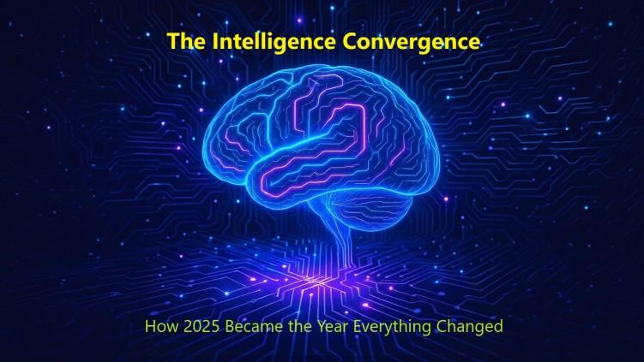](https://www.linkedin.com/pulse/intelligence-convergence-how-2025-became-year-changed-girish-hukkeri-x1hme)](https://www.linkedin.com/pulse/intelligence-convergence-how-2025-became-year-changed-girish-hukkeri-x1hme" \t "_self)**

**[The Intelligence Convergence: How 2025 Became the Year Everything Changed](https://www.linkedin.com/pulse/intelligence-convergence-how-2025-became-year-changed-girish-hukkeri-x1hme" \t "_self)**

[Girish Hukkeri](https://www.linkedin.com/pulse/intelligence-convergence-how-2025-became-year-changed-girish-hukkeri-x1hme" \t "_self)

* 2
  + 2 comments

Feed post

Published 4 months ago

**[[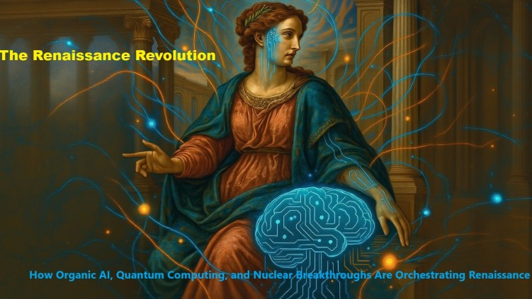](https://www.linkedin.com/pulse/renaissance-revolution-how-organic-ai-quantum-nuclear-girish-hukkeri-iidre)](https://www.linkedin.com/pulse/renaissance-revolution-how-organic-ai-quantum-nuclear-girish-hukkeri-iidre" \t "_self)**

**[The RenAIssance Revolution: How Organic AI, Quantum Computing & Nuclear Breakthroughs are Orchestrating Renaissance](https://www.linkedin.com/pulse/renaissance-revolution-how-organic-ai-quantum-nuclear-girish-hukkeri-iidre" \t "_self)**

[Girish Hukkeri](https://www.linkedin.com/pulse/renaissance-revolution-how-organic-ai-quantum-nuclear-girish-hukkeri-iidre" \t "_self)

* 6
  + 7 comments

Feed post

Published 4 months ago

**[[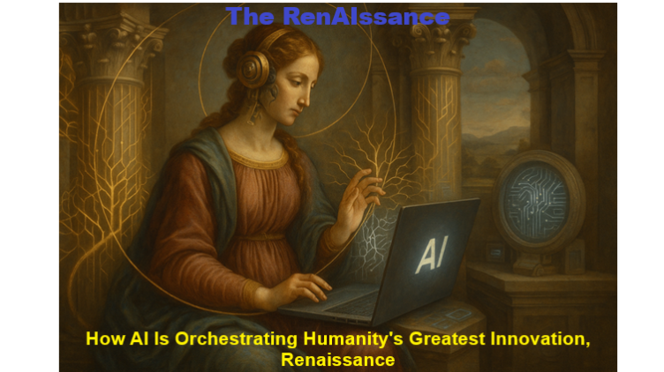](https://www.linkedin.com/pulse/renaissance-how-ai-orchestrating-humanitys-greatest-girish-hukkeri-dz1ne)](https://www.linkedin.com/pulse/renaissance-how-ai-orchestrating-humanitys-greatest-girish-hukkeri-dz1ne" \t "_self)**

**[The RenAIssance: How AI Is Orchestrating Humanity's Greatest Innovation, Renaissance](https://www.linkedin.com/pulse/renaissance-how-ai-orchestrating-humanitys-greatest-girish-hukkeri-dz1ne" \t "_self)**

[Girish Hukkeri](https://www.linkedin.com/pulse/renaissance-how-ai-orchestrating-humanitys-greatest-girish-hukkeri-dz1ne" \t "_self)

* 3
  + 3 comments

Feed post

Published 4 months ago

**[[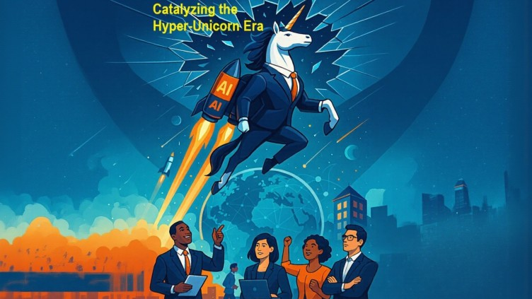](https://www.linkedin.com/pulse/catalyzing-hyper-unicorn-era-how-ai-first-ecosystems-turning-hukkeri-dkeje)](https://www.linkedin.com/pulse/catalyzing-hyper-unicorn-era-how-ai-first-ecosystems-turning-hukkeri-dkeje" \t "_self)**

**[Catalyzing the Hyper-Unicorn Era: How AI-First Ecosystems Are Turning Founders into Global Game-Changers](https://www.linkedin.com/pulse/catalyzing-hyper-unicorn-era-how-ai-first-ecosystems-turning-hukkeri-dkeje?lipi=urn%3Ali%3Apage%3Ad_flagship3_series_entity%3BPIbcuhYHRU6EKFjqttUFrw%3D%3D" \t "_self)**

[Girish Hukkeri](https://www.linkedin.com/pulse/catalyzing-hyper-unicorn-era-how-ai-first-ecosystems-turning-hukkeri-dkeje?lipi=urn%3Ali%3Apage%3Ad_flagship3_series_entity%3BPIbcuhYHRU6EKFjqttUFrw%3D%3D" \t "_self)

* 1
  + 2 comments

Feed post

Published 4 months ago

**[[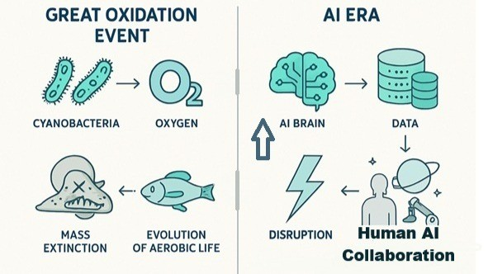](https://www.linkedin.com/pulse/ai-era-humanitys-multiverse-bang-girish-hukkeri-lan4e)](https://www.linkedin.com/pulse/ai-era-humanitys-multiverse-bang-girish-hukkeri-lan4e" \t "_self)**

**[The AI Era: Humanity's Multiverse Bang](https://www.linkedin.com/pulse/ai-era-humanitys-multiverse-bang-girish-hukkeri-lan4e" \t "_self)**

[Girish Hukkeri](https://www.linkedin.com/pulse/ai-era-humanitys-multiverse-bang-girish-hukkeri-lan4e" \t "_self)

* 1
  + 1 comment

Feed post

Published 4 months ago

**[[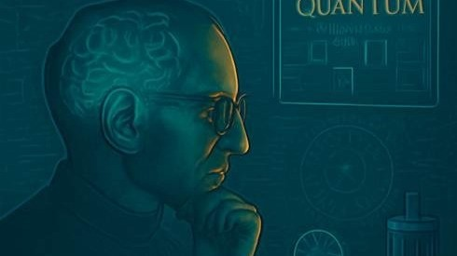](https://www.linkedin.com/pulse/breaking-intelligence-singularity-from-steve-jobs-paradox-hukkeri-ykxle)](https://www.linkedin.com/pulse/breaking-intelligence-singularity-from-steve-jobs-paradox-hukkeri-ykxle" \t "_self)**

**[Breaking the Intelligence Singularity: From Steve Jobs' Leadership Paradox to Consciousness-Enabled AI Systems - Part 2](https://www.linkedin.com/pulse/breaking-intelligence-singularity-from-steve-jobs-paradox-hukkeri-ykxle" \t "_self)**

[Girish Hukkeri](https://www.linkedin.com/pulse/breaking-intelligence-singularity-from-steve-jobs-paradox-hukkeri-ykxle" \t "_self)

* 2
  + 2 comments

Feed post

Published 4 months ago

**[[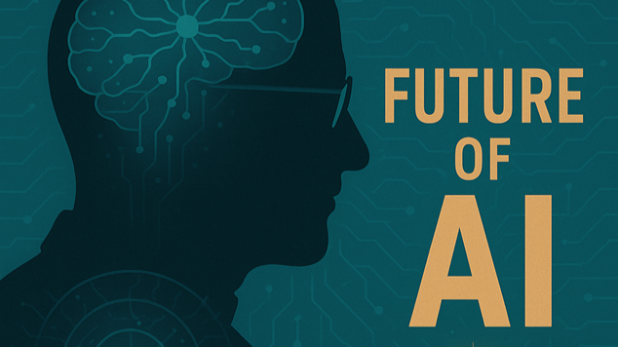](https://www.linkedin.com/pulse/breaking-intelligence-singularity-from-steve-jobs-paradox-hukkeri-k2xqe)](https://www.linkedin.com/pulse/breaking-intelligence-singularity-from-steve-jobs-paradox-hukkeri-k2xqe" \t "_self)**

**[Breaking the Intelligence Singularity: From Steve Jobs' Leadership Paradox to Consciousness-Enabled AI Systems - Part 1](https://www.linkedin.com/pulse/breaking-intelligence-singularity-from-steve-jobs-paradox-hukkeri-k2xqe" \t "_self)**

[Girish Hukkeri](https://www.linkedin.com/pulse/breaking-intelligence-singularity-from-steve-jobs-paradox-hukkeri-k2xqe" \t "_self)